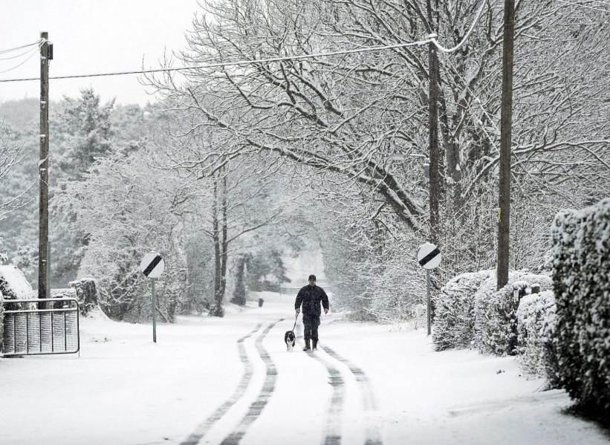
Winter

Watch the video and answer these questions.
- What are the 4 seasons of the year?

- What season are we in now?

- What can the weather be like in winter?

- What could you play with when it is windy?

- Name 3 things you could you do when it is snowy?

- Describe the trees in winter.

- What bird could you see, it has a red breast?

- Which animals hibernate?

- How can we help the birds in Winter?

Look outside, what is it like today?

