Cool Crabs
Where Do Crabs Live?

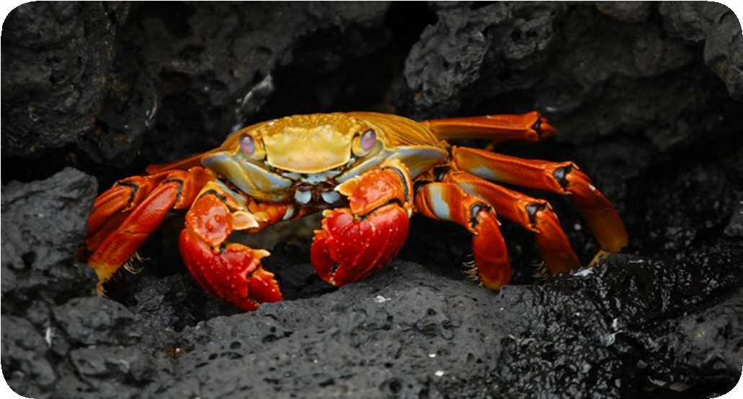
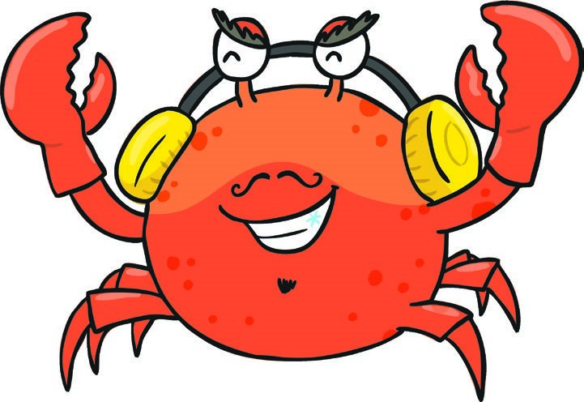
Most crabs live in the sea all over the world. They even live under the ice at the South Pole. One type of crab lives on land and can climb up trees!
How Many Legs Do Crabs Have?
Crabs have 10 legs. The front two legs have claws. They use the other eight legs for walking.
Can a Crab’s Shell Get Bigger?
A crab’s shell cannot grow or stretch. When a crab gets too big for its shell, it will climb out of it and make a new one.
What Is the Biggest Crab?
The biggest crab in the world is the Japanese spider crab. They can be up to 4 metres wide!
What Is the Smallest Crab?
The smallest crab in the world is the pea crab. They are only up to 1cm wide.
Fun Facts!
- Crab’s eyes are on sticks on top of their head.
- Most crabs have flat bodies. This means that they can squeeze into very small spaces.
- A group of crabs is called a cast.
Cool Crabs Questions
- Where do most crabs live? Tick one. in the trees on the ice in the sea
- How many legs do crabs have? Tick one.
2
5
10
- What does a crab do when its shell is too small? Tick one. it makes it bigger it climbs out of it it is never too small
- What is the smallest crab in the world? Tick one. the spider crab the tiny crab the pea crab
- What is a group of crabs called? Tick one.
a cast a gap a claw
Cool Crabs Answers

- Where do most crabs live? Tick one. in the trees on the ice in the sea
- How many legs do crabs have? Tick one.
2
5
10
- What does a crab do when its shell is too small? Tick one. it makes it bigger it climbs out of it it is never too small
- What is the smallest crab in the world? Tick one. the spider crab the tiny crab the pea crab
- What is a group of crabs called? Tick one.
a cast a gap a claw

Cool Crabs
Crabs are sometimes called the ‘spiders of the sea’ because of their long legs. Let’s look at some more interesting facts about crabs.
Where Do Crabs Live?
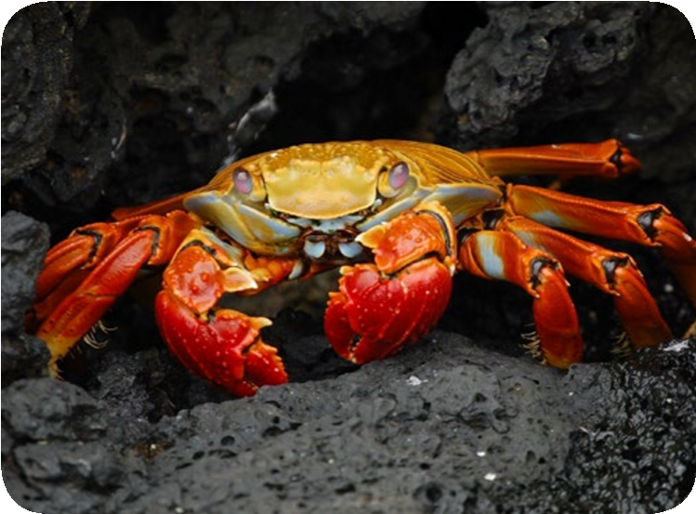
Crabs live in every sea around the world. They can live in underwater volcanoes and underneath the ice in Antarctica. One type of crab even lives on land and can climb trees!
What Is a Crab’s Body Like?
Crabs have 10 legs. The front two legs have claws. The other eight legs are used for walking.
Crabs have an exoskeleton. This means that they have a skeleton outside of their body. A crab’s exoskeleton is its shell.
A crab’s shell does not grow or stretch. When a crab grows bigger, it gets too big for its shell. The shell cracks and the crab climbs out of it. It will then make a new one.
The World’s Biggest and Smallest Crabs
The biggest crab in the world is the Japanese spider crab. They can be up to 4 metres across! The smallest crab in the world is the pea crab. They are only up to 1cm across. That’s a big difference!
Fun Facts!
- Crabs do not have teeth in their mouth but some crabs have teeth in their stomach!
- Crab’s eyes are on sticks on top of their head.
- The name for a group of crabs is a cast.
- Most crabs have flat bodies. This means that they can squeeze into very small spaces.
Cool Crabs Questions
- What are crabs sometimes called? Tick one. underwater fish spiders of the sea tree climbers
- Find and copy two facts about a crab’s legs.
1.
2.
- Which two of these does a crab’s shell not do?
crack grow
stretch
- Draw a line to complete the sentences.
The biggest crab is the |  | a cast.
The smallest crab is the |  | pea crab.
A group of crabs is called |  | Japanese spider crab.
- Which word means a skeleton that is outside of the body?

Cool Crabs Answers
- What are crabs sometimes called? Tick one. underwater fish spiders of the sea tree climbers
- Find and copy two facts about a crab’s legs.
Accept any two of the following: they are long, there are 10 of them, the front two legs have claws, the other eight legs are used for walking.
- Which two of these does a crab’s shell not do? crack grow
stretch
- Draw a line to complete the sentences.
The biggest crab is the
a cast.
The smallest crab is the
pea crab.
A group of crabs is called
Japanese spider crab.
- Which word means a skeleton that is outside of the body?
exoskeleton

Cool Crabs
Sometimes known as ‘spiders of the sea’ because of their long legs, crabs are interesting creatures with a lot of fun features. Let’s take a look.
Anywhere and Everywhere
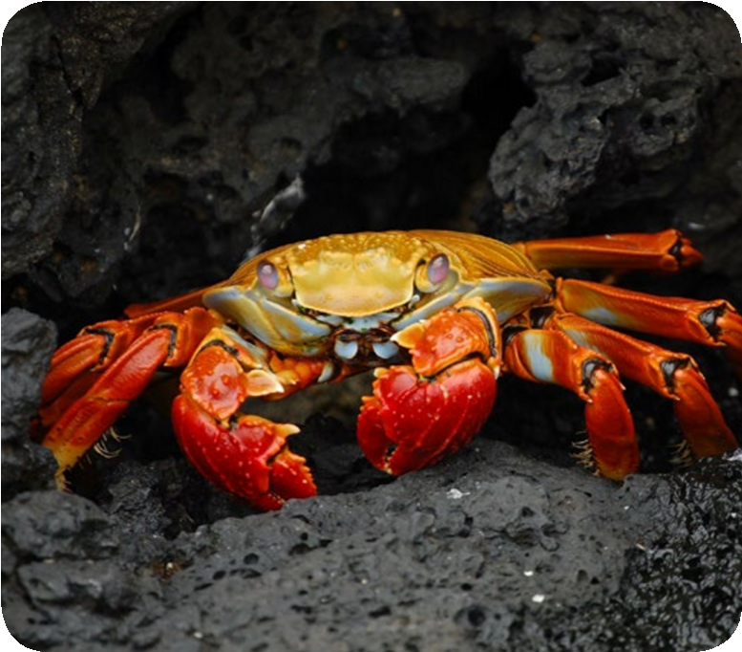
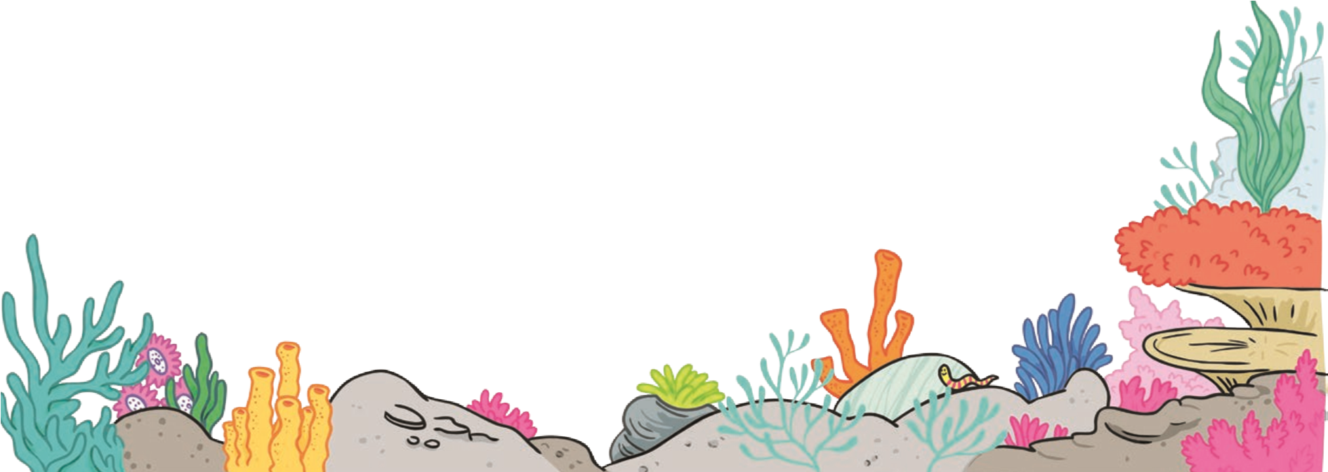
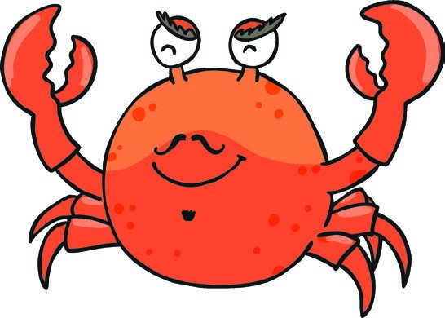
Crabs can be found in more places on earth than any other sea animal. They live in every ocean around the world and can be found in volcanoes and beneath the ice in Antarctica. One type of crab even lives on land and can climb trees!
Odd Bods
Crabs have unusual bodies. They are decapods. This means that they have 10 limbs. The front two legs have claws, known as pincers. The other eight legs are used for walking.
Crabs are also invertebrates. This means that they do not have a backbone. However, crabs have an exoskeleton (a skeleton outside their body). Their exoskeleton is their shell.
Crabs’ shells do not grow or stretch. When crabs grow bigger, they get too big for their shell. They begin to grow a soft shell underneath their hard shell. When the hard shell is too small, it cracks and the crab climbs out of it.
Page 1 of 2
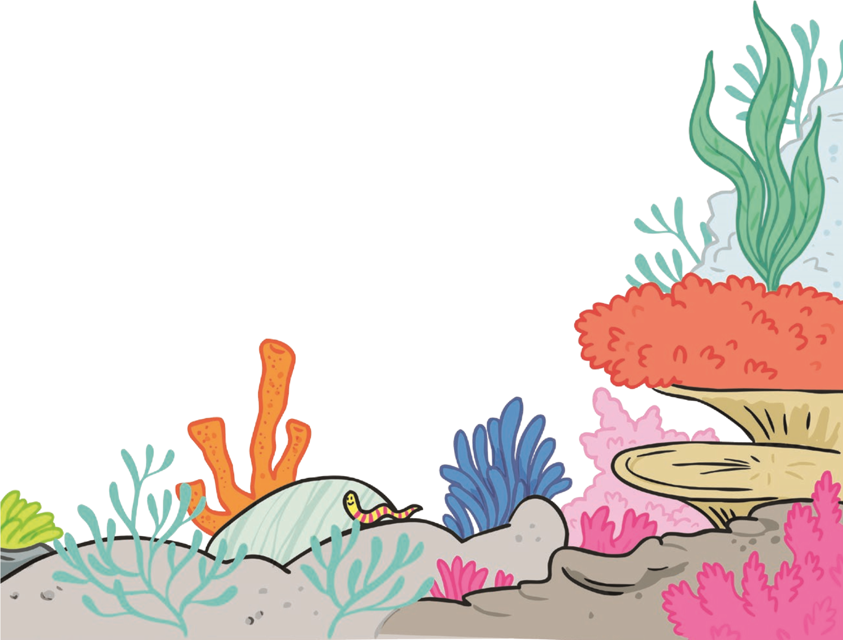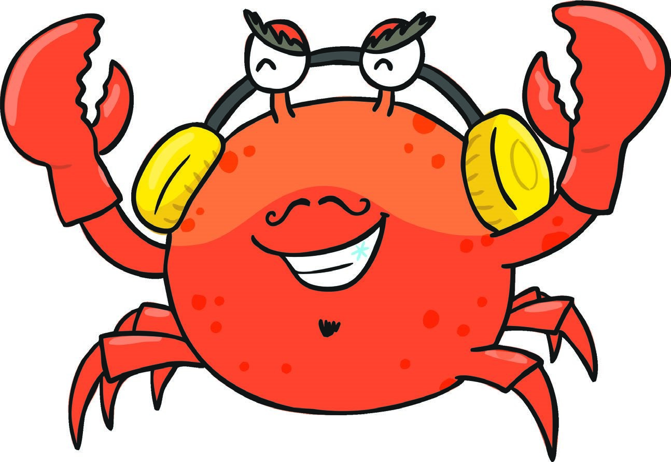
Cool Crabs
True or False?
Although there are said to be around 5000 different kinds of crab,
only 4500 of them are true crabs. 500 of these species are not
actually crabs because they do not have enough legs and their
body is too long.
The largest crab in the world is the Japanese spider crab which
can be up to 4 metres across! The smallest crab is the pea crab,
which measures up to 1cm. That’s a big difference!
Fascinating Fact
Crabs do not have teeth in their mouth but some crabs
(
!
such as the brown crab) have teeth in their stomach
Page 2 of 2
Cool Crabs Questions
- There are around different kinds of true crabs. Tick one.
500
4500
5000
- What is the name for a type of creature which has 10 limbs?

- Find one word in the text which means the same as starts.

- Give two reasons why some crabs are not classed as true crabs.
1.
2.
- Draw a line to match these facts to the correct animal.
brown crab |  | It has teeth in its stomach.
Japanese spider crab |  | It measures up to 1cm wide.
pea crab |  | It can be up to 4 metres across.
- Why do you think crabs are found in more places on earth than any other sea creature?

Cool Crabs Answers
- There are around different kinds of true crabs. Tick one.
500
4500
5000
- What is the name for a type of creature which has 10 limbs? a decapod
- Find one word in the text which means the same as starts. begins
- Give two reasons why some crabs are not classed as true crabs.
They do not have enough legs and their body is too long.
- Draw a line to match these facts to the correct animal.
brown crab |  | It has teeth in its stomach.
Japanese spider crab |  | It measures up to 1cm wide.
pea crab |  | It can be up to 4 metres across.
- Why do you think crabs are found in more places on earth than any other sea creature?
Various answers related to how a crab surivives.

