Here are our wonderful children enjoying their time at home. Amazing memories, cheers us all up!
Jack, George and Eddy Stone having a ‘forest school’ experience.
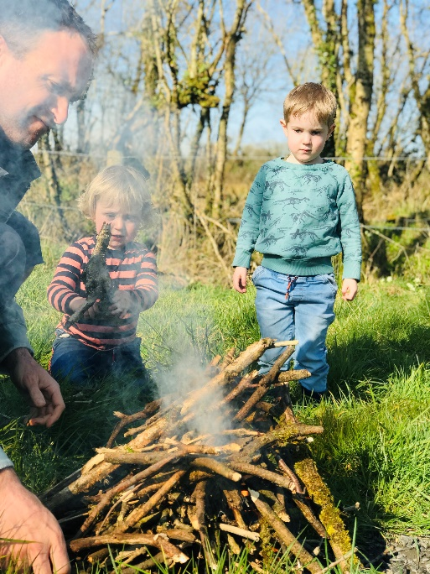
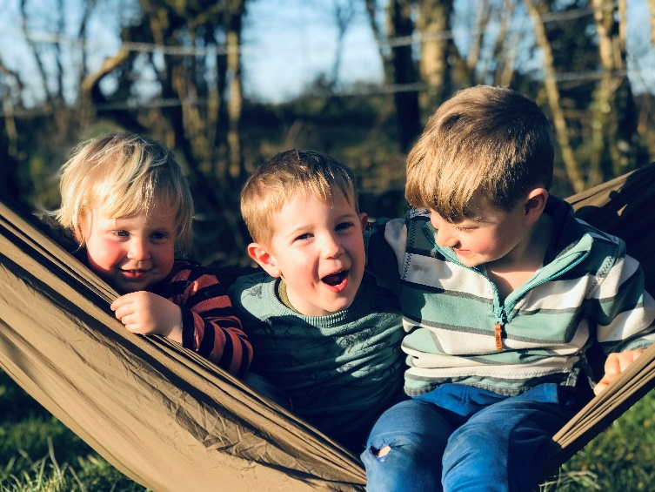

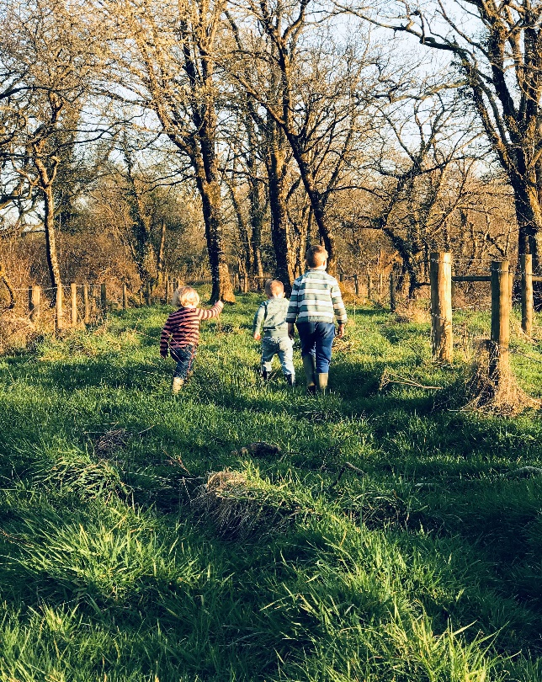
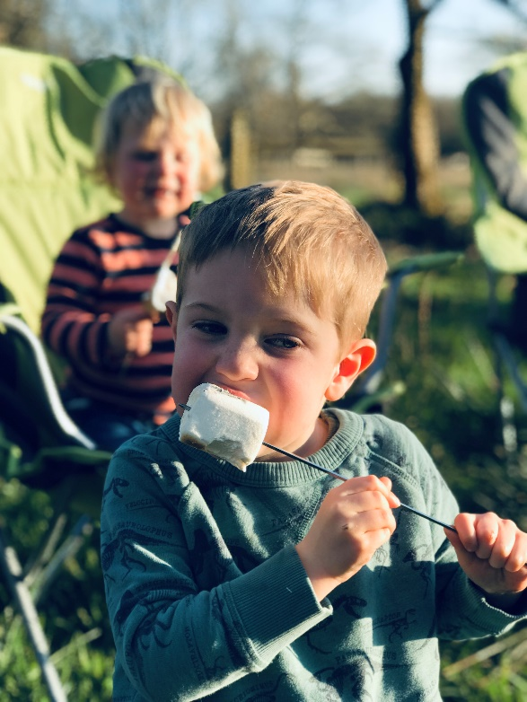

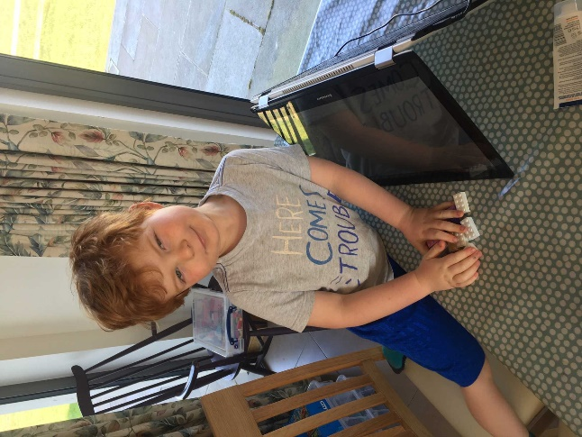
Harry has been preparing for a ‘skate show’ with Chloe, they even made their own tuck shop xx

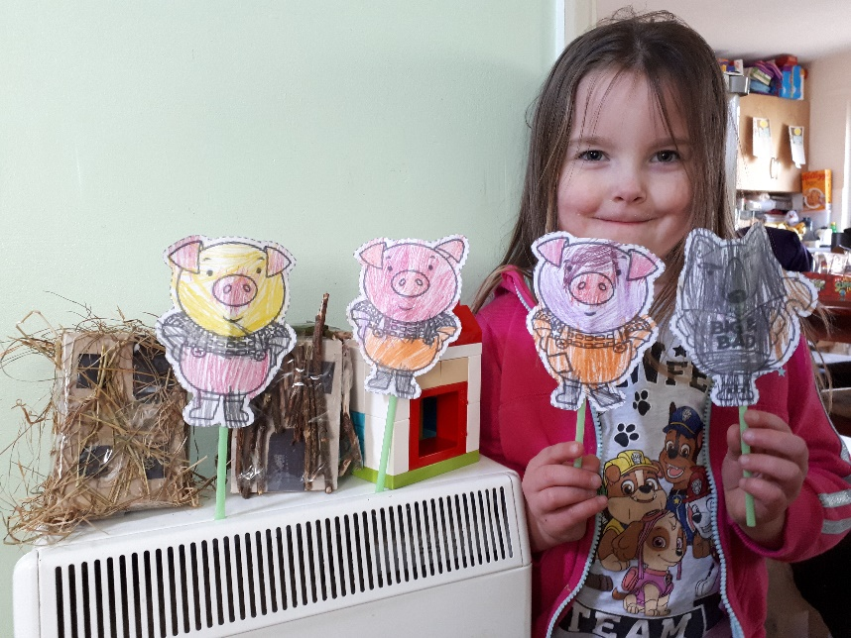
Lissy and Milly re-told this story- I think they should apply for a job with Wimpeys the builders! Great houses girls.
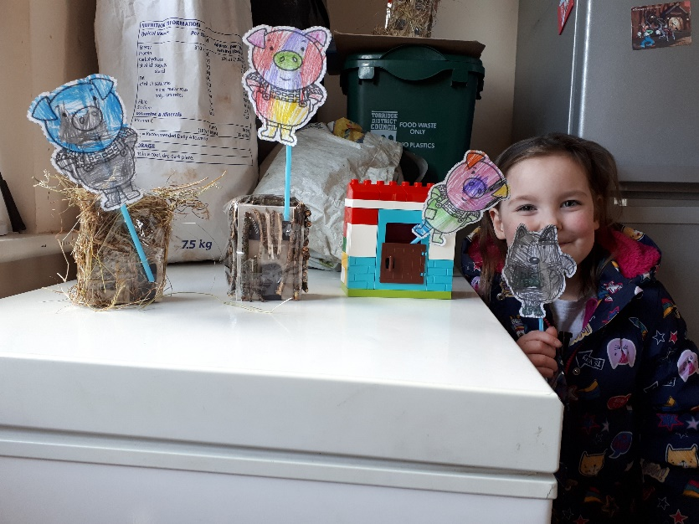

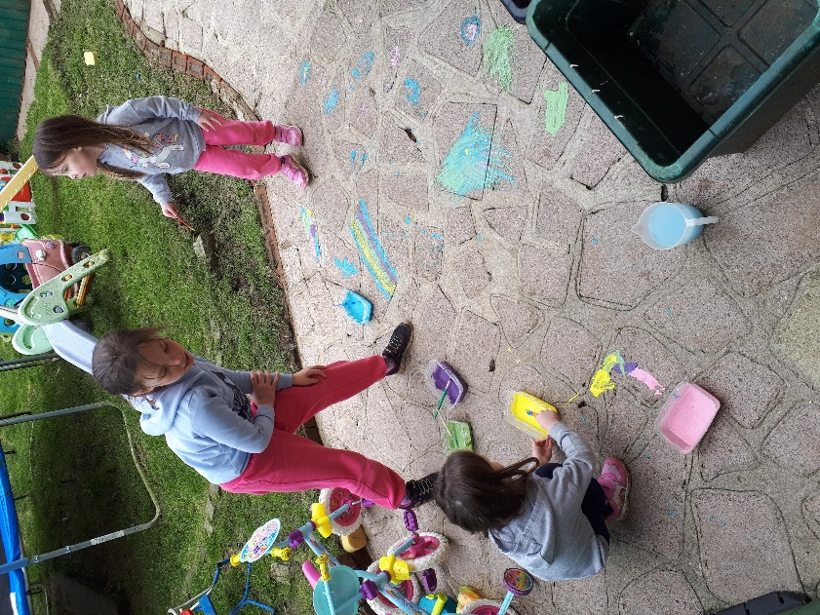
I love the idea of flour paint girls, we will try that at school. Sophie could you be our teacher?

