BRADWORTHY PRIMARY ACADEMY
ADMINISTRATION OF MEDICINES POLICY

This policy was reviewed and ratified: Spring 2025
It will be reviewed on an annual basis.

This policy is for use with pupils who have short term medical conditions that require medicine.

The needs of those pupils who have long term medical conditions are dealt with on an individual, case by case, basis with treatment plans, risk assessments and staff training needs as appropriate.

This policy relates to all sections and activities of the school, outdoor education

Bradworthy Academy promotes ongoing communication with parents in order to ensure that the specific medical needs of all pupils in our care are known and met. Parents must inform School if their child develops a medical condition, which will require either prescription or non-prescription medication to be taken at School and of any changes to the medication required.

Parents retain the prime responsibility for their child’s health and should provide the school with information about their child’s medical condition. Children should be kept at home if they are acutely unwell and in the case of contagious diseases only return when they are no longer infectious. Further information on ‘Infectious Disease Control’ can be found below.

AIMS

The aim of this policy is to effectively support individual children with medical needs and to enable pupils to achieve regular attendance.

RESPONSIBILITIES AND ROLES

Teaching staff are not required to administer medicines to children. Those members of staff who volunteer to administer medicines or administer medicines, as part of their role within school, will receive appropriate training where this is deemed necessary.

The Board of Governors fully indemnifies all staff against claims for any alleged negligence, providing they are acting within their conditions of service and following these guidelines.

Our senior administrator will ensures that the School’s insurance covers staff upholding this policy, providing support to pupils with medical conditions, administering medicines and that staff are aware of this insurance and what it covers.

Our administrative staff will obtain, input and disseminate known medical information and appropriate contact details for all new pupils.

Additionally, administrative responsibilities will include:

• Ensuring receipt, release and return, and storage of medication procedures are followed.
• Communicating with parents about matters related to day-to-day administration.
• In a fire evacuation, collecting the medicines of children whose lives are at risk without it.
• Organising for the First Aid boxes to be checked and replenished each term.
• Ensuring expired medicines throughout the school are collected by parents.

PRESCRIBED MEDICINES

Medicines should only be brought into school when essential; that is where it would be detrimental to a child’s health if the medicine were not administered during the school day.

Parents must complete the Parental Agreement to Administer Medicine in School Form or request for their child to carry their own Epipen and/or Asthma Reliever in writing, prior to any medicine being brought into school. These forms must be handed in to the school office.

Office staff will then liaise with relevant teaching staff as required.

The School will accept medicines that have been prescribed by a doctor, dentist, nurse prescriber or pharmacist prescriber.

Medicines should always be provided in the original container, as dispensed by a pharmacist, and include the prescriber’s instructions for administration and dosage.

Medicines will be securely stored.

CONTROLLED MEDICATION

The supply, possession and administration of some medicines are controlled by the Misuse of Drugs Act and its associated regulations. Some may be prescribed as a medicine for use by children, e.g. methylphenidate (Ritalin).

Any authorised and trained member of staff may administer a controlled drug to the child for whom it has been prescribed. Staff administering medicine should do so in accordance with the prescriber’s instructions.
The Headteacher has the authority to authorise a member of staff.

A pupil who has been prescribed a controlled drug may legally have it in their possession if deemed “Fraser Competent”; however our school does not allow this on our premises and does not allow children to self-administer controlled drugs to ensure the safety of the whole school community.

It is permissible for schools and settings to look after a controlled drug, where it is agreed that it will be administered to the child for whom it has been prescribed. Controlled drugs are subject to safe custody and must be stored in a locked receptacle in the school office.
The key to this cabinet must be securely stored and only accessible to staff authorised to have access to it.

Record Keeping for Controlled Drugs –
It is a legal requirement that a paper Controlled Drug Register (will be kept in a bound book format. The register must comply with the following:
• There must be a separate page for each strength & form of an individual drug.
• Each page must specify the name, strength and form of the drug at the head of the page and all of the entries on that page must relate to that drug only.
• Each entry must be in chronological order.
• Each entry must be legible and written in indelible ink.
• If a mistake is made then it should be crossed through with a single line so that it can still be read.
• The Controlled Drug Register must be kept on the premises to which it relates.
• The Controlled Drug Register must be available for inspection by an authorised person.

Relevant staff will be given annual training on the administration and safe storage of Controlled Drugs.

All pupils requiring controlled drugs must have a consultant’s letter stating diagnosis, medication prescribed and dosage before it can be administered.

Any changes to medication must be accompanied by a letter from their consultant.

All controlled drugs must be in the original packaging, with a pharmacy label including name and correct dosage.

NON-PRESCRIBED MEDICINES

This would include a child who suffers from seasonal allergies e.g. hay fever, or if a child needs medication for occasional use e.g. migraines or period pain.
This may also include a child wo needed to bring medication in to school for a short period of time e.g. a week’s course of penicillin.

Staff should never give non-prescribed medicine in school e.g. paracetamol to a child unless there is specific prior written permission from the parents. Parents must complete the form, Parental Agreement to Administer Medicine in School Form, prior to any medicine being administered by school staff.

These forms must be handed in to the school office.
Office staff will then liaise with relevant teaching staff as required.

Only in exceptional circumstances will more than one dose of a non-prescribed medicine be given to a child during the day.

Children operating in remote circumstances where contact with a parent may be difficult, such as hill walking on Dartmoor, may take a non-prescribed medication, such as for hay fever or pain relief, if permission has been given in advance on the appropriate form (SE03).

A child under 16 should never be given aspirin unless prescribed by a doctor.

ADMINISTERING MEDICINES IN SCHOOL

In the case of pupils, the School requests that medication is only taken at School if it would be detrimental to the pupil’s health not to administer the medication during the school day.

Where possible, medicines should be taken at home before, and after attending School.

Medication prescribed for one pupil should not under any circumstances be given to another pupil.

Training relating to the administration of medicines will be provided as deemed necessary by the Headteacher, or on request from a member of staff who is considering volunteering to do so.
In normal, non-specialist, circumstances it is not envisaged that training beyond the contents of this policy will be required, or that this would need to be delivered by anyone other than a senior member of staff.

All medicines supplied to the school by parents must be provided in the original container as dispensed and include the prescriber’s instructions for administration in clear English a consent form should be signed by the parent, detailing drug/dose/frequency.

Pupils will come to the school office at the prescribed times to receive their medication, unless other arrangements have been put in place – such as administration in class by the child’s class teacher.

Staff administering the medicine should remind the pupil to let them and their parents know if they experience any of the side effects. Any reported side effects should be added to the administration record and communicated to the parents.

Staff administering medication will check the pupil’s name, the name of the medication, the prescribed dose, the expiry date, method of administration, the time/frequency of administration, any side effects and the written instructions on the container before providing the medicine to the pupils.
If staff have any doubt over the procedure to be followed, the parent will be contacted before action is taken.

EMERGENCY ASHTMA INHALERS

At the point of this policy’s review, we hold two emergency asthma inhalers which kept in the staffroom with the first aid kit.

The protocols for its use are detailed as follows:
Emergency asthma inhalers for use in schools - GOV.UK (www.gov.uk)
From 1 October 2014, the Human Medicines (Amendment) (No. 2) Regulations 2014 will allow schools to buy salbutamol inhalers, without a prescription, for use in emergencies. The emergency salbutamol inhaler should only be used by children:

• For whom written parental consent for use of the emergency inhaler has been given.
• Who have either been diagnosed with asthma and prescribed an inhaler.
• Who have been prescribed an inhaler as reliever medication.

The inhaler can be used if the pupil’s prescribed inhaler is not available (for example, because it is broken, or empty).

The protocol should include the following – on which this guidance provides advice:
• Arrangements for the supply, storage, care, and disposal of the inhaler and spacers in line with the School’s policy on supporting pupils with medical conditions.
• Having a register of children in the school that have been diagnosed with asthma or prescribed a reliever inhaler, a copy of which should kept with the emergency inhaler.
• Having written parental consent for use of the emergency inhaler included as part of a child’s individual healthcare plan.
• Ensuring that the emergency inhaler is only used by children with asthma with written parental consent for its use.
• Appropriate support and training for staff in the use of the emergency inhaler in line with the school’s wider policy on supporting pupils with medical conditions.
• Keeping a record of use of the emergency inhaler as required by supporting pupils and informing parents that their child has used the emergency inhaler.

A child may be prescribed an inhaler for their asthma which contains an alternative reliever medication to salbutamol (such as terbutaline). The salbutamol inhaler should still be used by these children if their own inhaler is not accessible – it will still help to relieve their asthma and could save their life.

Details of the medicine administered must be recorded and signed, and parents informed on the same day.

ADMINISTRATION OF MEDICINES ON SCHOOL TRIPS

We will make all reasonable adjustments to ensure that children may take a full part in all aspects of both our core and extended curriculums.

Where a child requires medication to be administered on a trip or visit, it is the responsibility of the trip or visit organiser to assess the practicalities of administering such medicine as is required.

First Aid kits will always be carried by staff escorting pupils on school trips. The member of staff organising the trip will request that the school office provides them with medical information, from school records, on a need-to-know basis for each pupil.

Pupils who are on prescribed medications that they will need access to during the course of the school trip will hand these over to the member of staff in charge of the trip for safekeeping, and written instructions from his/her parent will also be gained explaining the need for the medication and administration instructions.

Parents must complete a consent form for any school visit, and where necessary they will also complete an additional form to give consent for medication to be administered, as they would for in-school administration.

Staff are not obliged to administer pupils’ prescribed medications, and if instructions are unclear, they may decline to do so.

If a pupil requests paracetamol from the trip leader during the trip, and it is within four hours of leaving school, then the trip leader will phone the child’s parents, to discuss whether it is safe to do so, i.e. that he/she has not received any in the previous four hours, in order to avoid double dosing.

Children operating in remote circumstances where contact with a parent may be difficult, such as hill walking on Dartmoor, may take a non-prescribed medication, such as for hay fever or pain relief, if permission has been given in advance on the appropriate form (SE03).

A limited supply of over-the-counter medication e.g. paracetamol, antihistamine, in the first aid kit, to administer if deemed necessary.

If prescription or over the counter medication is administered to a pupil, e.g. paracetamol or antihistamine, staff must record the administration and ensure that parents are informed afterwards.

EMERGENCY MEDICINE ON SCHOOL TRIPS

All pupils with a diagnosis of asthma or anaphylaxis must have their asthma reliever or adrenaline pen with them prior to setting off. The trip leader is responsible for ensuring this and must physically see inhalers and adrenaline pens.

The person leading any trip must ensure that a spare inhaler or adrenaline pen for a pupil is available. If this isn’t possible then a pupil will not be allowed to join the trip.

SELF-MANAGEMENT OF EPIPENS AND ASTHMA RELIEVERS

Children are supported and encouraged to take responsibility for managing their own epipens and asthma relievers from an early age.

Children may carry and administer their own epipens and asthma relievers, where appropriate, etc. In these circumstances parent’s must give written permission for their child to carry their own Epipen and/or Asthma Reliever.

CHILDREN WITH LONG-TERM OR COMPLEX MEDICAL NEEDS

Where a child has a long-term or complex medical need, the school will draw up a health care plan in consultation with parents and relevant health professionals, if necessary.

STORAGE OF MEDICINES

Most medicines will be kept in a locked cupboard in the school office or a classroom, or in the staffroom if refrigeration is required and should be collected at the end of the required administration period by the parent.

Controlled drugs will be kept locked in the school office as explained above.

Staff should ensure children know where their medicine is kept in school and on trips/matches.

Expiry dates are reviewed in each term holiday and reminders are sent to parents to collect and where necessary replace medicines.

CONTROL OF INFECTIOUS DISEASES

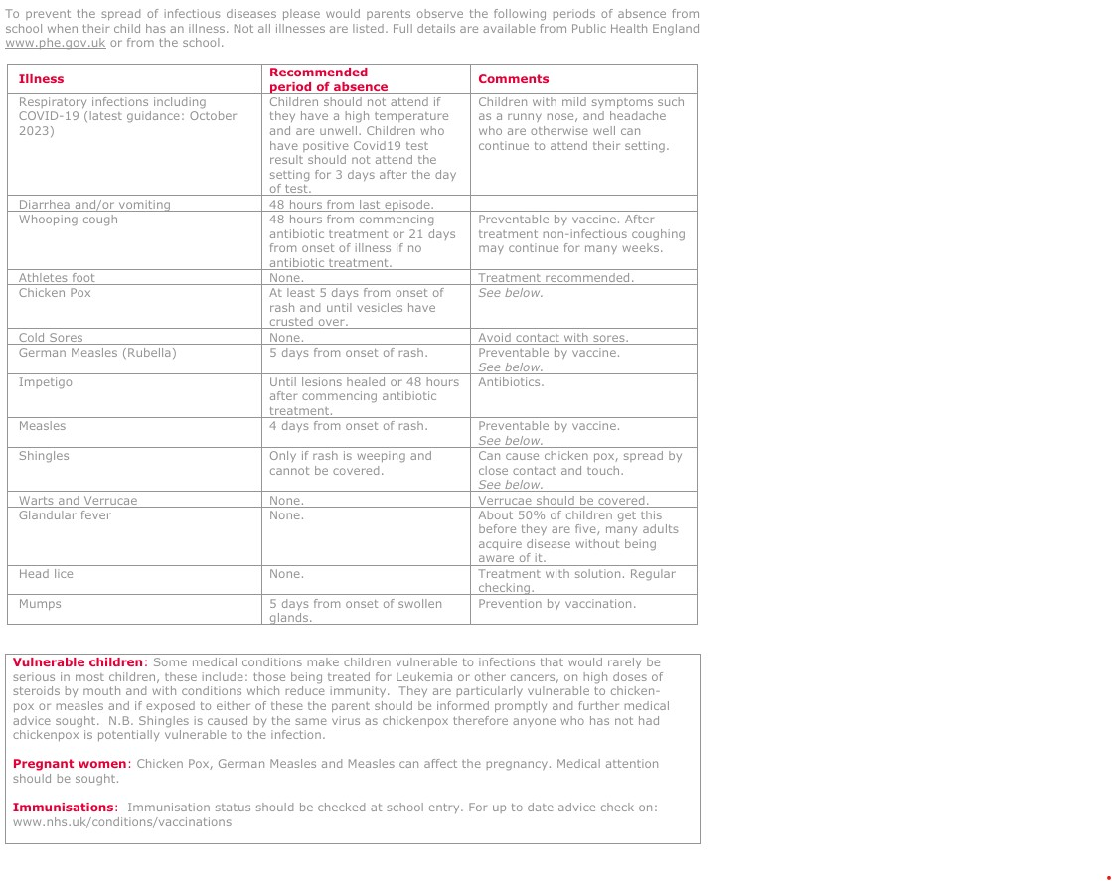


BRADWORTHY PRIMARY ACADEMY
ADMINISTRATION OF MEDICINES

Name of pupil …………………………………………………………………………………………………….........................
Address ……………………………………………………………………………………………………………
………………………………………………………………………………………………………………………
Medical condition of pupil ……………………………………………………………….……………………….
Name of prescribing doctor (if applicable)……………………………………………………………………...
Medicine……………………………………………………………………………………………………………
Dose …………………………………… Frequency of dose ………………………….……………………….

Please sign where necessary:

1. I confirm that the above medicine has been prescribed by a doctor, and that I give my permission for the Headteacher (or their nominee) to administer the medicine to my son/daughter during the time he/she is at school.

Signed ………………………………………………………………...…………………………………………...
(Parent/Guardian/Person with parental responsibility)
Date .……………………………………………………………………………………………………………….

2. The above medicine has not been prescribed by a doctor, however I confirm that I give my permission for the Headteacher (or their nominee) to administer the medicine to my son/daughter during the time he/she is at school.

Signed ………………………………………………………………...…………………………………………
(Parent/Guardian/Person with parental responsibility)
Date .……………………………………………………………………………………………………………….

3. I give my permission for my son/daughter to carry their asthma inhaler with
them whilst at school and to manage its use.

Signed ………………………………………………………………...…………………………………………...
(Parent/Guardian/Person with parental responsibility)
Date .……………………………………………………………………………………………………………….

The information given here is requested in confidence, to ensure that the
Headteacher is fully aware of the medical needs of your child.
While staff members cannot be compelled to give medical treatment to a pupil,
we are willing to support this through parental consent, and these guidelines, as
part of our pastoral role.
Where such arrangements fail it is the parents’ responsibility to make appropriate
alternative arrangements.

Record of Administration:

Name of Medication | Dose/Quantity Given | Time and Date Given | Staff Initials

