The Highwayman
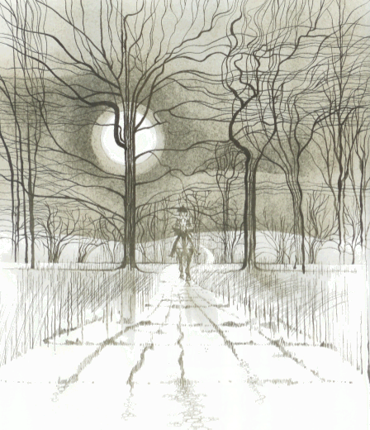
Class Six

The Highwayman
By Alfred Noyes
Part One
I
The wind was a torrent of darkness among the gusty trees,
The moon was a ghostly galleon tossed upon cloudy seas,
The road was a ribbon of moonlight, over the purple moor,
And the highwayman came riding-
Riding-riding-
The highwayman came riding, up to the old inn-door.
II
He'd a French cocked-hat on his forehead, a bunch of lace at his chin,
A coat of the claret velvet, and breeches of brown doe-skin;
They fitted with never a wrinkle: his boots were up to the thigh!
And he rode with a jewelled twinkle,
His pistol butts a-twinkle,
His rapier hilt a-twinkle, under the jewelled sky.
III
Over the cobbles he clattered and clashed in the dark inn-yard,
And he tapped with his whip on the shutters, but all was locked and barred;
He whistled a tune to the window, and who should be waiting there
But the landlord's black-eyed daughter,
Bess, the landlord's daughter,
Plaiting a dark red love-knot into her long black hair.
IV
And dark in the old inn-yard a stable-wicket creaked
Where Tim the ostler listened; his face was white and peaked;
His eyes were hollows of madness, his hair like mouldy hay,
But he loved the landlord's daughter,
The landlord's red-lipped daughter,
Dumb as a dog he listened, and he heard the robber say-
V
"One kiss, my bonny sweetheart, I'm after a prize to-night,
But I shall be back with the yellow gold before the morning light;
Yet, if they press me sharply, and harry me through the day,
Then look for me by moonlight,
Watch for me by moonlight,
I'll come to thee by moonlight, though hell should bar the way."
VI
He rose upright in the stirrups; he scarce could reach her hand,
But she loosened her hair i' the casement! His face burnt like a brand
As the black cascade of perfume came tumbling over his breast;
And he kissed its waves in the moonlight,
(Oh, sweet black waves in the moonlight!)
Then he tugged at his rein in the moonlight, and galloped away to the West.
Part Two
I
He did not come in the dawning; he did not come at noon;
And out o' the tawny sunset, before the rise o' the moon,
When the road was a gipsy's ribbon, looping the purple moor,
A red-coat troop came marching-
Marching-marching-
King George's men came marching, up to the old inn-door.
II
They said no word to the landlord, they drank his ale instead,
But they gagged his daughter and bound her to the foot of her narrow bed;
Two of them knelt at her casement, with muskets at their side!
There was death at every window;
And hell at one dark window;
For Bess could see, through the casement, the road that he would ride.
III
They had tied her up to attention, with many a sniggering jest;
They bound a musket beside her, with the barrel beneath her breast!
"Now keep good watch!" and they kissed her.
She heard the dead man say-
Look for me by moonlight;
Watch for me by moonlight;
I'll come to thee by moonlight, though hell should bar the way!
IV
She twisted her hands behind her; but all the knots held good!
She writhed her hands till here fingers were wet with sweat or blood!
They stretched and strained in the darkness, and the hours crawled by like
years,
Till, now, on the stroke of midnight,
Cold, on the stroke of midnight,
The tip of one finger touched it! The trigger at least was hers!
V
The tip of one finger touched it; she strove no more for the rest!
Up, she stood up to attention, with the barrel beneath her breast,
She would not risk their hearing; she would not strive again;
For the road lay bare in the moonlight;
Blank and bare in the moonlight;
And the blood of her veins in the moonlight throbbed to her love's refrain.
VI
Tlot-tlot; tlot-tlot! Had they heard it? The horse-hoofs
ringing clear;
Tlot-tlot, tlot-tlot, in the distance? Were they deaf that they did
not hear?
Down the ribbon of moonlight, over the brow of the hill,
The highwayman came riding,
Riding, riding!
The red-coats looked to their priming! She stood up strait and still!
VII
Tlot-tlot, in the frosty silence! Tlot-tlot, in the echoing night
!
Nearer he came and nearer! Her face was like a light!
Her eyes grew wide for a moment; she drew one last deep breath,
Then her finger moved in the moonlight,
Her musket shattered the moonlight,
Shattered her breast in the moonlight and warned him-with her death.
VIII
He turned; he spurred to the West; he did not know who stood
Bowed, with her head o'er the musket, drenched with her own red blood!
Not till the dawn he heard it, his face grew grey to hear
How Bess, the landlord's daughter,
The landlord's black-eyed daughter,
Had watched for her love in the moonlight, and died in the darkness there.
IX
Back, he spurred like a madman, shrieking a curse to the sky,
With the white road smoking behind him and his rapier brandished high!
Blood-red were his spurs i' the golden noon; wine-red was his velvet coat,
When they shot him down on the highway,
Down like a dog on the highway,
And he lay in his blood on the highway, with a bunch of lace at his throat.
* * * * * *
X
And still of a winter's night, they say, when the wind is in the trees,
When the moon is a ghostly galleon tossed upon cloudy seas,
When the road is a ribbon of moonlight over the purple moor,
A highwayman comes riding-
Riding-riding-
A highwayman comes riding, up to the old inn-door.
XI
Over the cobbles he clatters and clangs in the dark inn-yard,
And he taps with his whip on the shutters, but all is locked and barred;
He whistles a tune to the window, and who should be waiting there
But the landlord's black-eyed daughter,
Bess, the landlord's daughter,
Plaiting a dark red love-knot into her long black hair.

The Highwayman – part 2
Bess twisted her hands but she couldn’t undo the ropes. Eventually, at midnight, she was able to touch the trigger of the gun.

The highwayman did not come back in the morning or during the day. As the sun set, King George’s soldiers came marching to the inn.

The soldiers had tied Bess standing up with a gun pointing at her chest. They were laughing at her, then kissed her and told her to watch through the window for the highwayman. She knew that he would come back that night.

Bess could touch the trigger of the gun with the tip of one finger. She didn’t struggle any more in case the soldiers heard her. She waited for the highwayman, but she couldn’t see him yet.

The Highwayman – part 3
The soldiers didn’t say anything to the landlord, but after having a drink, they tied his daughter to her bed. They waited by the window so that they could see the highwayman when he came.

The highwayman’s ghost rides over the cobbled yard of the inn and whistles a tune. Bess’s ghost hears him as she waits in her window, plaiting a red ribbon into her hair.

Bess heard a horse’s hooves in the distance and knew that the soldiers must have also heard it. She saw the highwayman riding over the hill as the soldiers looked at her.

The highwayman turned back the way he had come, to the West. He did not know who had been shot. In the morning he found out that Bess had waited for the man she loved and had died.

The highwayman rode back to the inn, holding his sword high. The soldiers shot him and he fell off his horse onto the road, dead.

Some people say that during windy nights when the moon is shining on the moor, the highwayman’s ghost comes riding back to the inn.

The highwayman was coming nearer on his horse. Bess breathed in deeply, then pulled the trigger of the gun and killed herself to warn the highwayman that the soldiers were waiting for him.

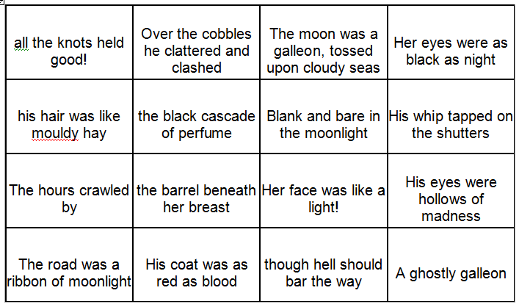

Simile

Personification

Alliteration

Metaphor

The Highwayman: Who Was Most Important?
Each of the characters below plays a key part in the poem. You need to make notes on each character, based on the events they control and have influence over within the poem.

Bess The Highwayman
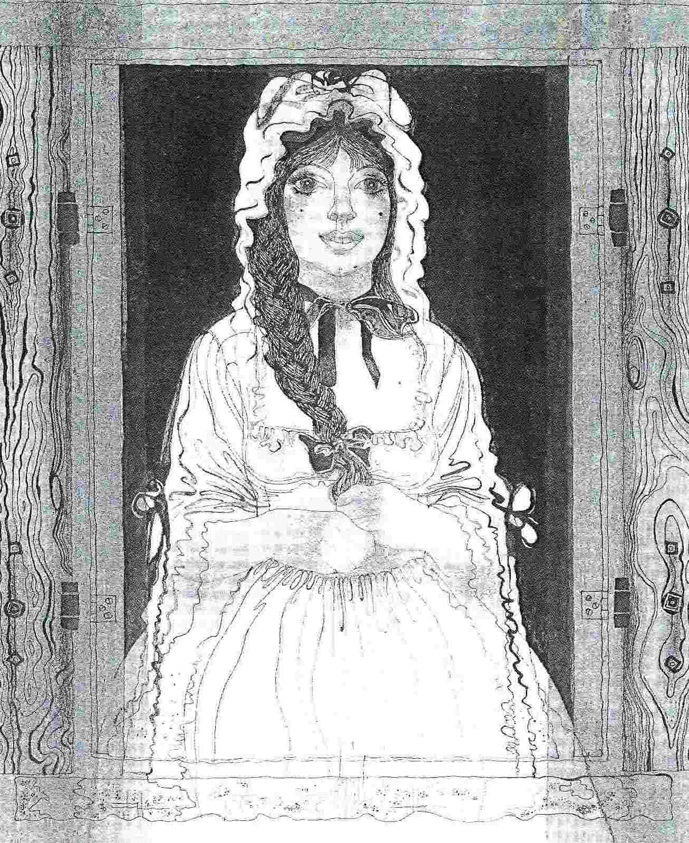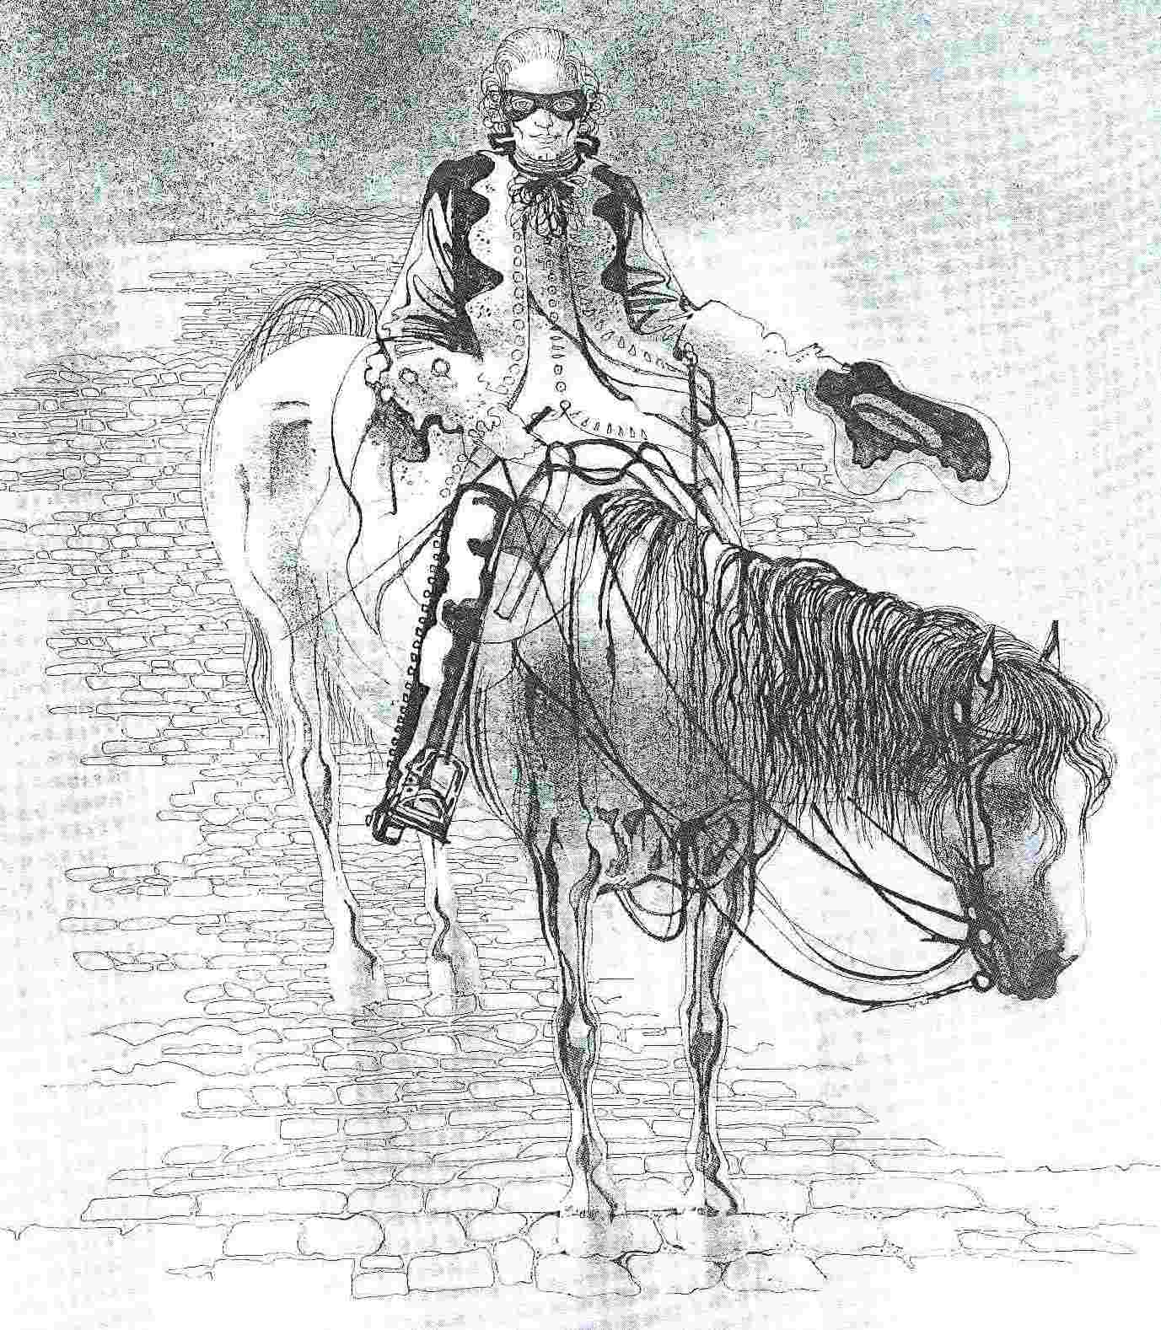
Tim the Ostler The Soldiers
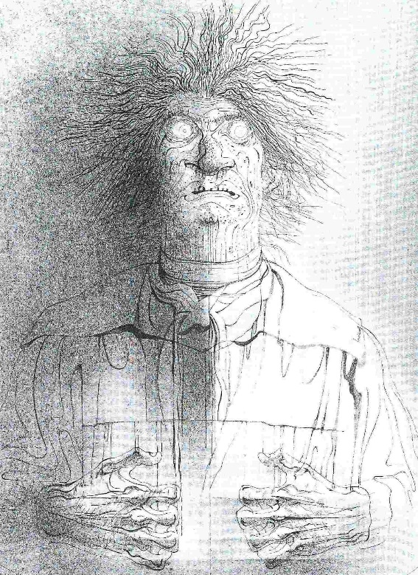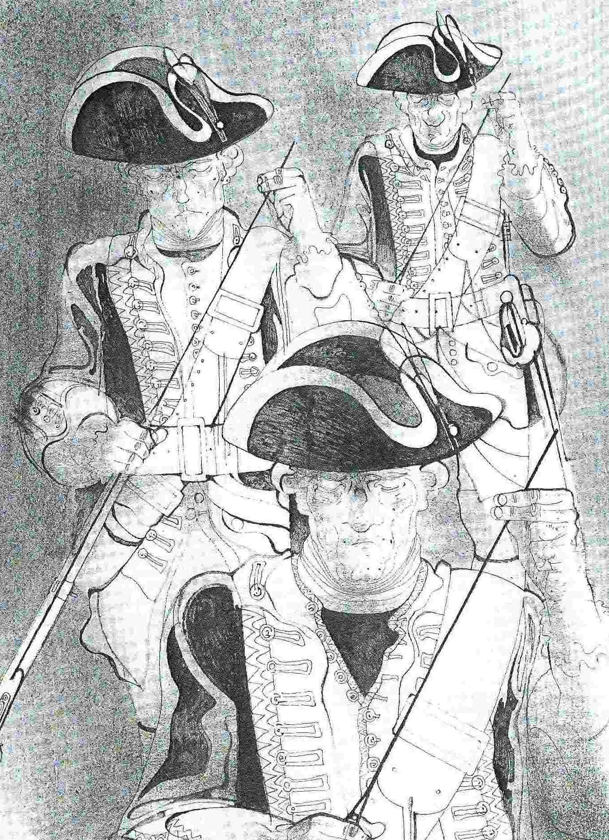

Which character is the most important?

