Bradworthy Primary Academy
Children’s Names:

 | R | Yr1 | Yr2 | Yr3 | Yr4 | Yr5 | Yr6

Red Not Meeting Expectations
Amber Meeting Expectations
Green Exceeding Expectations

If expectations are not being met this must be enlarged upon on the attached sheet.

PSHE / RSE Progression

Schools must show how well they support children’s spiritual, moral, social and cultural (SMSC) development, including the promotion of British Values, and the effectiveness of this will be evaluated as part of the ‘personal development’ judgement of a school inspection. PSHE and Citizenship Education encompasses many of the elements of effective SMSC provision as well as contributing to personal development by equipping pupils with the attributes, knowledge and skills they need to support physical, mental and emotional wellbeing in school and beyond. PSHE and Citizenship education also contributes by developing positive attitudes to learning, a positive and respectful culture and by encouraging learners to develop positive behaviour and conduct.
Additionally it is vital that children benefit from Relationship and Sex Education (RSE) which has been compulsory since 2020 so that:
- It equips children and young people with knowledge, understanding, skills, and confidence to cope with the pressures and challenges of modern society.
- It helps students have safe, fulfilling, and enjoyable relationships and take responsibility for their sexual health and well-being.
- It promotes respect for oneself and others.
- It positively impacts the physical and mental health of young people.

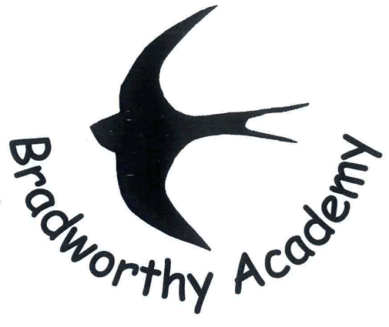
We expect schools to use their PSHE education programme to equip pupils with a sound understanding of risk and with the knowledge and skills necessary to make safe and informed decisions.
Schools should seek to use PSHE education to build, where appropriate, on the statutory content already outlined in the national curriculum, the basic school curriculum and in statutory guidance on: drug education, financial education, sex and relationship education (SRE) and the importance of physical activity and diet for a healthy lifestyle.
Guidance for Personal, Social, Health and Economic (PSHE) Education 2019

Levels Expected at the end of Early Years Foundation Stage:

Personal, Social and Emotional Development (Making Relationships)
Children play co-operatively, taking turns with others. They take account of one another’s ideas about how to organise their activity. They show sensitivity to others’ needs and feelings, and form positive relationships with adults and other children.
Personal, Social and Emotional Development (Self-Confidence and Self-Awareness)
Children are confident to try new activities, and say why they like some activities more than others. They are confident to speak in a familiar group, will talk about their ideas, and will choose the resources they need for their chosen activities. They say when they do or don’t need help.
Personal, Social and Emotional Development (Managing Feelings and Behaviour)
Children talk about how they and others show feelings, talk about their own and others’ behaviour, and its consequences, and know that some behaviour is unacceptable. They work as part of a group or class, and understand and follow the rules. They adjust their behaviour to different situations, and take changes of routine in their stride.

Physical Development (Health and Self-Care)
Children know the importance for good health of physical exercise, and a healthy diet, and talk about ways to keep healthy and safe.

Understanding the World (People and Communities)
Children talk about events in their own lives and the lives of family members. They know that other children don’t always enjoy the same things, and are sensitive to this. They know about similarities and differences between themselves and others, and among families, communities and traditions.
Understanding the World (The World)
Children talk about events in their own lives and the lives of family members. They know that other children don’t always enjoy the same things, and are sensitive to this. They know about similarities and differences between themselves and others, and among families, communities and traditions.

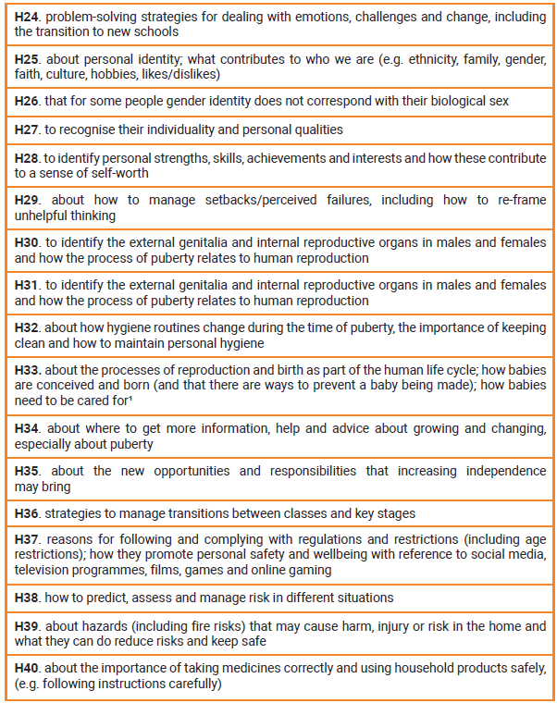
Health and Wellbeing KS1 Health and Wellbeing KS2

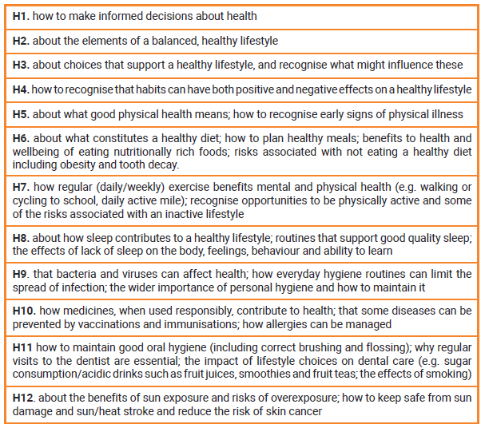
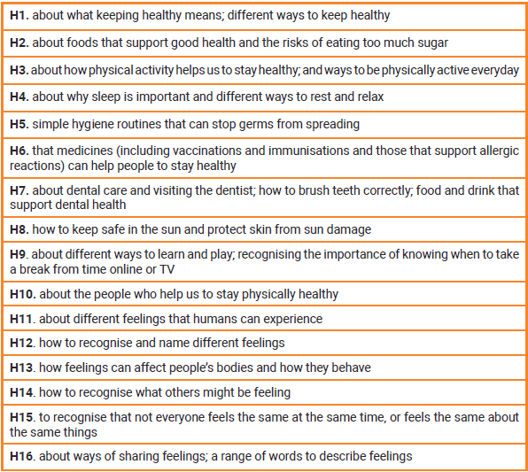

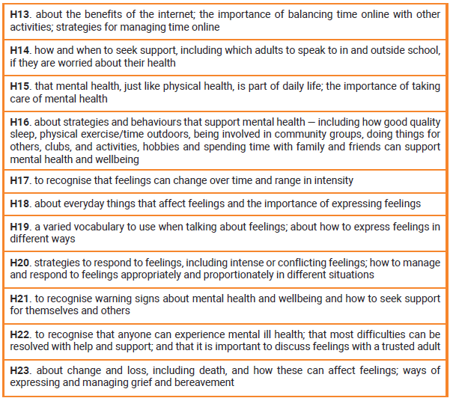
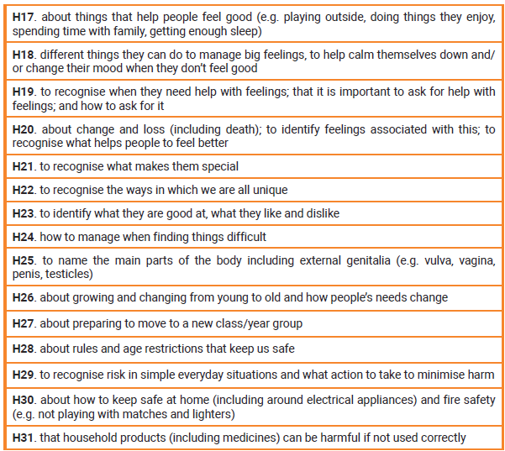
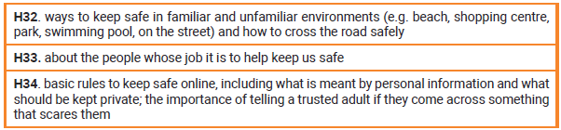
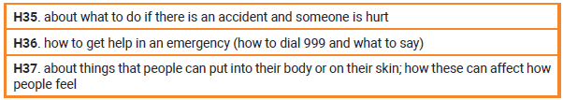
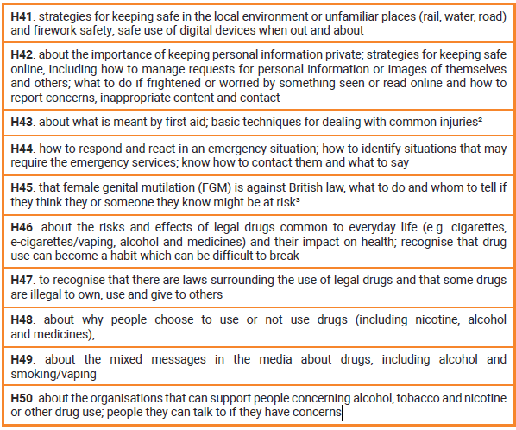

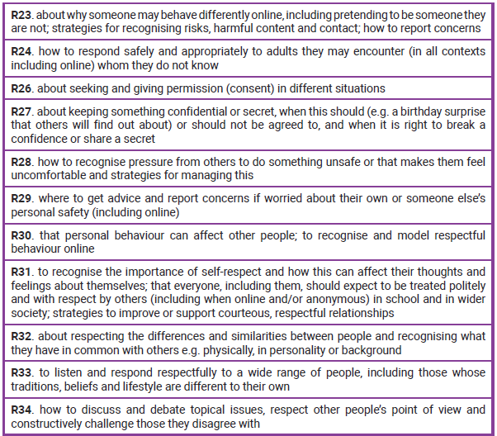
Relationships KS1 Relationships KS2
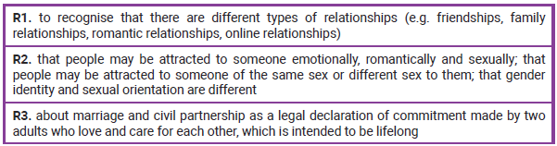
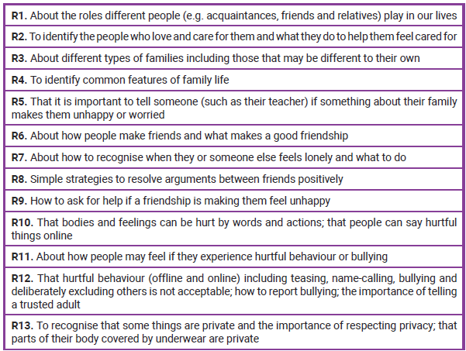

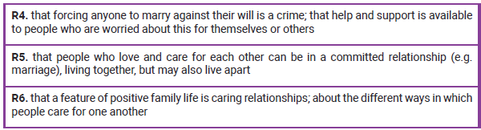

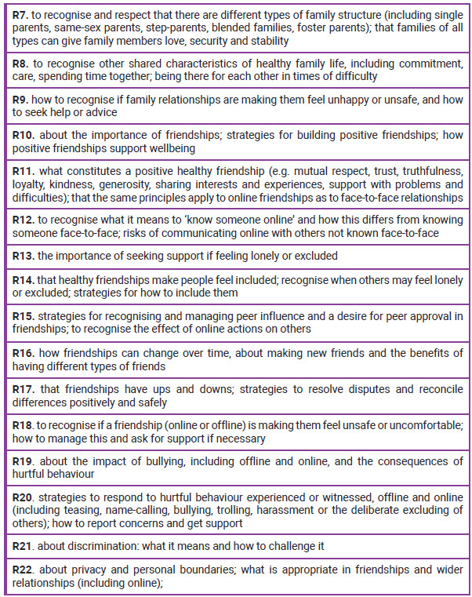

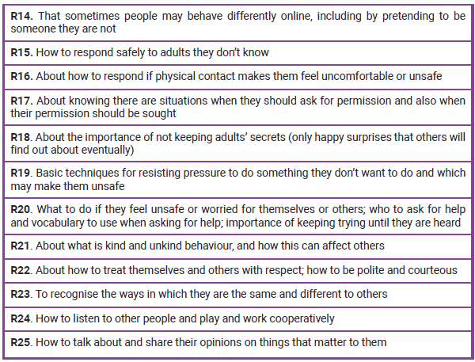

Living in the Wider World KS1 Living in the Wider World KS2


