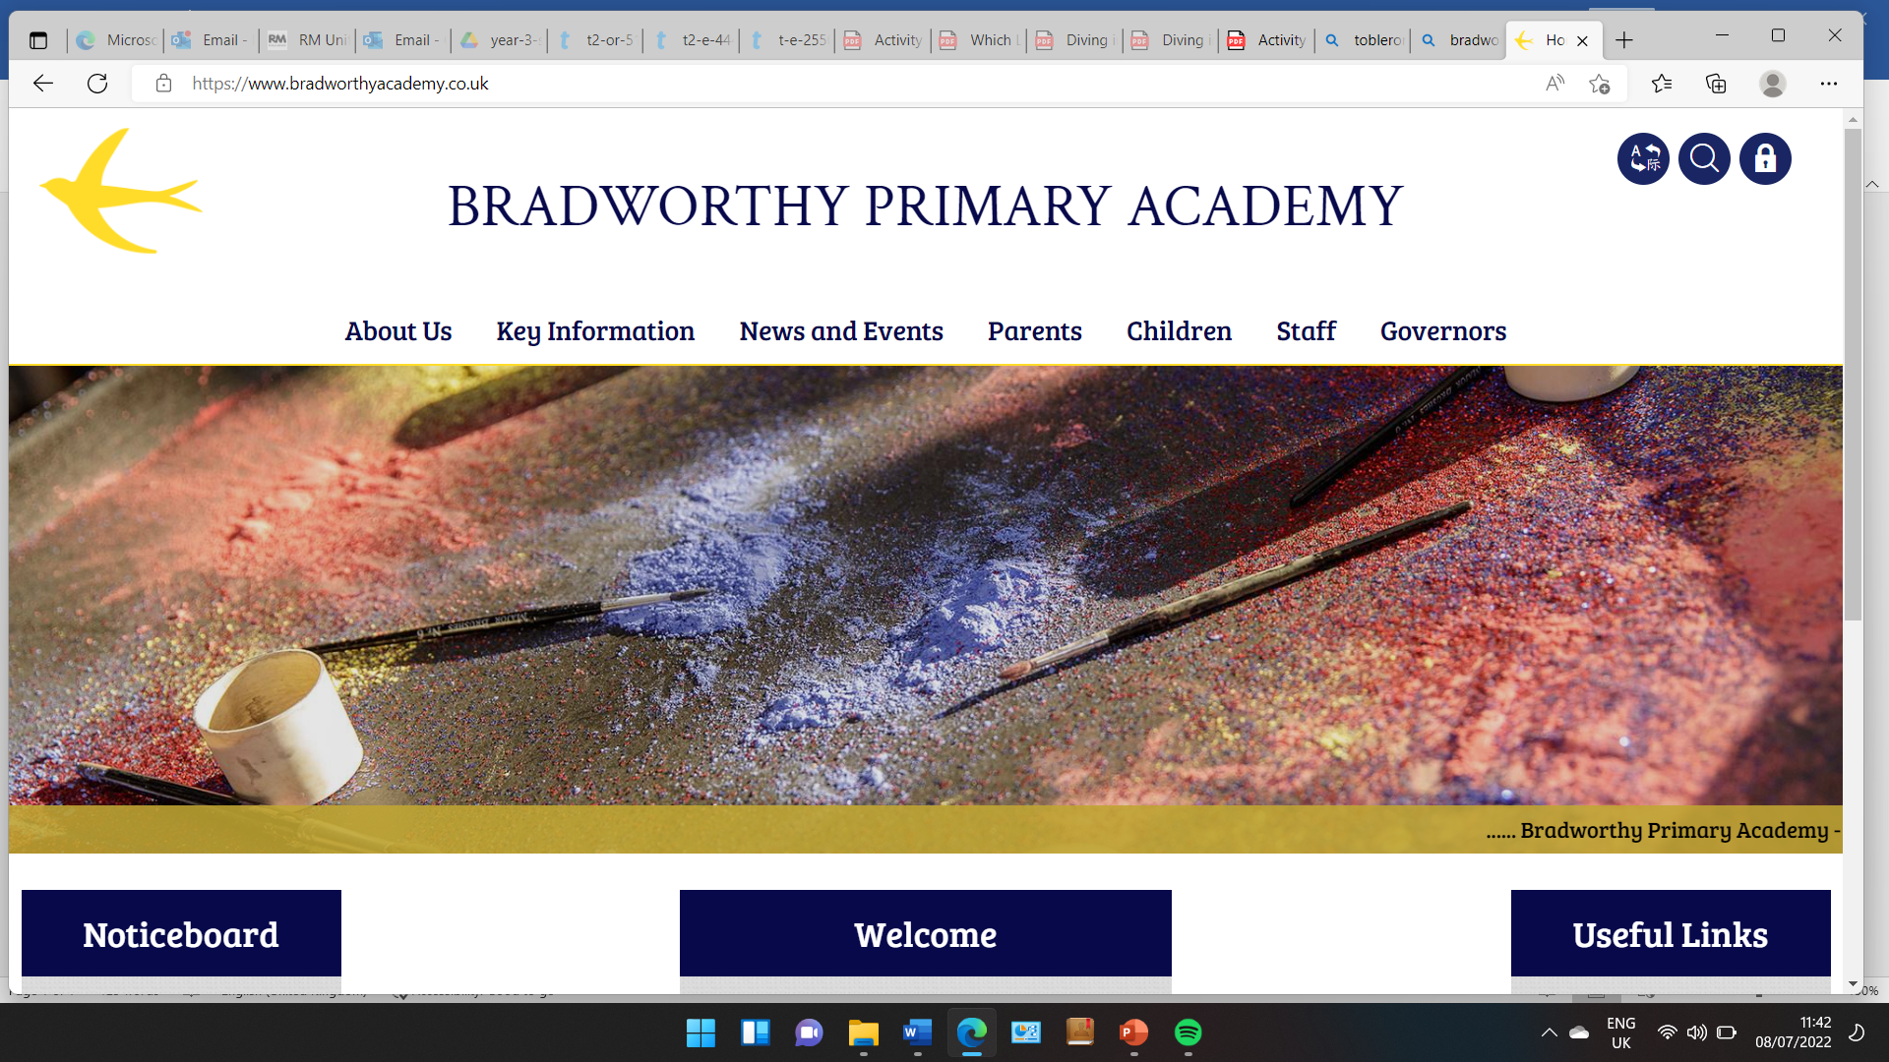
Class 3

Class Three
Dear All,
We have had a great full week back to school. The children have been working so hard and we are super impressed with them!
Dates for your diary:
Tuesday 30th pm - Class 3 Beach Trip
Tuesday 7th October - Westward Ho! Rangers

Mon 10 Nov - 13 Nov Yr 3 Swimming

Mon 17 Nov - 20 Nov Yr 3 Swimming

Friday 28th November - Class 3 Trip to Rosemoor
Thurs 21st May, Fri 22nd May - Yr 3 Plymouth Residential

If anything changes, we will let you know!

Website

Please check out our Class page on the school website, it has lots of photos of the children taking part in different activities.

French

Mrs Raffe, who teaches French on a Monday will be holding a tasting session for the class to try out some different foods. This will happen before the end of this half term. If there are any allergies we are not already aware of, please let Mrs Raffe know as soon as possible.

Here are some photos from the past week:


