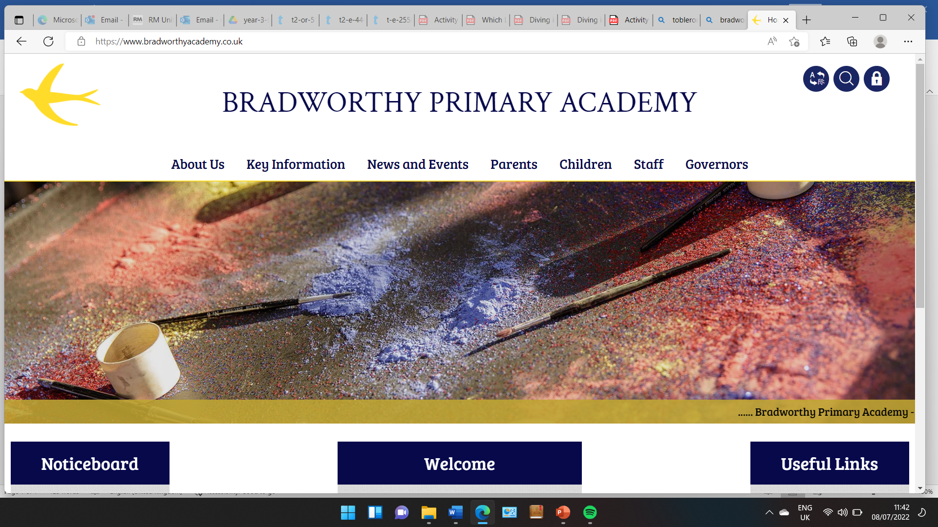
Class 3

Welcome to Class 3
Wednesday 3rd September 2025
Dear Everyone,
We wanted to send a ‘hello’ to you all and also to tell you a few things about Class 3. Apologies if anything seems obvious, we thought it best to cover all bases!
Staff timetable in Class 3
On a Monday, lovely Mrs Raffe will be teaching the class.
On Tuesdays through to Fridays, myself (Miss Young) will be teaching the class.
We will also have the fantastic Kim and Jo with us at different points throughout the week to support the children with their learning.
On a Monday, we will have Alex in Class 3 to teach some Music in the morning.
On Tuesday, the children will take part in a gym session. This is something that is part of our PE curriculum which all children will take part in.
On a Wednesday afternoon, the children will have their weekly climbing lesson. Again, this is part of their PE curriculum.
On a Thursday and Friday afternoon, between 2:30pm and 3:30pm, Elliot will be taking the class for PE and seeing them out at the end of the day.
PE Kits
Please can all children have their PE kit in school every day of the week, as you can see from our timetable, they will be doing a lot of sport! This is a pair of PE shorts, a pair of blue socks, a pair of trainers and a spare polo shirt to change into if they get really sweaty!
It is really important to have a full PE kit in each day, please!
Snacks and Drinks bottles
Please may children always bring in a named drinks bottle each day. They can refill these in class. As Year 3 is in KS2, they will not benefit from the ‘free fruit’ the government provides for KS1 children. Please can you ensure children have either a snack token or a snack from home for break time and also a snack if they are after school for a long length of time.

Caps and Suncream
Children will need a cap in school each day, as usual. We have a small number of caps in class that they can borrow if on occasion they forget theirs, but it would be really helpful to us if children can remember theirs each day, or even leave one on their peg. On hot days, it would be great if children could come in wearing suncream if possible. They can keep a named bottle in their bag for when the sun decides to grace us with a visit!
Again, please can children have a cap in school each day!
School dinners/Packed lunches/pencil cases
School dinners in KS2 are unfortunately not provided for free by the government. If your child is having a school dinner, please make sure you fill in and return a dinner menu form.
We have limited space in class and therefore we ask children to keep their lunch box in their bag on their peg.
We will not be having pencil cases in class. Children can get quite upset when things go missing or things get broke. Therefore it is best these stay at home, unless your child is regularly in after school club and wishes to use it then.
Communication
You are very welcome to message us on the class email. This has now changed. The best email to use is iyoung@bradworthy.devon.sch.uk or alternatively come and speak to us if there is a question you would like to ask us, or you would like to have a chat with us about something. Our priority in class is that your child is safe and happy and we believe having a strong relationship with good communication with you is key to this. We really value your thoughts, as you know your child best! Please do not hesitate to speak to us regarding anything you are concerned about.
If you would like to meet with us before waiting for parents’ evenings to be offered (these are usually October time – ish!) then you are more than welcome to email me and arrange a time to pop in for a chat.
Reading Records and Reading Books
The children will all come home with a reading record this week. We will begin the process of getting them a reading book this week/next week. Please bear with us! These reading records need to come into school each day.
Home time
Children will be coming out of the Club Room door at the end of the day, if you are collecting your child at 3:30pm.
Topic
Our topic this term is ‘Coasts’ where we will be particularly learning about coastal erosion and coastal defences. We are hoping several trips to the beach to support our learning and will send a letter out in due course.
We will also be learning a little bit about the Vikings, Ancient Greece and Extreme Earth over the next school year.
Homework
We will not be setting any formal homework as of yet. However, as in previous school years there is an expectation for children to read at least 3 times a week, preferably more! Our Year 3 reading curriculum focuses a lot on the comprehension side of texts and therefore the more fluent the children are with their reading, the better!
If your child would like to practice some maths at home throughout the year, or if you would like to boost your child’s confidence in maths, the best things for them to practice is their times tables. By the end of Year 2, the age related expectations are that children know all their 2, 5 and 10 times tables. By the end of Year 3, the age related expectations is that they know all of the 2, 5 and 10 times tables as well as the 3, 4 and 8 times tables. So the more practice, the better!

Apologies for the length of this welcome letter! We thought the more information for you, the more any questions you had would be answered.
If we have missed anything, please drop us an email and if anything changes within class, we will do our best to let you know.
We really look forward to getting to know you all. Please do come in and say hello if we haven’t already met you!
Kindest regards,
Imogen

Imogen Young
Class 3 Teacher
iyoung@bradworthy.devon.sch.uk

Bradworthy Primary Academy
www.bradworthyacademy.co.uk
01409 241365

