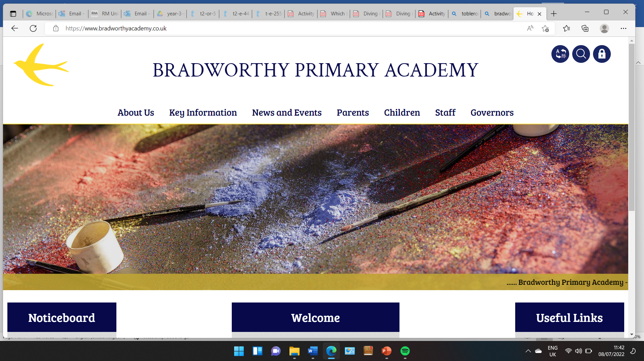
Class 3

Highlights This Week in Class 3
Friday 16th May 2025
Dear All,
Apologies for the lack of newsletters the past few weeks, school has been very busy!
Our trip to Westward Ho!
We have been very fortunate in class 3 this half term with some wonderful trips out. A few weeks ago, we had a trip to Bude to visit the library and the Castle to learn about some local history and a local inventor, Sir Goldsworthy Gurney. We also had a return visit to Rosemoor to learn about animals and their habitats. One group was lucky enough to find a newt in the woods!
This week, we had a lovely day out with the Rangers at Northam Burrows on Wednesday. The sun was shining brightly and we learnt more about our Autumn topic of coastal erosion and in particular how it had affected Westward Ho! over the years. The day was another reminder of what a beautiful part of the world we live in, and how lucky we are!
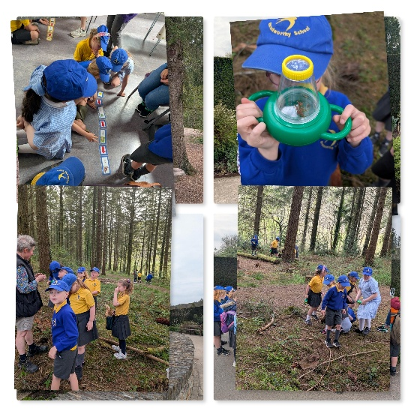 | 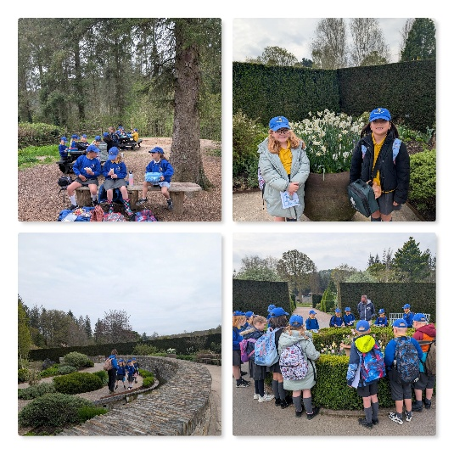 | 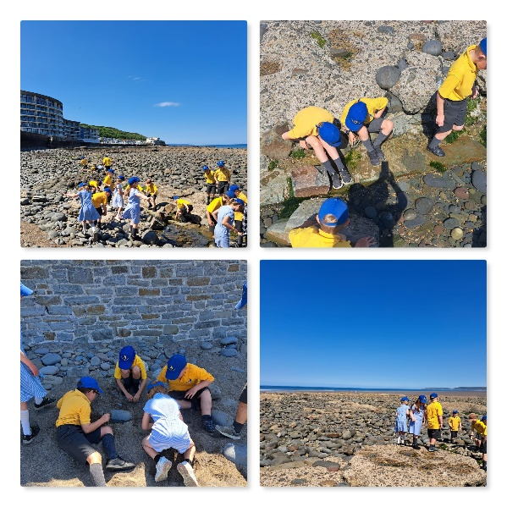
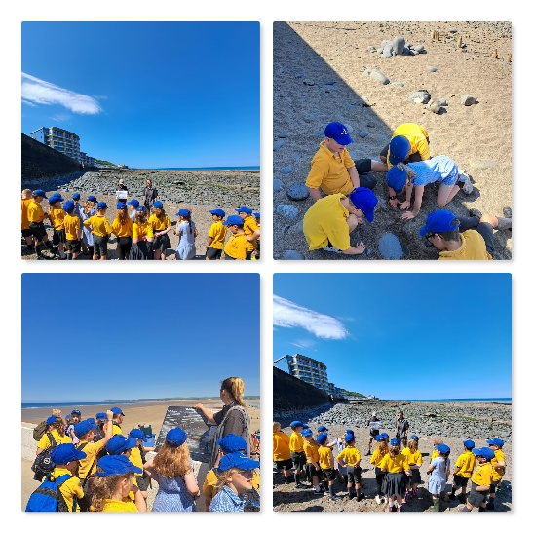 | 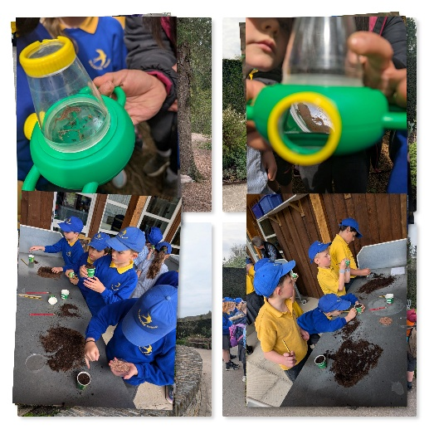 | 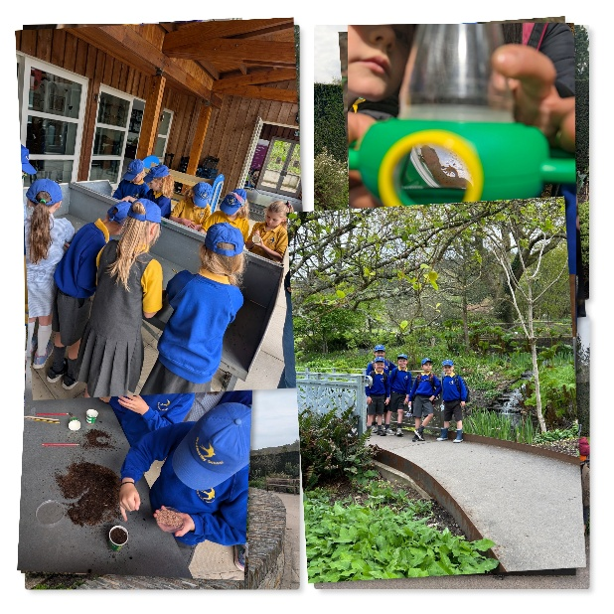

Homework – Reading and Maths
Please continue to listen to your child read at least 3 times a week. I understand how difficult this can be fitting it into busy family life but it really makes such a difference. Even if your child is a very fluent reader, they gain so much from reading with an adult who can show expression in their voice and question them on parts of the story, or why the author has chosen particular words.
For Maths, times table practice is a straight forward skill to practice at home. For children who are confident on the times tables they need to learn the division sums for each times table. E.g. 4x3=12 so 12÷3=4. In Year 4, there is a compulsory times table check in the summer term. The more children are familiar with their times tables now, the easier it will be to pick up new times tables in Year 4 in preparation for this.
By the end of Year 2, children working at expected levels are expected to know the multiplication and division statements for the 2,5 and 10 times tables. In Year 3 we introduce and practice statements for the 3, 4 and 8 times tables.
Therefore the more they know these by the end of Year 3, the better! Little and often is the best method.
Spellings
We have been learning a new scheme for spellings that better fit with our Read Write Inc phonics scheme that was rolled out in September. For this reason, we have paused our weekly spelling tests and spellings on Ed Shed. We have been recapping our phonics learning over the past few weeks and reminding ourselves of the different possible spellings for each sound. Spelling is still being taught and practiced regularly throughout the week.
Science this week:
This week, we have continued on our Animals, including Humans topics. In previous weeks we have been learning about nutrition and this week we were learning about skeletons of different animals, vertebrates and invertebrates. We also learnt what endoskeletons, exoskeletons and hydrostatic skeletons were!
English this week:
We have been reading and ‘picking apart’ the story of Mimi and the Mountain Dragon by Michael Morpurgo, in order to create our own versions of the story. We have been incorporating our topic learning on natural disasters and weaving this into our story plans. This week we have created our own monsters who the characters in our story believe causes a natural disaster.
Here are some of the classes ideas:
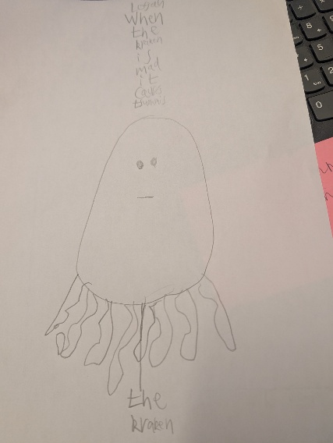 | 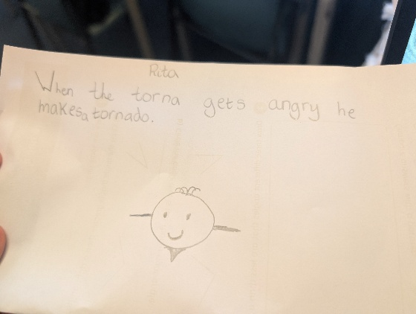 | 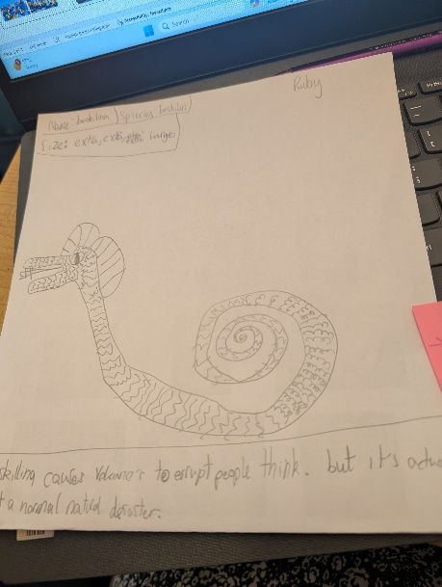
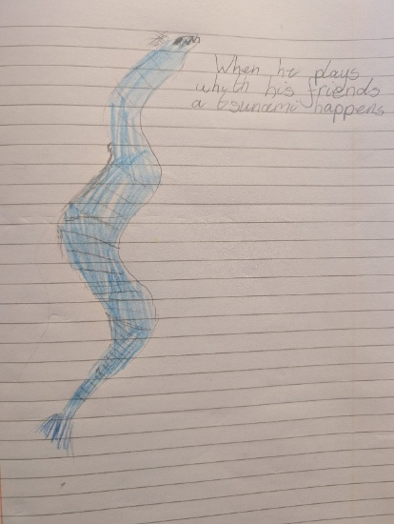 | 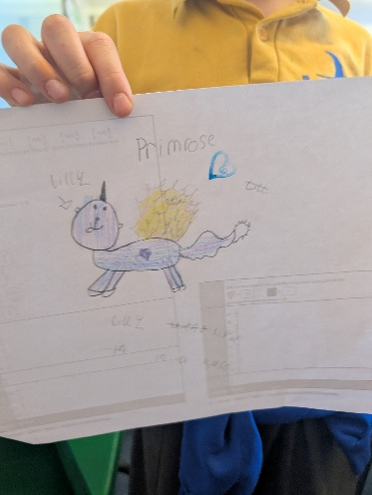 | 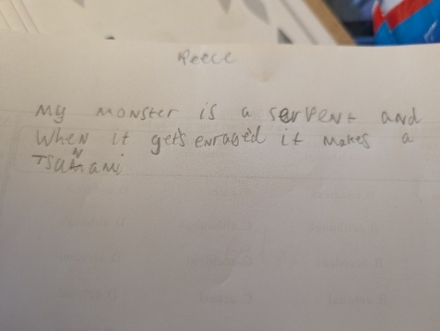
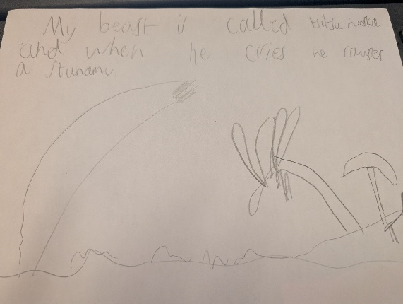 | 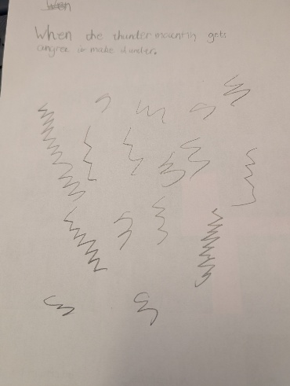 | 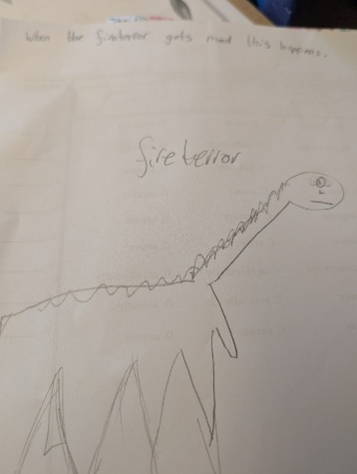

Maths this week:
We have started a new unit on Shape this week. Today we took to the playground to learn about different types of angles, acute, obtuse and right angles!
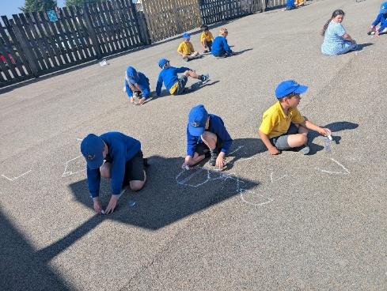 | 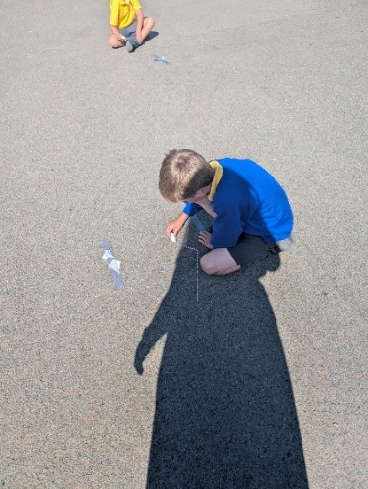 | 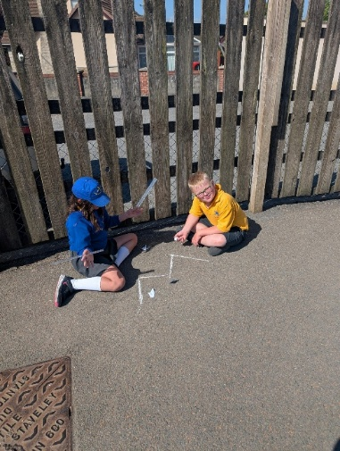 | 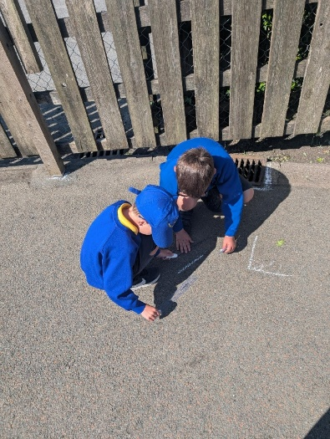
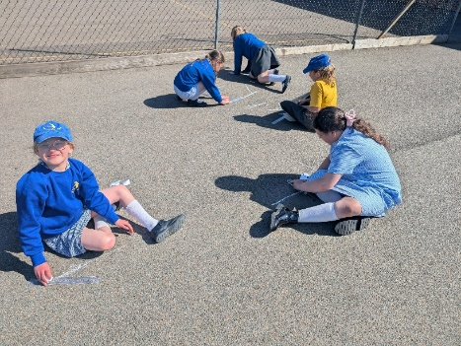 | 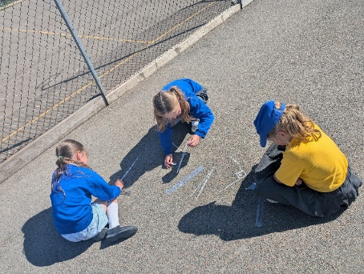 | 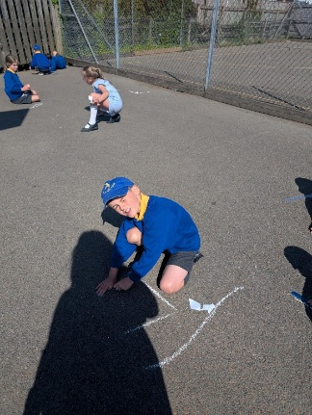 | 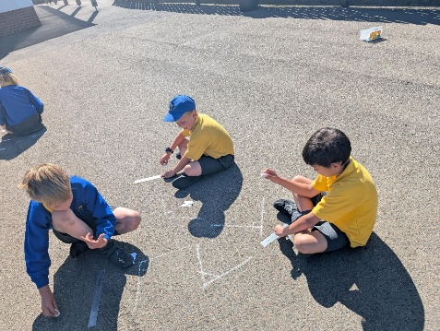
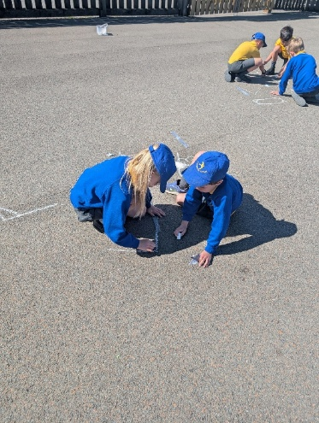 | 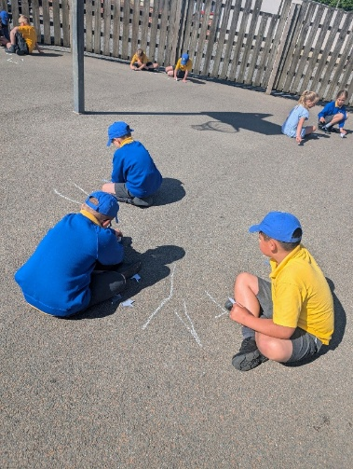 | 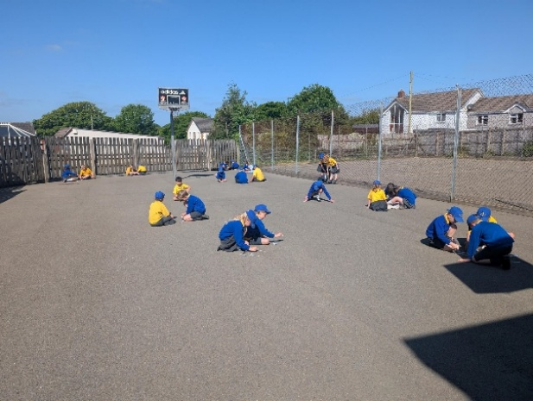

Residential
Please hand any remaining residential forms into the office.
If anyone would like to meet wit me to discuss any queries or worries, please come and see me or email in and we can arrange a quick chat.

That’s it for now, I think we are all caught up!
Have a wonderful weekend everyone!
Take care,
Imogen x

