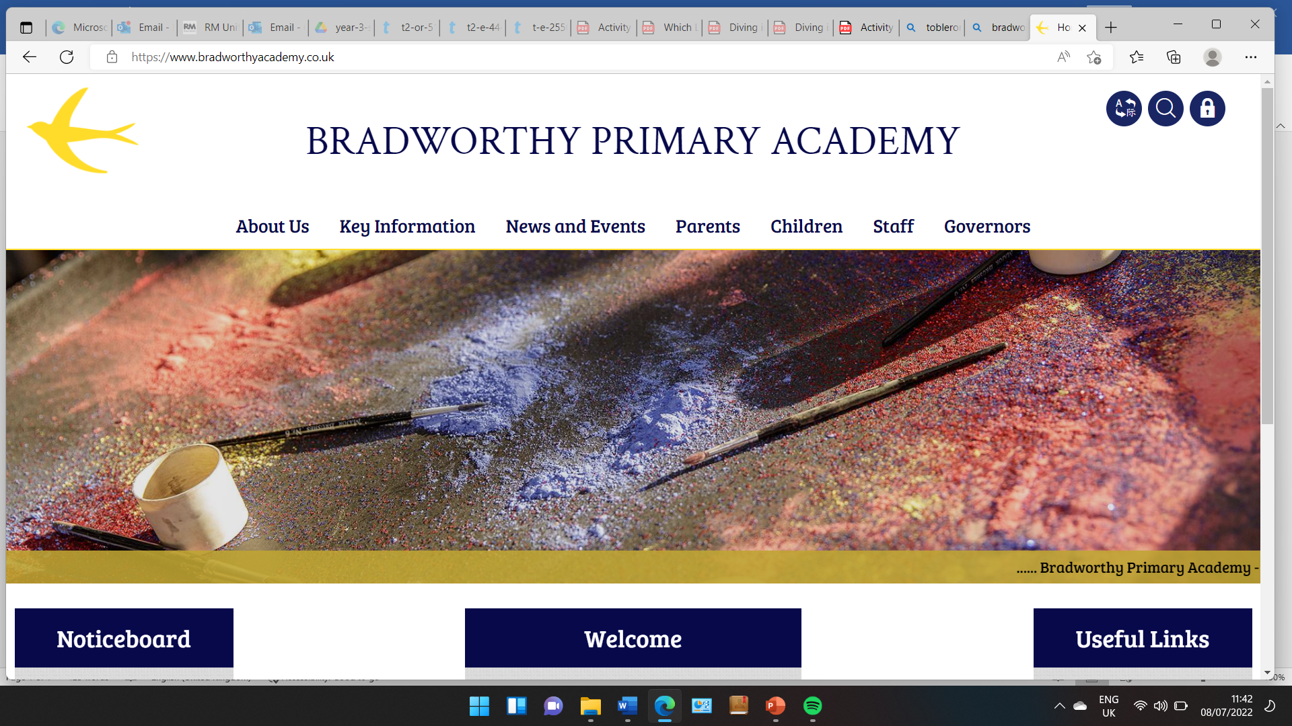
Class 3

Year 3 Rosemoor Trip - Friday 25th April 2025
Thursday 3rd April 2025
Dear Parents and Carers,
We are visiting Rosemoor on Friday 25th April for the late morning and afternoon to learn more about our Science topic ‘Animals Including Humans’. We will be leaving around 10:30am and returning by 3:15pm approximately. Children will need to bring with them a snack and a packed lunch, and a drinks bottle. Bus children can come in and go home as usual and we will have a normal end to the school day.
The Rosemoor visit and session is free for schools, however they do ask for a donation to cover the costs of the equipment and resources we will be using. Please enclose £1.50 as a contribution to the session. Thank you.
Please can the children come into school with the following:
- A snack
- A drink
- A packed lunch
- A waterproof coat
- Old trainers or wellies
- A rucksack to put their snack, lunch and drink in.
- A cap is essential for school trips – it really helps us with head counts!!
We will have the use of both minibuses for our trip, however we will need some parent helpers to help with our adult to child ratio. We won’t be able to fit you on the bus though, sorry!
Please can you fill out the attached permission slip allowing your child to attend our trip and indicate if you are able to help on the day and transport yourself there and back.
Thank you,
The Class 3 Team
------------------------------------------------------------------------------------------------------------
Year 3 Rosemoor Trip – Friday 25th April 2025
I give permission for ____________ to attend a trip to Rosemoor on Friday 25th April 2025
Signed: __________________ Printed: ___________________
Please indicate below if you are able to help as a volunteer on the day ______________________________

Please enclose or BACs £1.50 as a contribution to the session at Rosemoor

