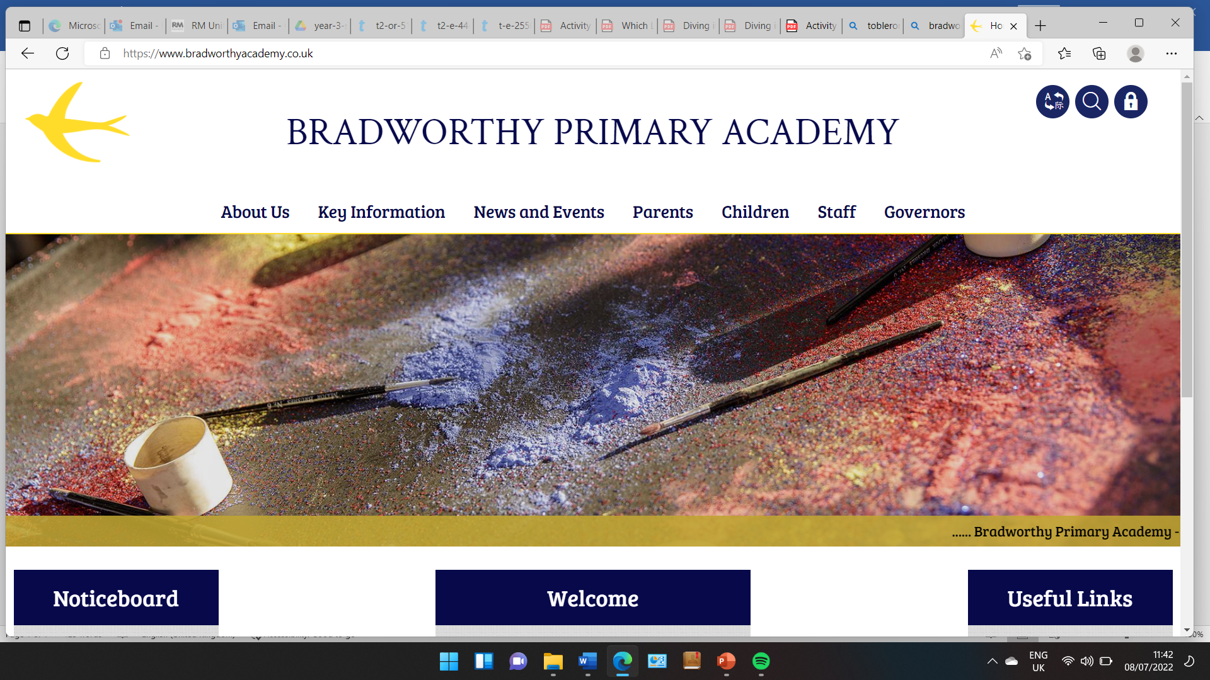
Class 3

Year 3 Trip to The Castle in Bude – Tuesday 22nd April 2025
Thursday 3rd April 2025
Dear Parents and Carers,
We are visiting The Castle in Bude on Tuesday 22nd April for the morning and early afternoon. We are going to spend some time learning about some of Bude’s history with an outreach education officer at The Castle. We will be splitting our time between the Castle and the library- which Kymble will kindly be opening up for us.
We will be leaving just 10:15 am and aim to return sometime in the afternoon. Children will need to bring with them a snack, a packed lunch and a drink. The end of the day will be as usual, and bus children can come and go on their bus like normal.
Please can the children come into school with the following:
- A snack
- A drink
- Waterproof coat
- A packed lunch
- A rucksack to put everything in
- A cap
We will have the use of both minibuses for our trip, however we will need some parents to help with our adult to child ratio. We won’t be able to fit you on the minibus though – sorry!
Please may you fill out the attached permission slip allowing your child to attend our trip and indicate if you are able to help.
Thank you,
The Class 3 Team
-------------------------------------------------------------------------------------------------------
Year 3 Trip to The Castle in Bude – Tuesday 22nd April 2025
I give permission for ____________ to attend a trip to The Castle in Bude on Tuesday 22nd April 2025.
Signed: __________________ Printed: ___________________
Please indicate below if you are able to help volunteer on the day:
________________________________________________________

