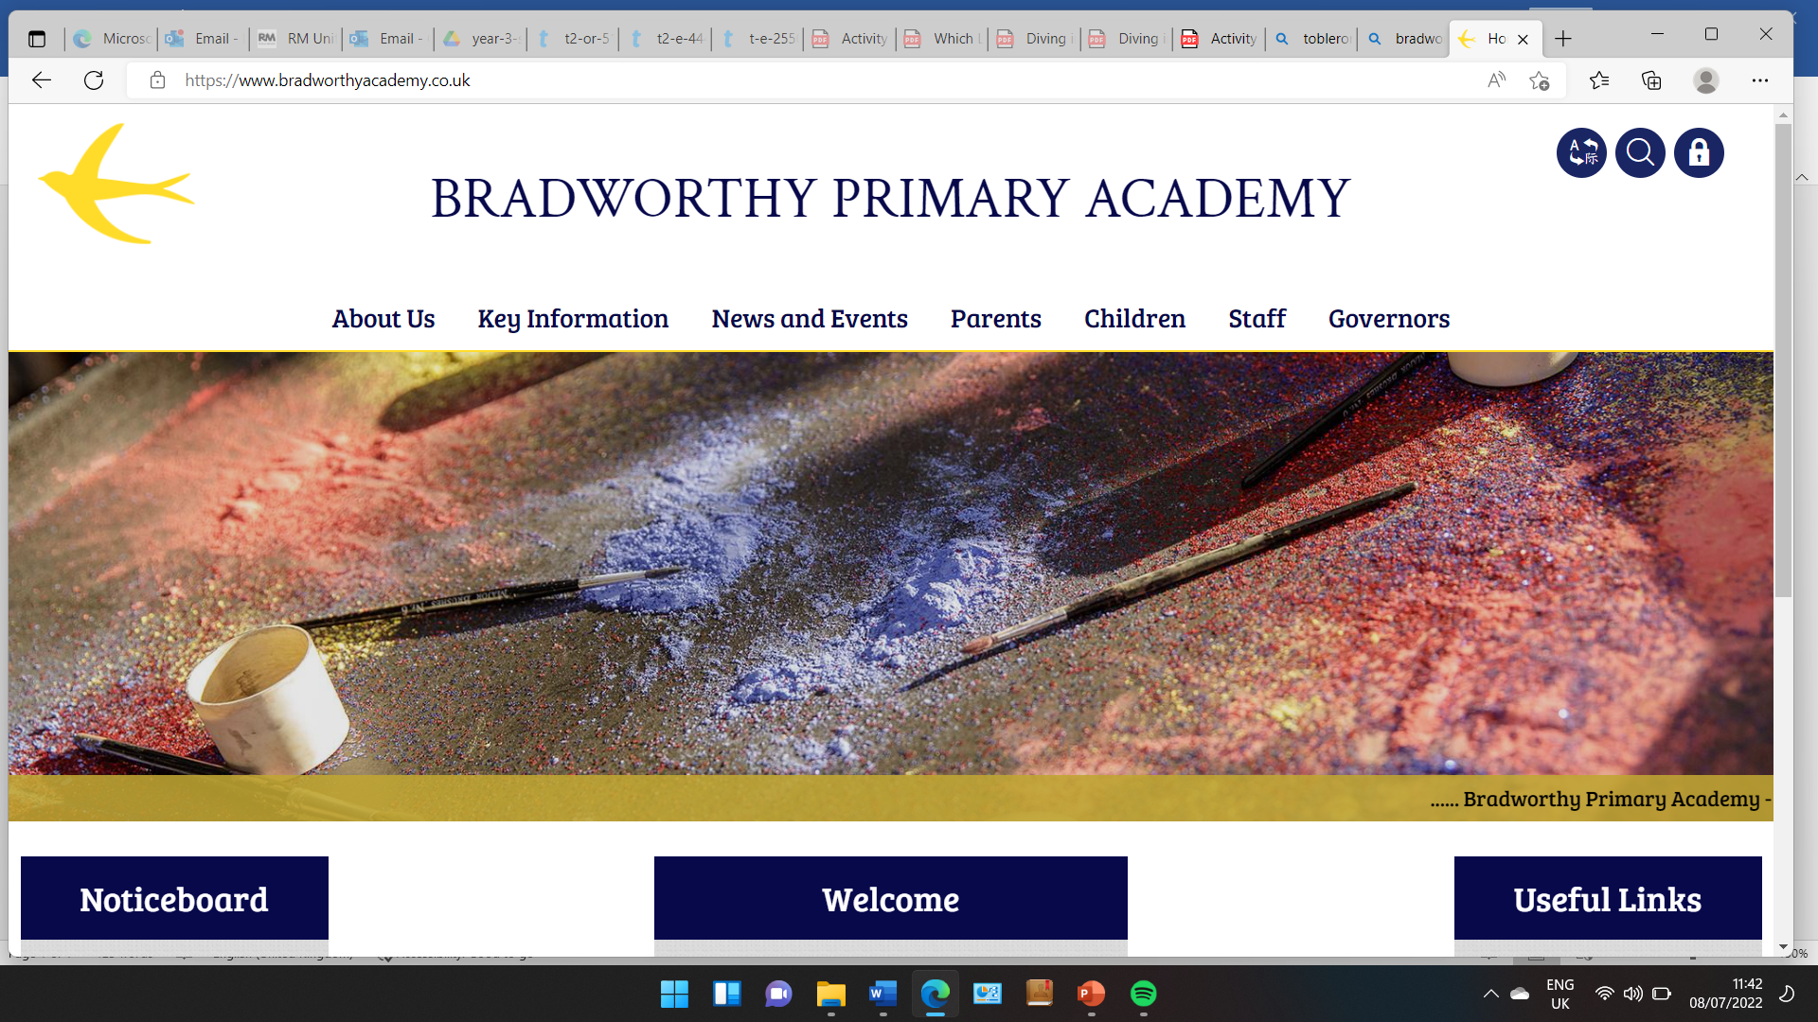
Class 3

Highlights This Week in Class 3
Friday 28th March 2025
Dear All,
English this week:
We have finished writing our Viking stories this week! I will be popping some up on the website for you to read!
DT:
We finished our CAMs DT project this week, here are our photos!
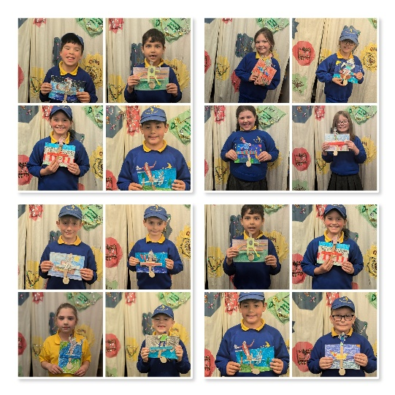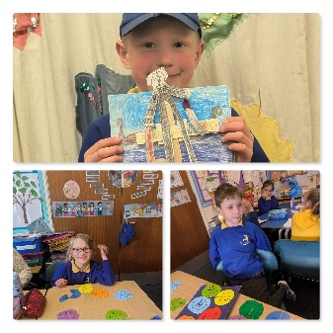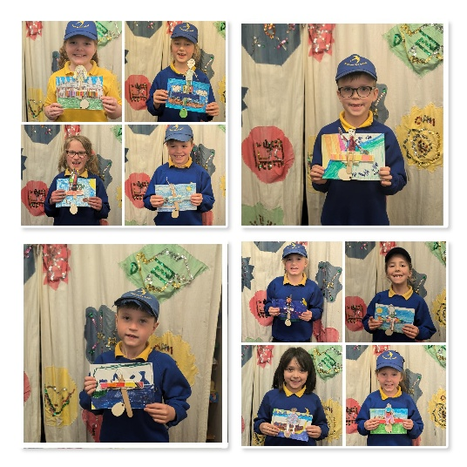
Homework
Please continue to listen to your child read and encourage them to practice their times tables either on paper, verbally or on Ed Shed. A fresh set of spellings will come up on Ed Shed this evening. (Please see spelling lists at the bottom of the letter for those of you who don’t use Ed Shed). When spellings are particularly hard, I’m am reducing the amount to learn. However, I am unable to match this with Ed Shed, which will always show the full set of ten words.
Parents Evening:
Just a quick reminder that it would be lovely to arrange a short catch up over the next week before the Easter holidays, if we didn’t catch up on parents evening week. Please pop me an email or drop in and we can arrange a day and time.
Trips next Summer Term:
We have been very slack on trips this Spring term – not for lack of want but more a very busy time learning and buses booked out to other activities! However, we have fully made up for this in the summer term – which will be no bad thing, with hopefully lots of warm weather!
Here is a list of the upcoming trips including our altered residential:
- Tuesday 22nd April – Trip to the Castle and Library in Bude (First day of Summer Term!)
- Friday 9th May – Beach Trip - location tbc
- Wednesday 14th May – Westward Ho! Rangers – Coastal Erosion
- Wednesday 11th and Thursday 12th June – 1 night Residential in Plymouth
- Date tbc – Rosemoor
I will send out trip permissions and details soon.
(Please note our trip to The Castle in Bude is on the first day of the Summer Term – so there won’t be any reminders!)
Next week will be Chelsea’s last week before she goes on her maternity leave. We cannot wait to see her and baby when he makes an appearance and wish her a restful few weeks before the time comes. She has been such an asset to our class and we will miss her dearly whilst she is off.
We will continue to have the lovely Nikita in class with us!
Have a wonderful weekend everyone!
Take care,
Imogen x
28.3.25 | 28.3.25 | 28.3.25 | 28.3.25
Grizzly Bears | Honey Bears | Polar Bears | Panda Bears
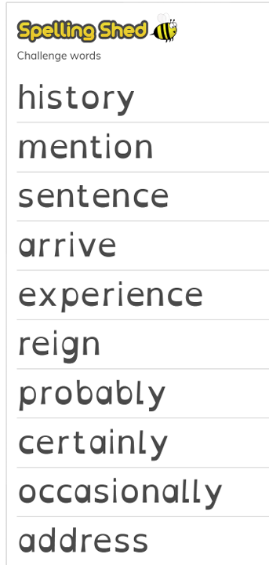 |  | 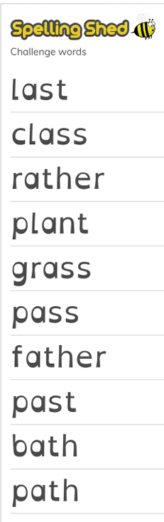 | 

