
Class 3

Highlights This Week in Class 3
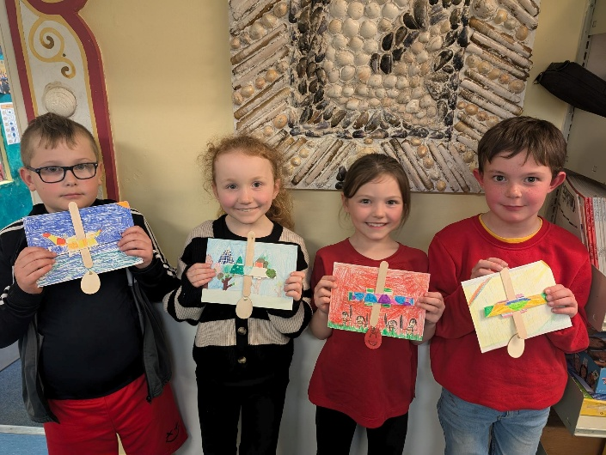
Friday 21st March 2025
Dear All,
DT this week:
On Thursday and Friday we have been learning about CAM mechanisms, what they are, what they do and how to use them in our design of a Viking character. On Thursday we learnt about CAMs and planned our design. On Friday, we followed our plans to make our mechanism. They are looking fantastic! We will finish them off next week by designing and gluing on our character and fixing any problems with our prototype!
Homework
Please continue to listen to your child read and encourage them to practice their times tables either on paper, verbally or on Ed Shed. A fresh set of spellings will come up on Ed Shed this evening. (Please see spelling lists at the bottom of the letter for those of you who don’t use Ed Shed). When spellings are particularly hard, I’m am reducing the amount to learn. However, I am unable to match this with Ed Shed, which will always show the full set of ten words.
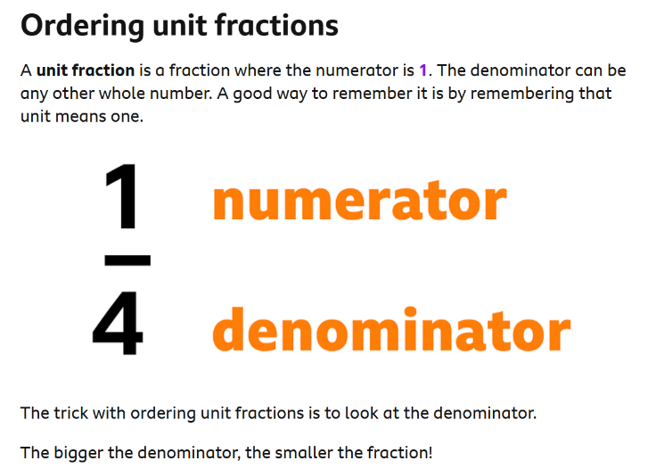
English this week:
We have begun writing our Viking stories this week! We have completed our first draft and second draft, including editing some of our writing to improve it.
Maths this week:
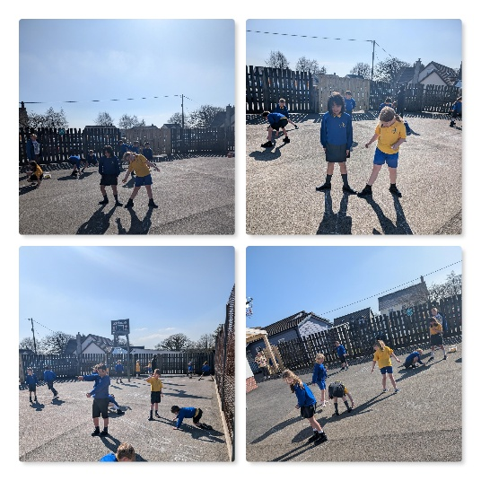
We have continued our learning on fractions this week. We have been learning to compare the sizes of fractions.
Science this week:
This week we did some learning on shadows and designing a curtain using the best materials to stop the light getting into a bedroom.

Parents Evening:
Just a quick reminder that it would be lovely to arrange a short catch up over the next couple of weeks before the Easter holidays, if we didn’t catch up on parents evening week. Please pop me an email or drop in and we can arrange a day and time.
Park Treat:
The class worked hard this week with their writing, maths and spellings that we had a treat on Thursday and spent some time at the park, having lots of fun. (Apologies, I forgot to take any photos!)
Viking Top Trump Winner:
Rita has won second prize for her Viking character design which she sent in to top trumps. Congratulations Rita!!
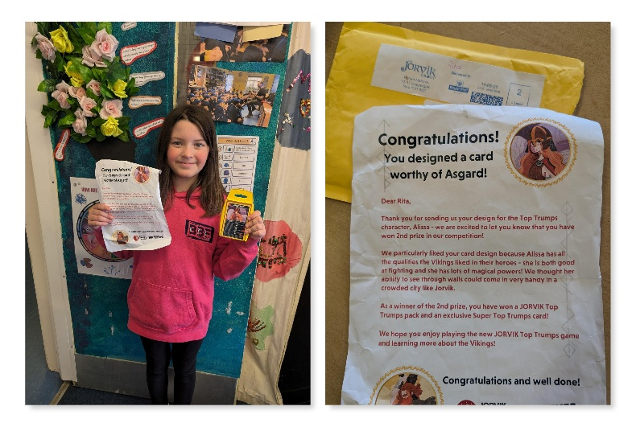

Have a wonderful weekend everyone!
Take care,
Imogen x
21.3.25 | 21.3.25 | 21.3.25 | 21.3.25
Grizzly Bears | Honey Bears | Polar Bears | Panda Bears
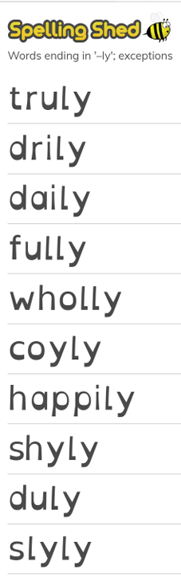 |  | 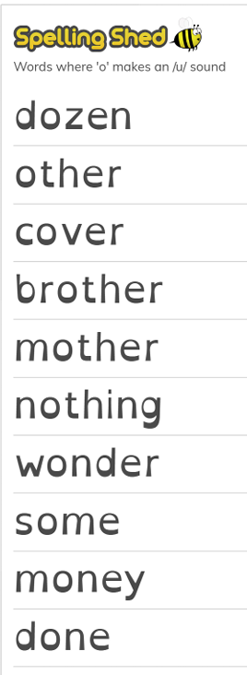 | 

