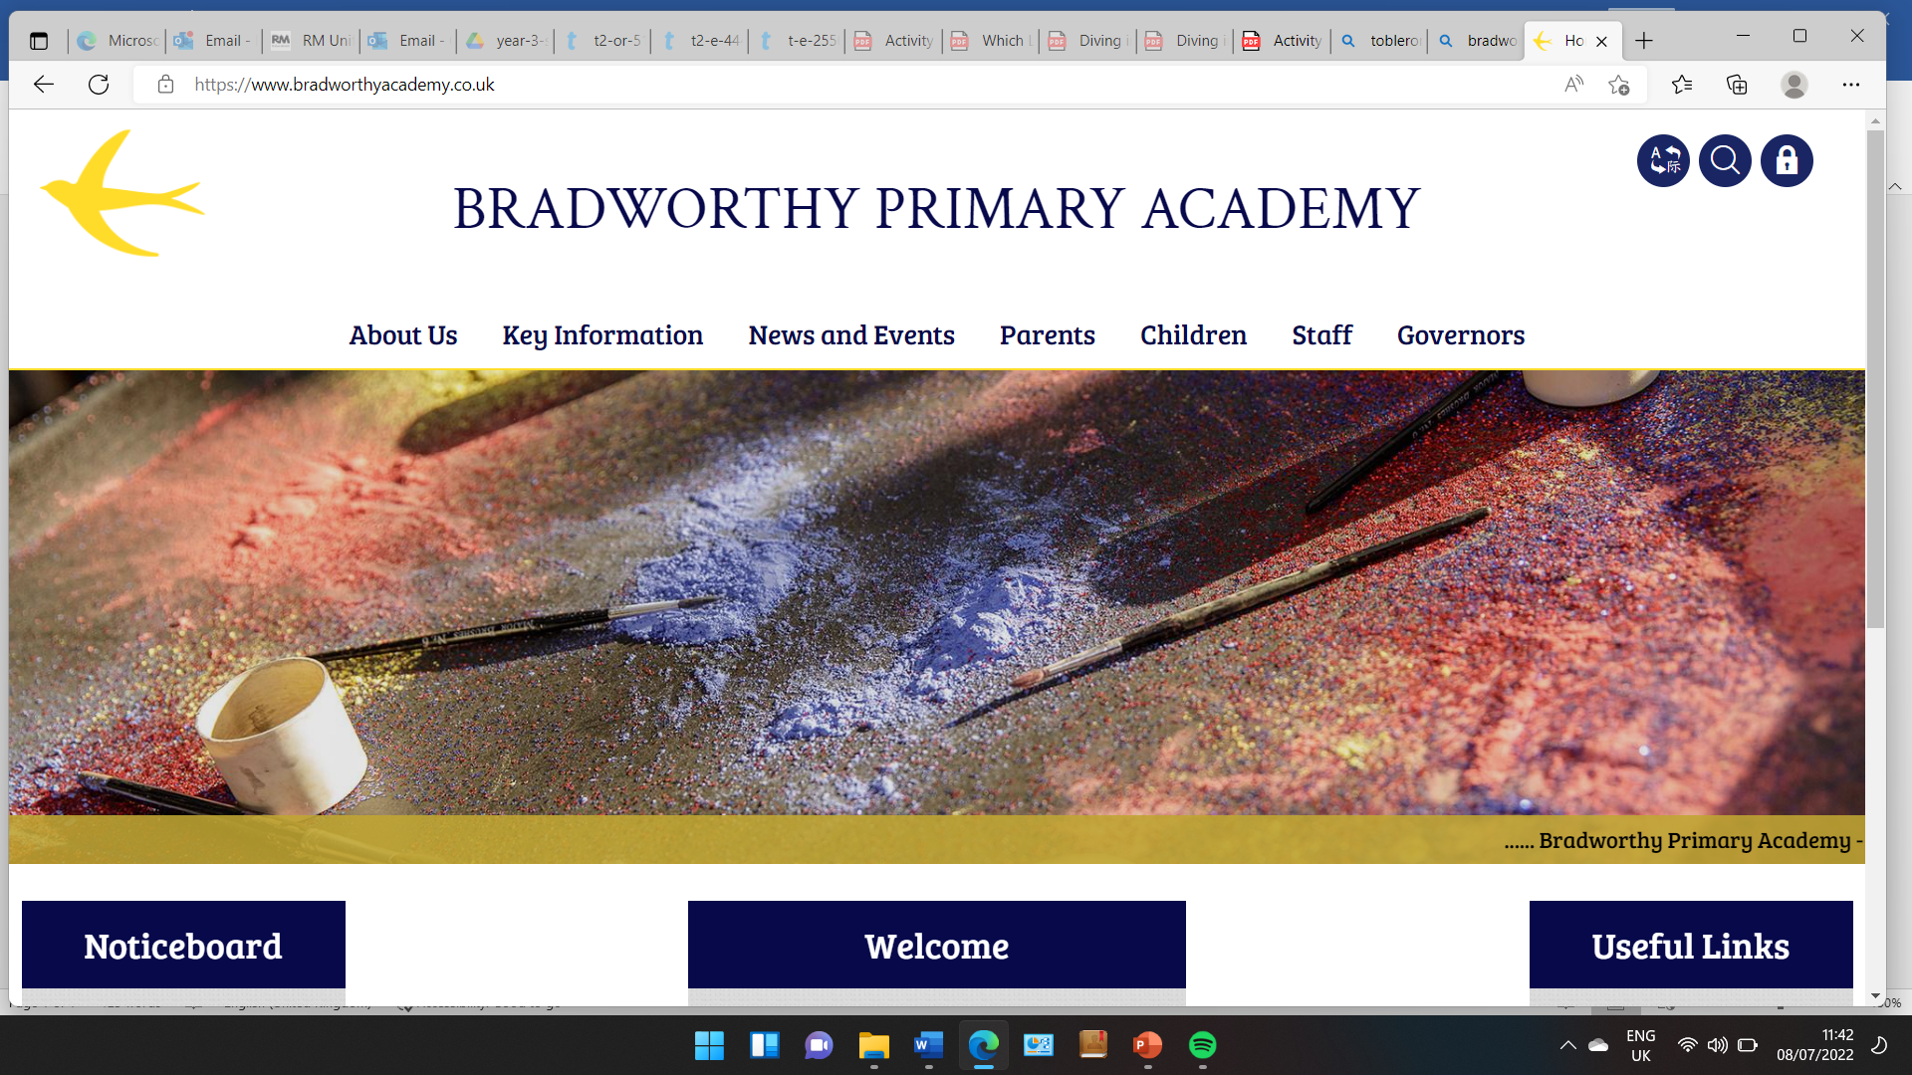
Class 3

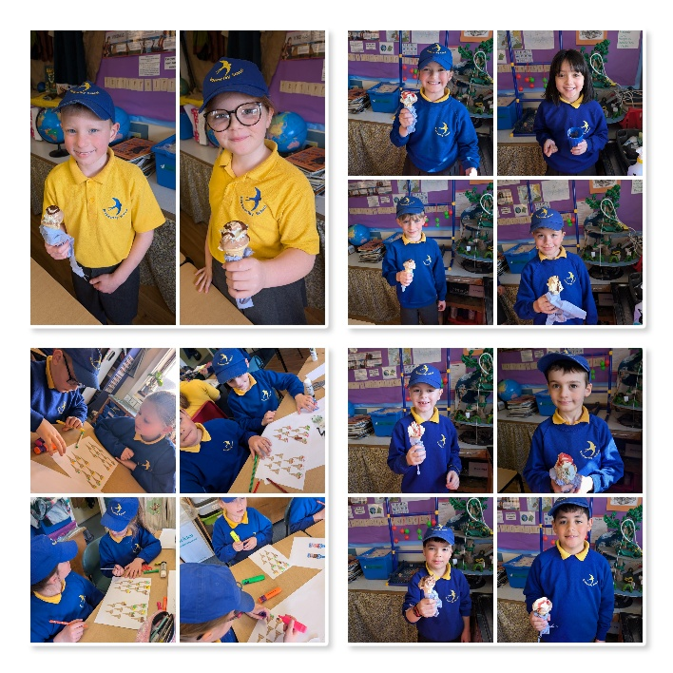
Highlights This Week in Class 3
Friday 13th March 2025
Dear All,
Topic this week:
This week, Rita showed us her family tree she has made at home that dates back to William the Conqueror times! Thank you so much Rita and family – this was so interesting to look at. This week we have been learning a little more about Viking Gods and Goddesses and what their powers were. We also took a look at the well-known attack on Lindisfarne when the Vikings came over and raided the monastery.
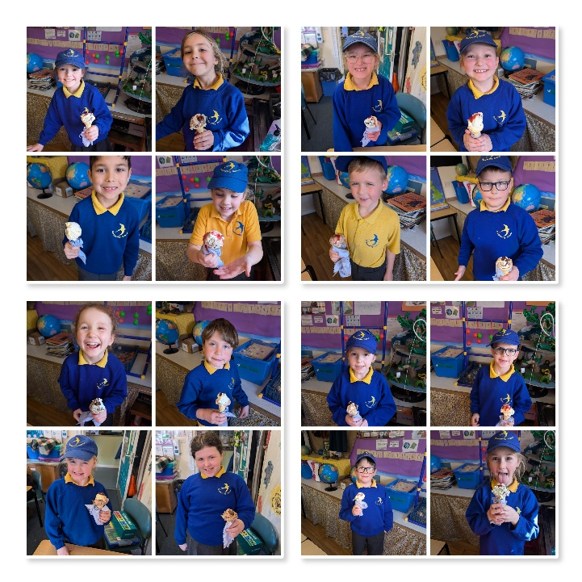
Homework
Please continue to listen to your child read and encourage them to practice their times tables either on paper, verbally or on Ed Shed. A fresh set of spellings will come up on Ed Shed this evening. (Please see spelling lists at the bottom of the letter for those of you who don’t use Ed Shed). When spellings are particularly hard, I’m am reducing the amount to learn. However, I am unable to match this with Ed Shed, which will always show the full set of ten words.
Maths this week
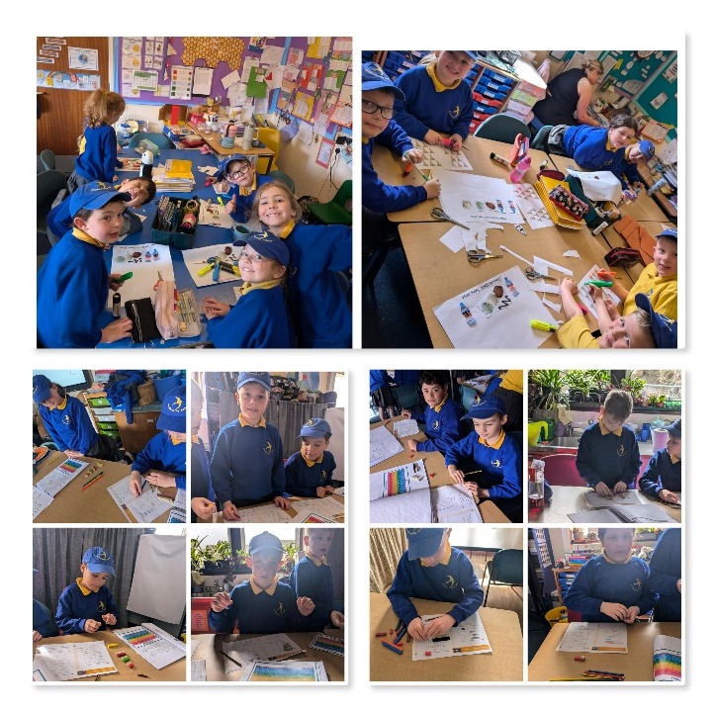
We have started our unit on fractions this week, looking at what a numerator and denominator is and how to identify which unit fractions are the biggest e.g. 1/8 or 1/12. The governors visited to look at the maths going on around the school and it was lovely to show them our learning.
As promised, we had our real-life ice cream maths lesson this week. On Friday, the children had to work out how many combinations of different ice-creams they could make from 2 scoop cones, 3 flavoured ice-creams and 2 flavoured sauces. We worked out there were 12 combinations! The children then all enjoyed an ice-cream of their choice flavours and topping.

English this week:
We have been planning our stories this week by planning our characters, setting and speech that we will use. We began our first draft on Friday morning. The children were really engaged and focused with their writing and I can’t wait to read them all!
Parents Evening:
It was genuinely so lovely to see lots of you this week at parents evening. Thank you so much for coming.
If you didn’t make an appointment or couldn’t, it would be lovely to arrange a short catch up over the next couple of weeks before the Easter holidays. Please pop me an email or drop in and we arrange a day and time.
Have a wonderful weekend everyone.
Take care,
Imogen x
14.3.25 | 14.3.25 | 14.3.25 | 14.3.25
Grizzly Bears | Honey Bears | Polar Bears | Panda Bears
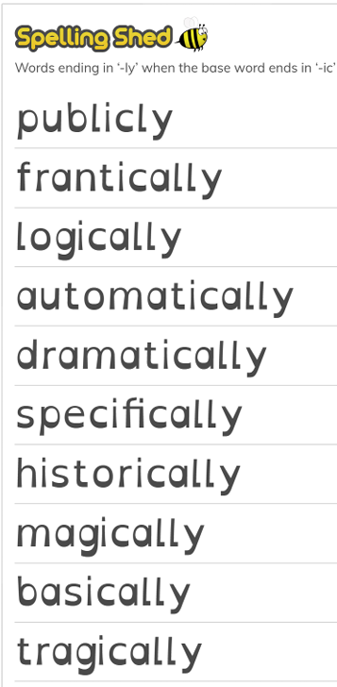 | 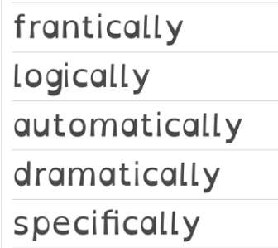 | 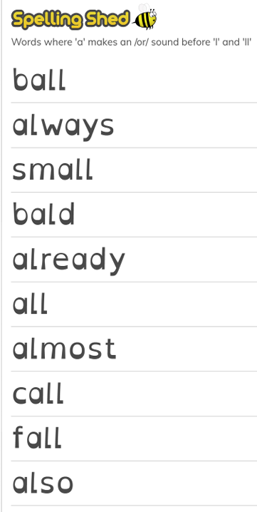 | 

