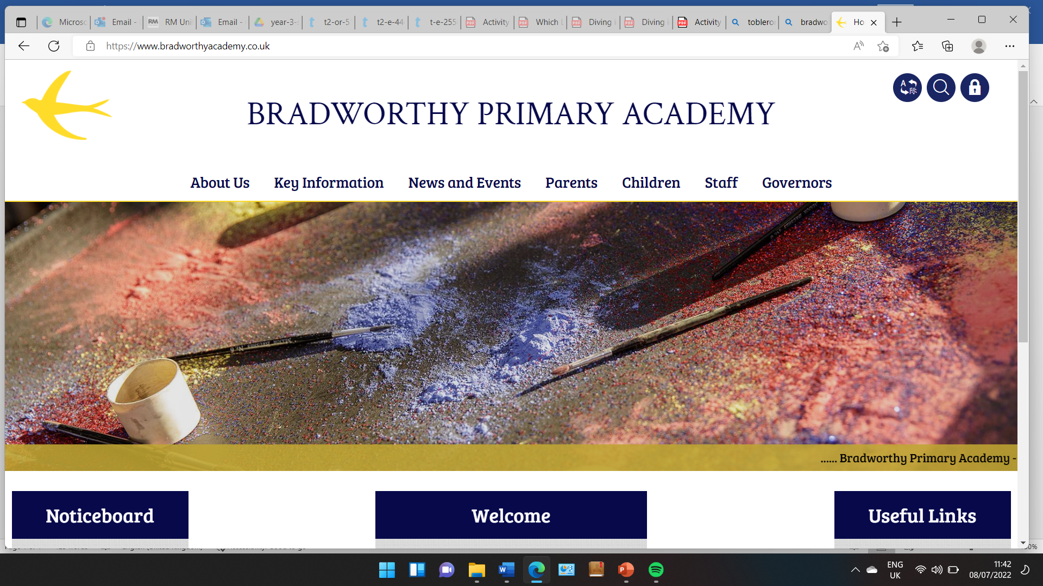
Class 3

Highlights This Week in Class 3
Friday 7th March 2025
Dear All,
Topic this week:
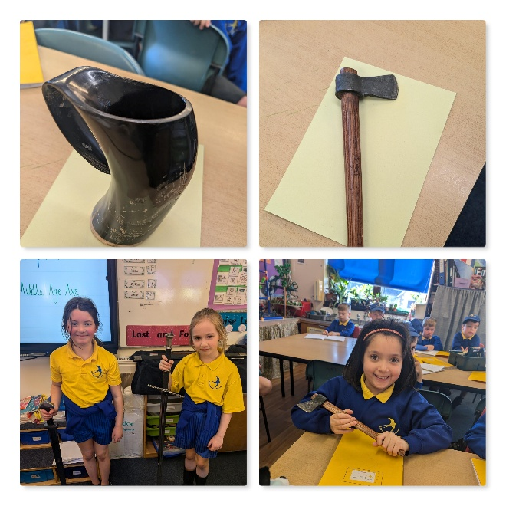
This week, Alex who teaches the class Music, brought in some replicas of Viking and Saxon artefacts. It was really interesting to get close to some Viking weaponry that would have been used. Thank you Alex!
Homework
Please continue to listen to your child read and encourage them to practice their times tables either on paper, verbally or on Ed Shed. This is really important because it links directly to our maths class learning at the moment. A fresh set of spellings will come up on Ed Shed this evening. (Please see spelling lists at the bottom of the letter for those of you who don’t use Ed Shed). When spellings are particularly hard, I’m am reducing the amount to learn. However, I am unable to match this with Ed Shed, which will always show the full set of ten words.
Maths this week
This week we have been learning about scaling and ‘how many combinations’. We spoke a lot about ice cream flavours in our lesson, learning how many combinations of 2 scoop ice creams we could make from 5 flavours of ice-cream. Next week we will be putting this into practice and as a treat for all the fantastic hard work with our learning this week, we will be making our own 2 scoop ice-creams to enjoy! Yum!

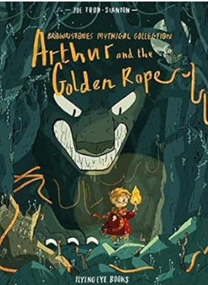
English this week:
Continuing with our unit on Arthur and the Golden Rope, this week we have been learning about how to use speech marks within our writing. We have also been creating our own mythical beast to use in our own stories that we plan next week. Next week we will be doing some shared writing in preparation for writing our own independent Viking stories.

Science
This week in Science, we continued our learning on our topic ‘Light’. We have been learning about reflections this week and spent the afternoon using mirrors for different activities. This including a very fun session on the playground using only a mirror held above us, to follow different straight and wiggly lines on the floor!
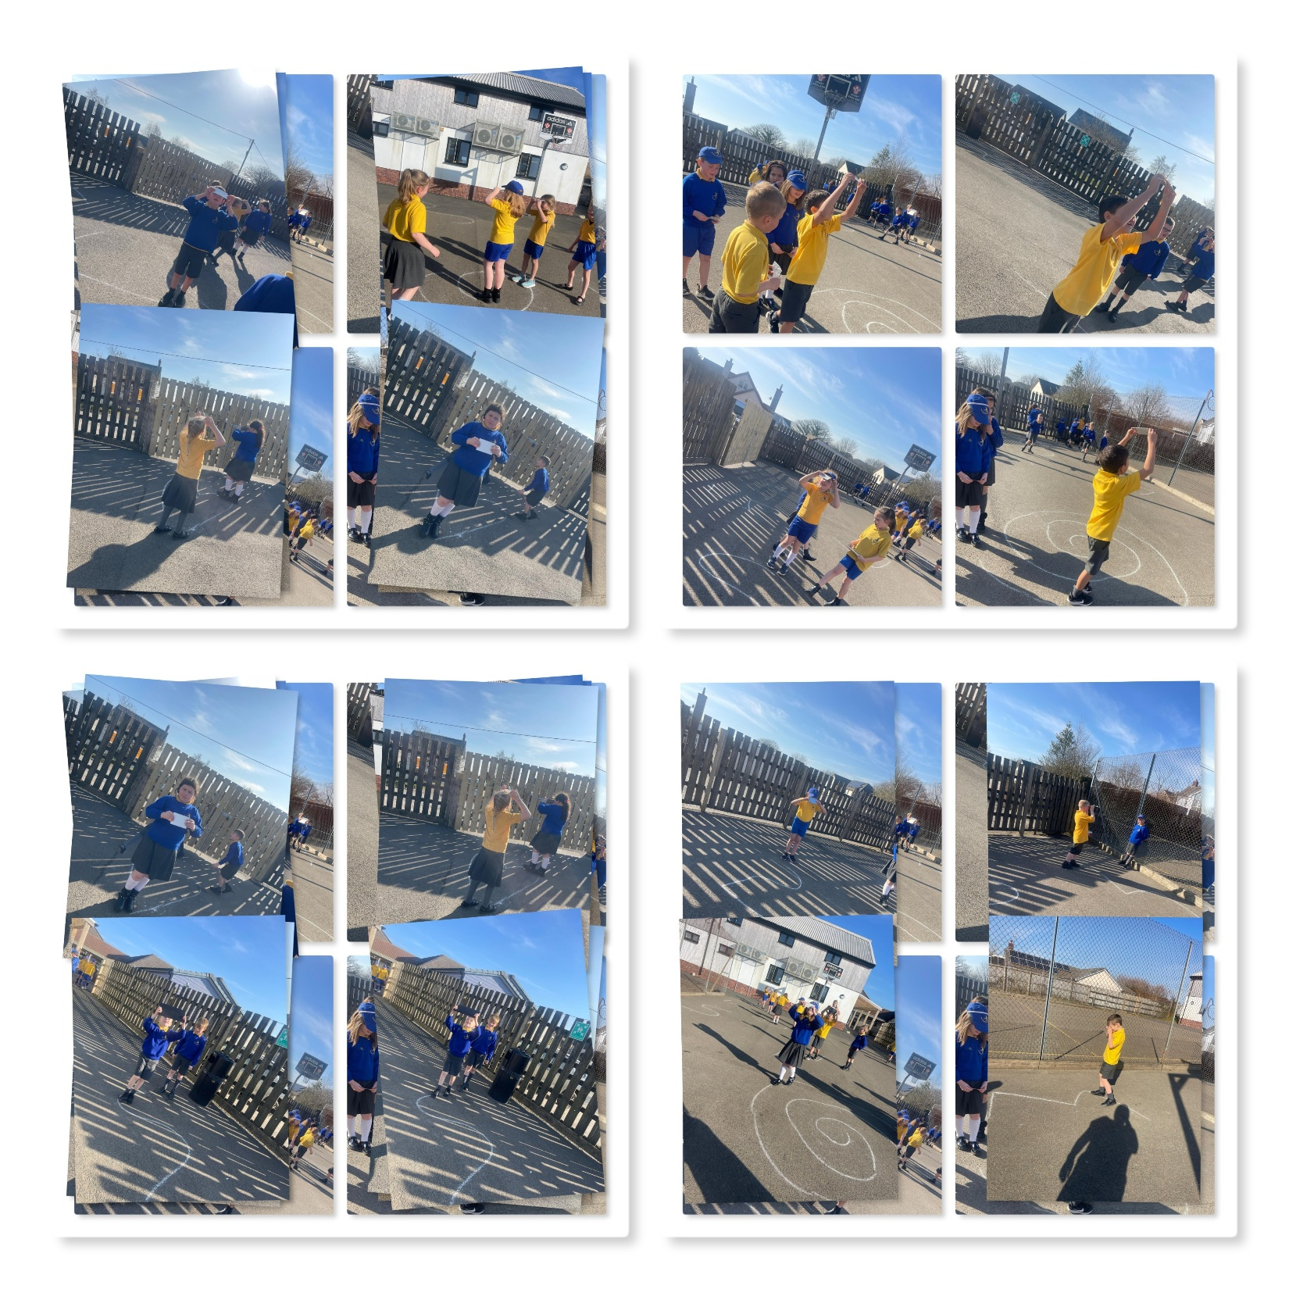
Have a wonderful weekend everyone!
Take care,
Imogen x
7.3.25 | 7.3.25 | 7.3.25 | 7.3.25
Grizzly Bears | Honey Bears | Polar Bears | Panda Bears
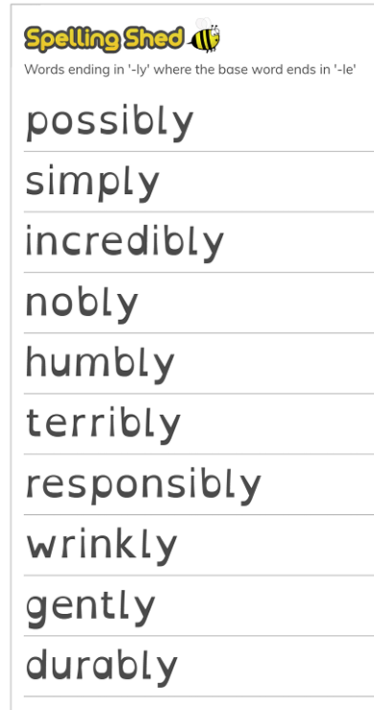 |  | 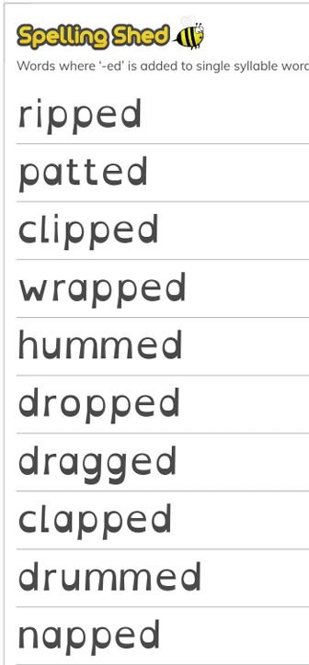 | 

