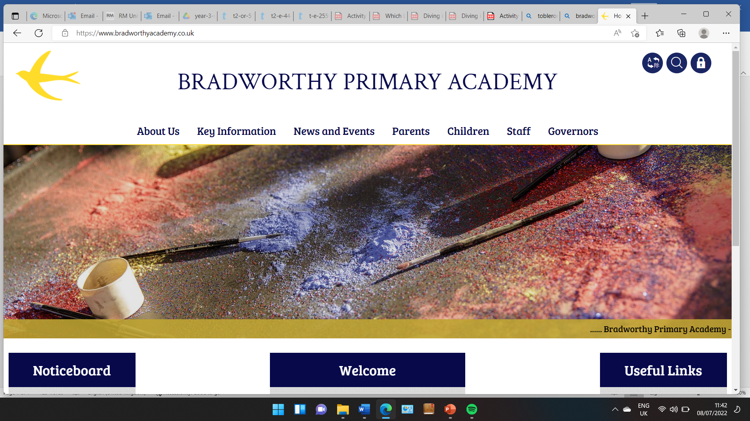
Class 3

Highlights This Week in Class 3
Friday 14th February 2025
Dear All,
Topic this week:
Today we have designed our own Viking Sheilds. Have a look at some of our designs below:
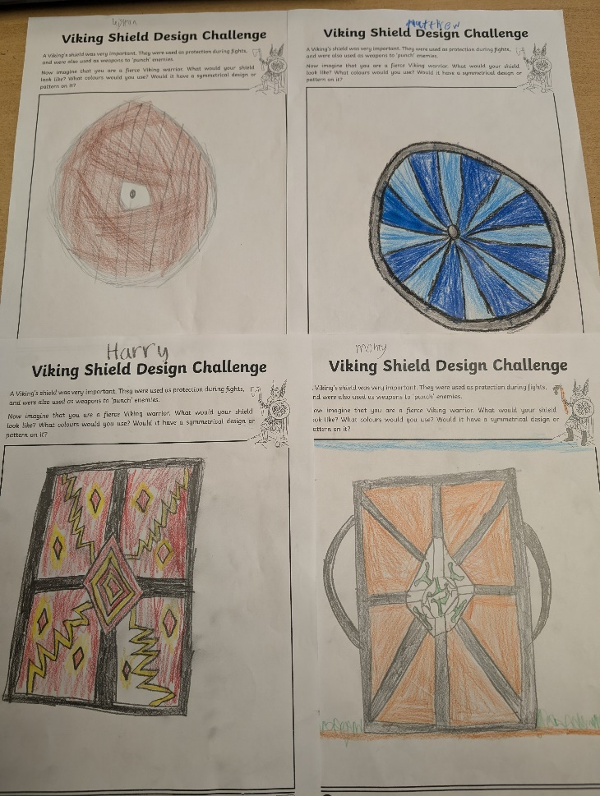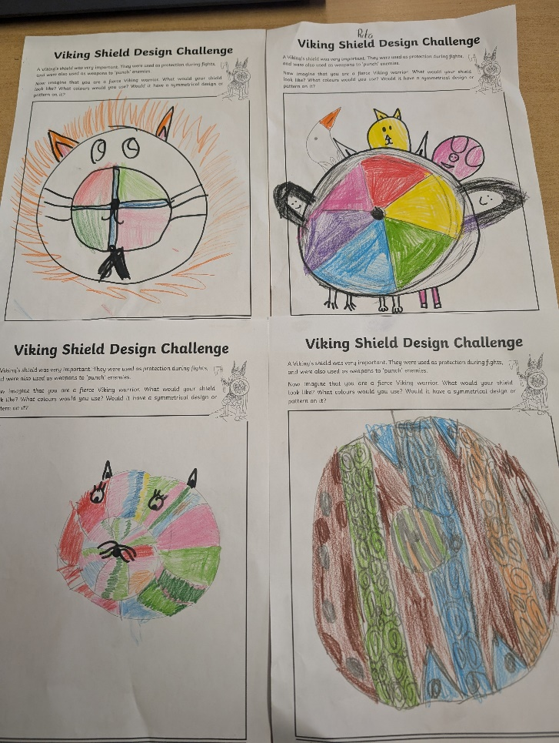
Homework and Maths
Please continue to listen to your child read and encourage them to practice their times tables either on paper, verbally or on Ed Shed. This is really important because it links directly to our maths class learning at the moment. A fresh set of spellings will come up on Ed Shed this evening. (Please see spelling lists at the bottom of the letter for those of you who don’t use Ed Shed). When spellings are particularly hard, I’m am reducing the amount to learn. However, I am unable to match this with Ed Shed, which will always show the full set of ten words. Ed Shed is set to do a mix of challenge words over half term so I will test the words below on the Friday of the first week back. So essentially, they have double the time to learn these words!

Maths this week
We have been learning how to multiply 2-digit numbers by 1-digit numbers within the times tables that we know.
We will continue to practice multiplication and division after half term. Then we will be learning about fractions.
English this week:
We have finished off our writing unit: The Day the Crayons Quit. The children have been learning how to write persuasively and use things like subordinate connections (I SAW A WABUB words), rhetorical questions and flattery. They wrote their final letter this week and took home a copy to show you. We have also displayed our writing on our proud cloud in class!
Have a wonderful weekend and a fab half term!
Take care,
Imogen x
21.2.25 | 21.2.25 | 21.2.25 | 21.2.25
Grizzly Bears | Honey Bears | Polar Bears | Panda Bears
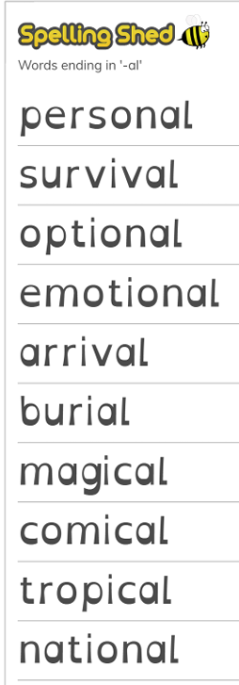 |  | 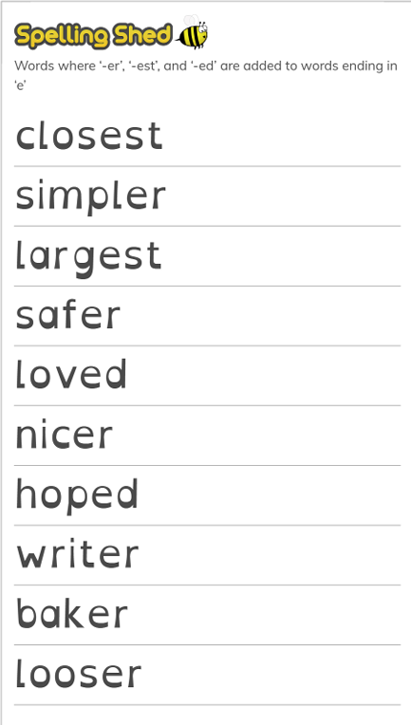 | 

