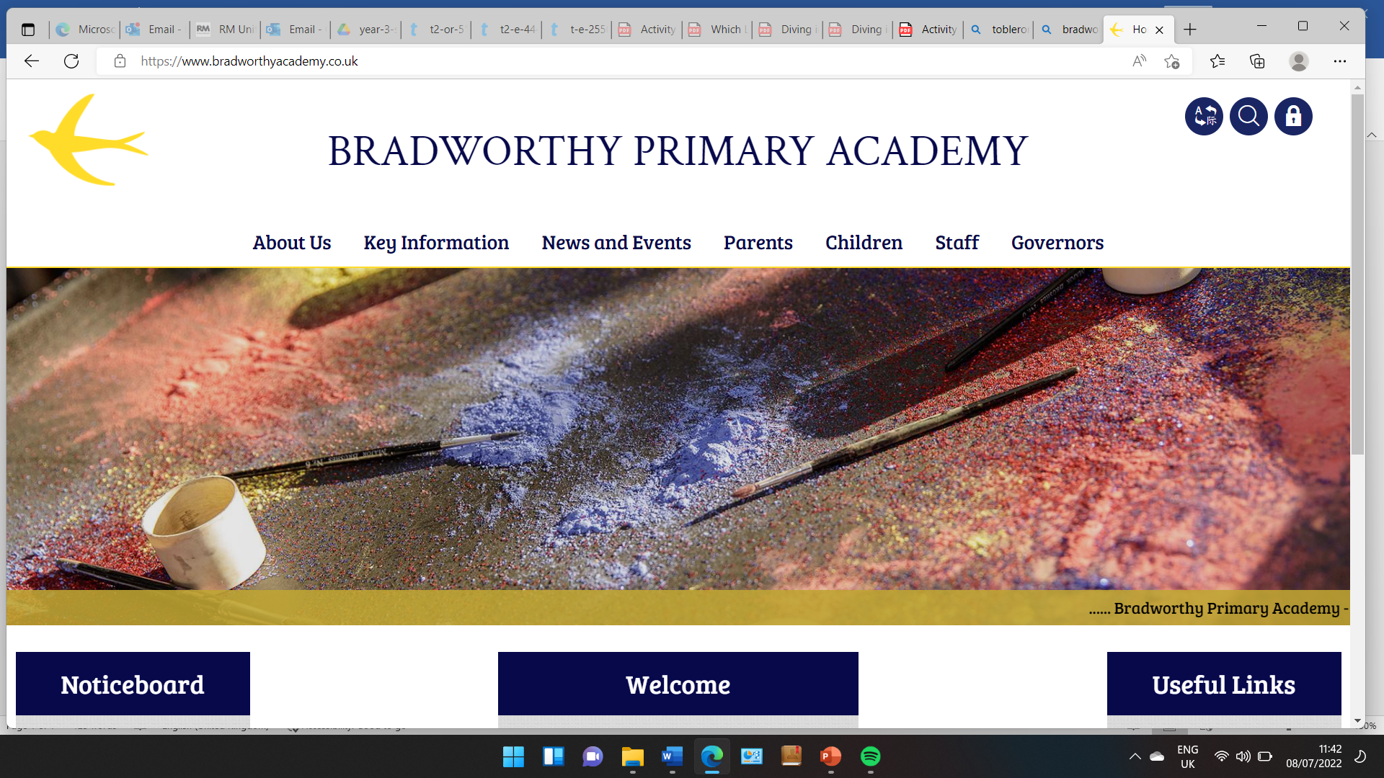
Class 3

Highlights This Week in Class 3
Friday 17th January 2025
Dear All,
I hope you all had a wonderful Christmas and New Years. Thank you so much for all the presents, cards and well wishes at the end of the term. We are incredibly proud of the class, with their hard work and focus, including their positivity and energy surrounding their first KS2 play. They did fantastically and we couldn’t be prouder!
I wanted to also remind you that if you would like to meet with me regarding your child’s learning or something else, you are always welcome to come in and arrange a catch up. Our door is always open!
This Week:
Topic this week:
This week we have begun our new topic on the Vikings. This is always a fun topic to do and the children really enjoyed their introduction to who the Vikings were this week and where they were from. We did some map work and learned some basic facts about who they were and what they did.
English this week:
This week, we began our new unit using the story ‘The Day the Crayons Quit’. We enjoyed this funny book about some very disgruntled crayons who wrote letters of complaint to their owner. Today we begun our own dairy entries to help us get into character of a piece of equipment from the PE shed.
Homework
Please continue to listen to your child read and encourage them to practice their times tables either on paper, verbally or on Ed Shed. We have been focusing directly on the 3 times table this week and how to multiple and share by 3. A fresh set of spellings will come up on Ed Shed this evening. (Please see spelling lists at the bottom of the letter for those of you who don’t use Ed Shed).
Mental Health and PSHE
As we tackle the dreary months of January and February (!) we are going to continue our work on gratitude. Please can each child bring in a clean jar to school. Thank you.
Take care,
Imogen x
17.1.25 | 17.1.25 | 17.1.25 | 17.1.25
Grizzly Bears | Honey Bears | Polar Bears | Panda Bears
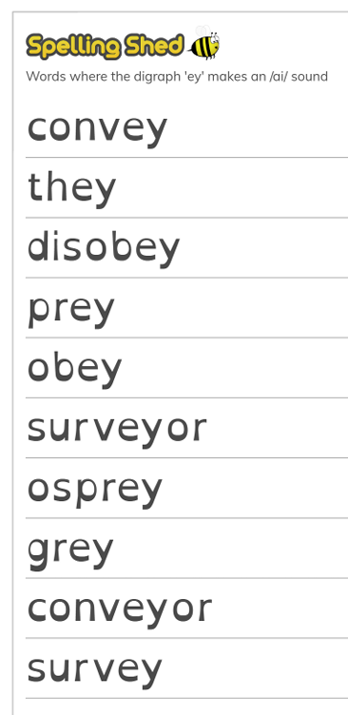 |  | 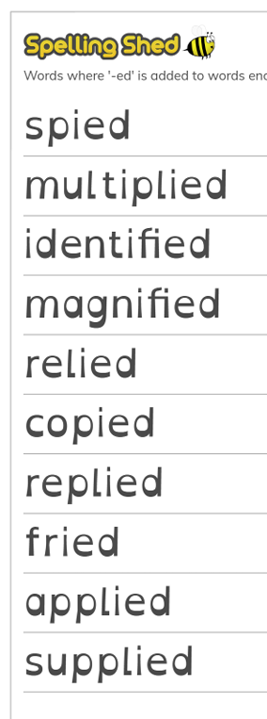 | 

