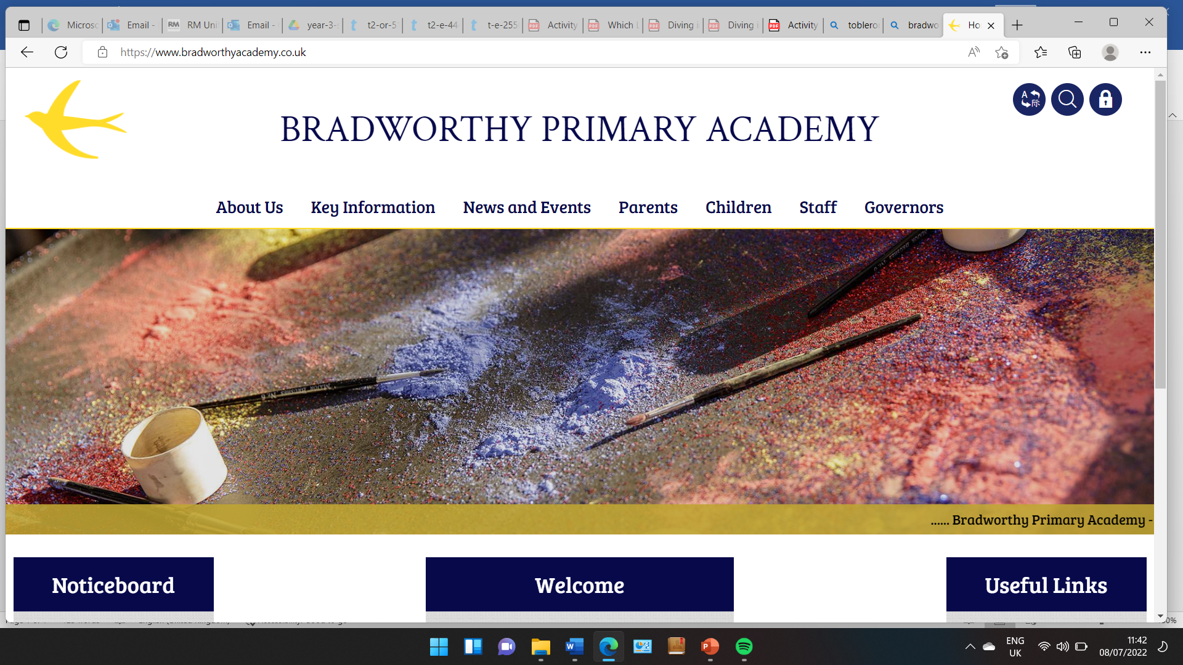
Class 3

Highlights This Week in Class 3
Friday 24th January 2025
Dear All,

This Week:
Topic this week:
Continuing on our topic this week, we have been learning more about the Vikings, and particularly the Battle of Hastings in 1066 when the Viking time period came to an end. The children really enjoyed this.
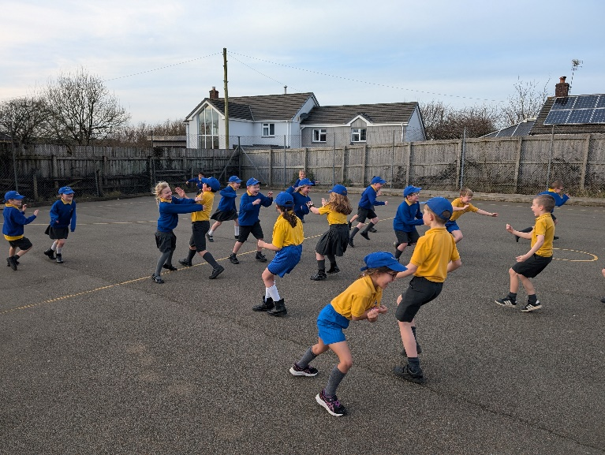

Homework
Please continue to listen to your child read and encourage them to practice their times tables either on paper, verbally or on Ed Shed. We have been focusing directly on the 3 times table this week and how to multiple and share by 3. A fresh set of spellings will come up on Ed Shed this evening. (Please see spelling lists at the bottom of the letter for those of you who don’t use Ed Shed).
Mental Health and PSHE
We have spent a full day talking about our feelings this Friday and how they present differently in our body. We talked about our brain and how we all have mental health, sometimes good and bad, just like our physical health. We drew body maps of ourselves and colour coded where we might feeling different feelings like anger, happiness, anxiety, sadness and excitement. We then made big body maps in groups and used smarties to colour code these different points on our bodies. We also have looked at why we are special and unique and what our interests are. This is ahead of mental health week which focuses this year on Know Yourself, Grow yourself.
Take care,
Imogen x
17.1.25 | 17.1.25 | 17.1.25 | 17.1.25
Grizzly Bears | Honey Bears | Polar Bears | Panda Bears
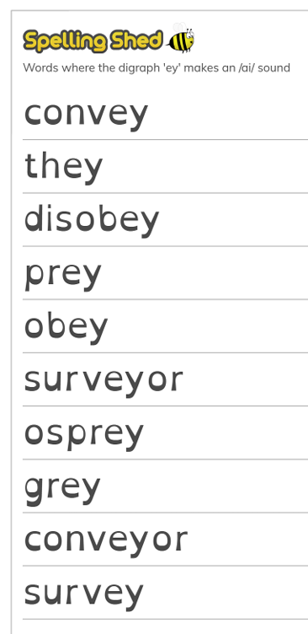 |  | 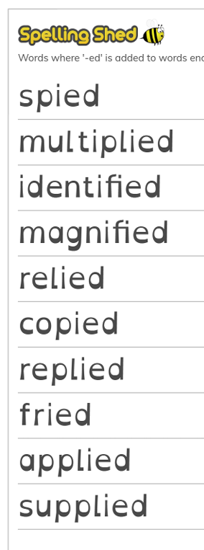 | 

