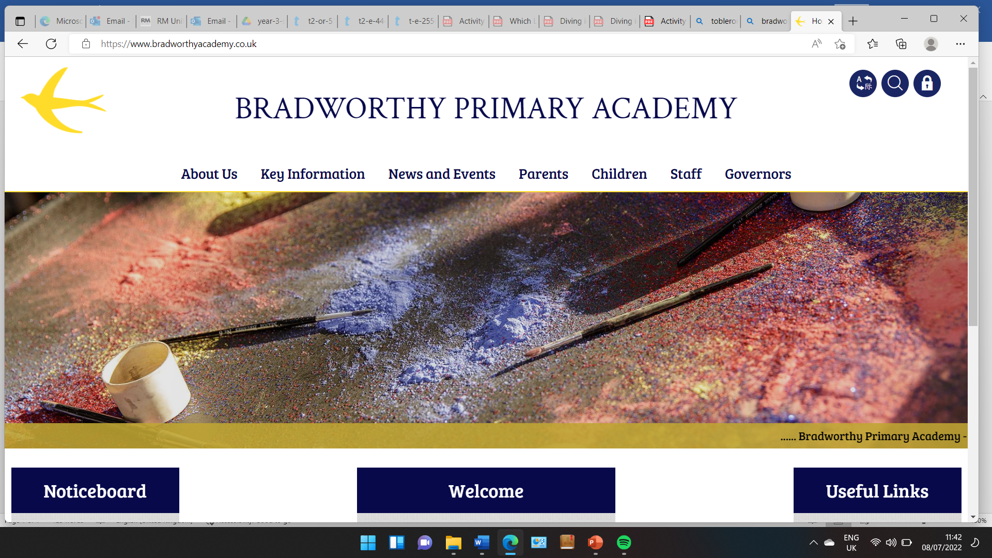
Class 3

Highlights This Week in Class 3
Friday 28th February 2025
Dear All,
Topic this week:
This week, with Mr Sentance, the children have been learning about Odin and his 8 legged horse Sleipnir. They have also been discussing the meaning of home and ‘house’ – this year’s Bradworthy Arts Festival Theme.
Homework and Maths
Please continue to listen to your child read and encourage them to practice their times tables either on paper, verbally or on Ed Shed. This is really important because it links directly to our maths class learning at the moment. A fresh set of spellings will come up on Ed Shed this evening. (Please see spelling lists at the bottom of the letter for those of you who don’t use Ed Shed). When spellings are particularly hard, I’m am reducing the amount to learn. However, I am unable to match this with Ed Shed, which will always show the full set of ten words. Ed Shed is set to do a mix of challenge words over half term so I will test the words below on the Friday of the first week back. So essentially, they have double the time to learn these words!
Maths this week
We have been learning how to divide 2-digit numbers by 1-digit numbers within the times tables that we know.
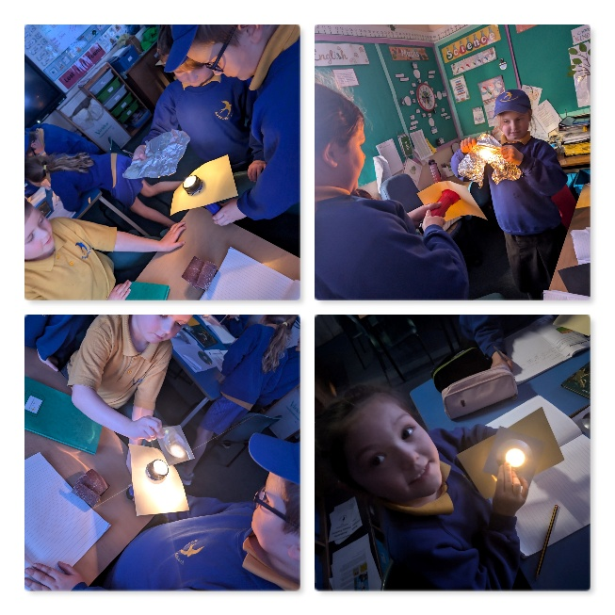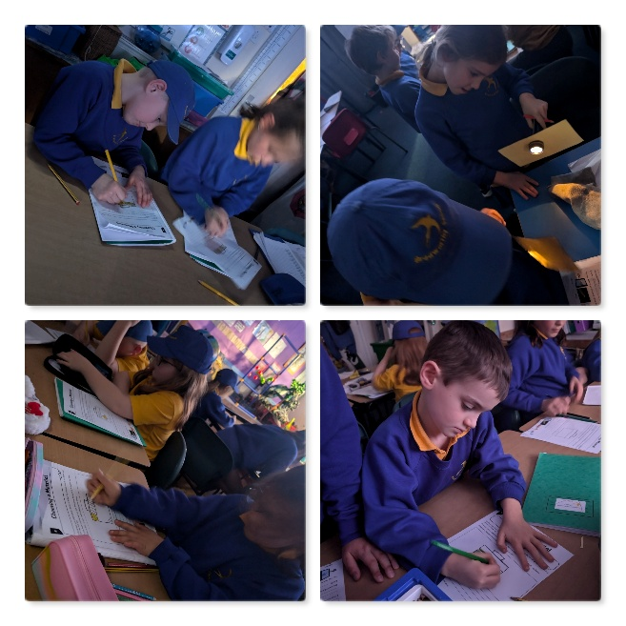

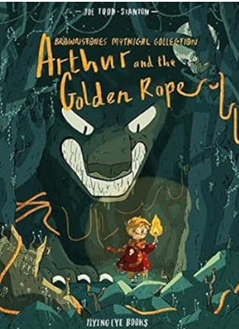
English this week:
We have started our new class story called Arthur and the Golden Rope. We have been looking closely this week at how to write speech, beginning with just a pair of speech marks and different verbs for the word ‘said’.
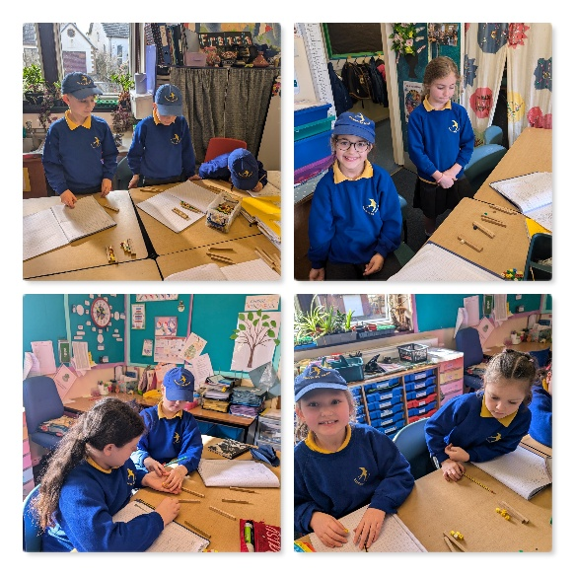
Science
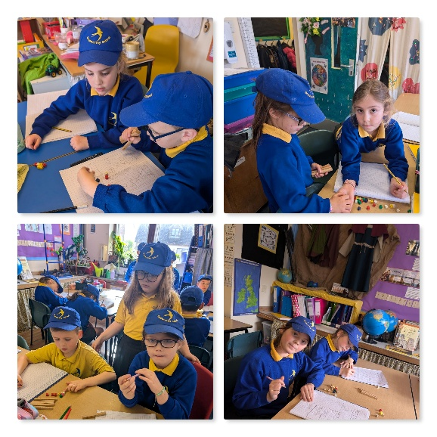
This week in Science, we continued our learning on our topic ‘Light’. We tested the reflective properties of different materials and discussed the safety uses of these materials.

Have a wonderful weekend!
Take care,
Imogen x
28.2.25 | 28.2.25 | 28.2.25 | 28.2.25
Grizzly Bears | Honey Bears | Polar Bears | Panda Bears
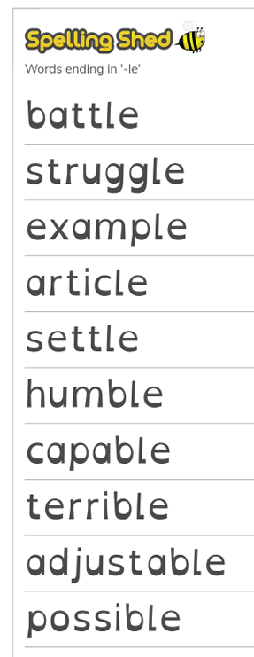 |  | 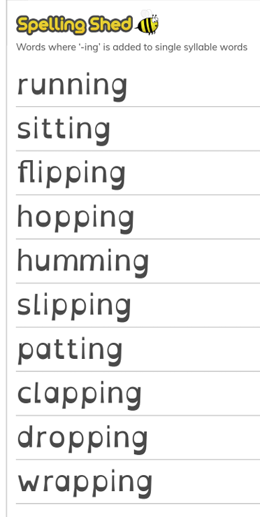 | 

