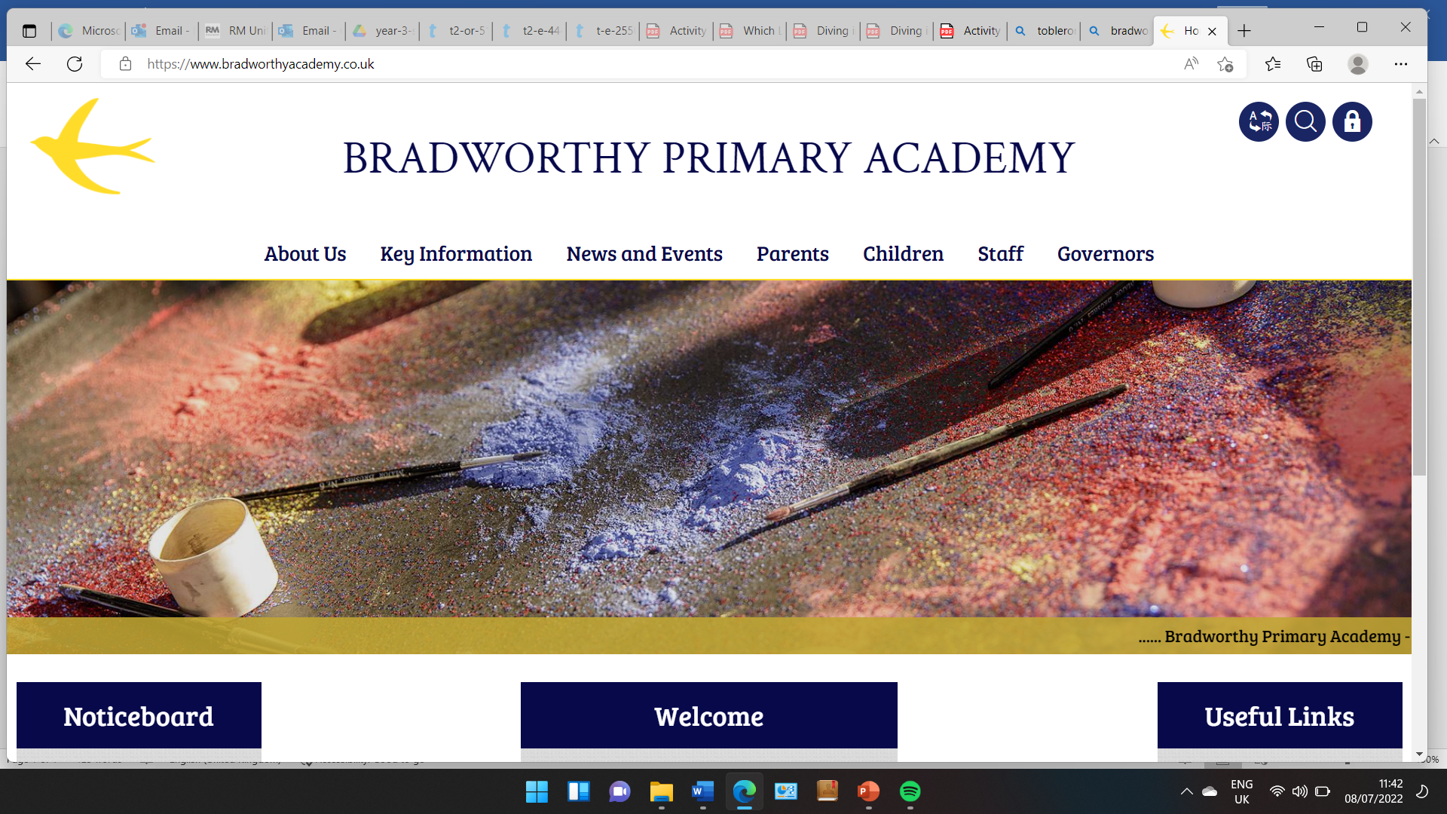
Class 3

Highlights This Week in Class 3
Friday 31st January 2025
Dear All,
Topic this week:
This week we looked in depth at the Anglo-Saxon Kings, King Alfred and King Athelstan to learn their effects on the Vikings and power changes in England. We tried to work out which we thought was the better King, which was quite tricky!
Homework and Maths
Please continue to listen to your child read and encourage them to practice their times tables either on paper, verbally or on Ed Shed. We have been focusing directly on the 4 and 8 times table this week and how to multiple and share by 4 and 8. A fresh set of spellings will come up on Ed Shed this evening. (Please see spelling lists at the bottom of the letter for those of you who don’t use Ed Shed).
Maths this week
We have been learning more about multiplication and division this week and showing our sums using concrete resources. See our photos below.
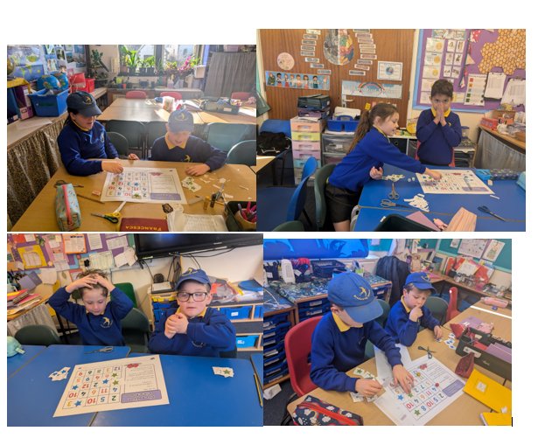
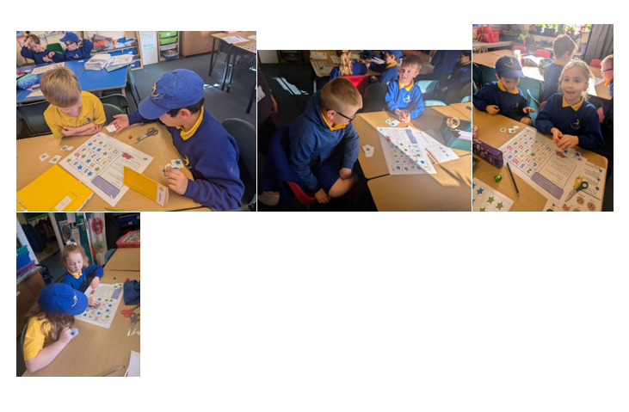
Message from Mrs Raffe
We have been practicing our learning on money this half term so any practice using coins at home and counting up change would be fantastic. We have also been continuing to tell the time so reinforcing this at home also would be really useful. Thank you!
Take care,
Imogen x
31.1.25 | 31.1.25 | 31.1.25 | 31.1.25
Grizzly Bears | Honey Bears | Polar Bears | Panda Bears
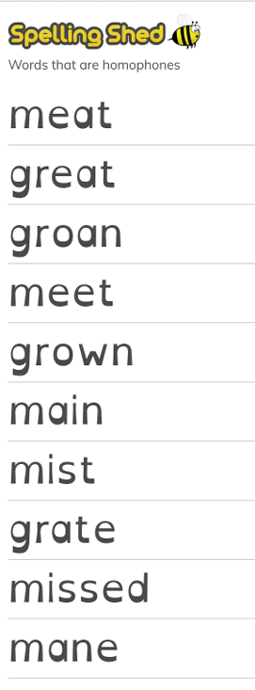 |  | 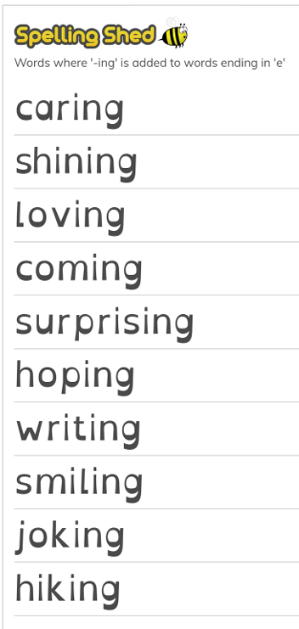 | 

