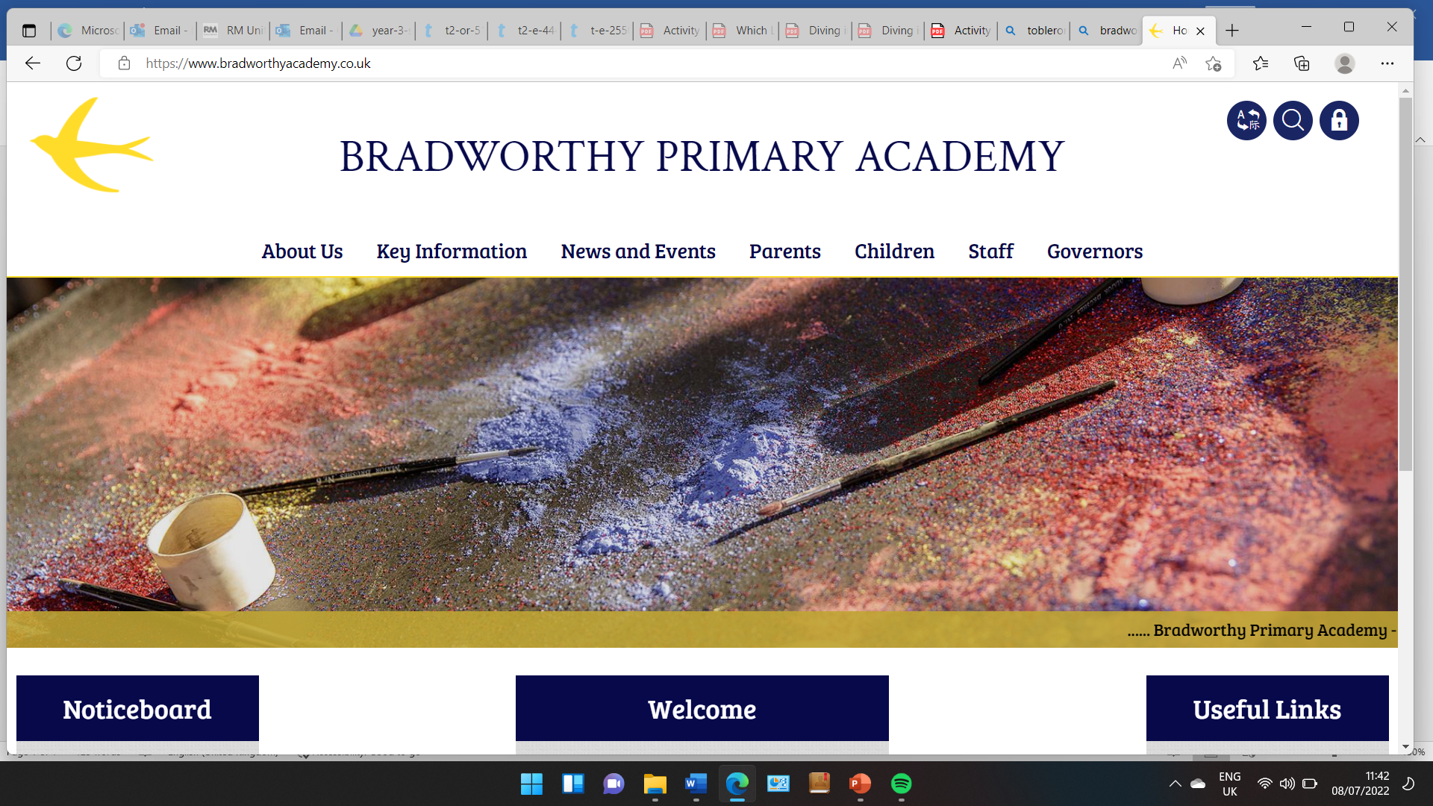
Class 3

Highlights This Week in Class 3
Friday 7th February 2025
Dear All,
Topic this week:
This week we have been learning about games that are thought to have been played around the Viking time period. We have had a go at playing some of them this week! We have played Ladder Toss and Kubb and also a version of 3 in a row!
Homework and Maths
Please continue to listen to your child read and encourage them to practice their times tables either on paper, verbally or on Ed Shed. This is really important because it links directly to our maths class learning at the moment. A fresh set of spellings will come up on Ed Shed this evening. (Please see spelling lists at the bottom of the letter for those of you who don’t use Ed Shed). When spellings are particularly hard I’m am reducing the amount to learn. However, I am unable to match this with Ed Shed, which will always show the full set of ten words.
Maths this week
We have been learning this week how to multiply by tens, e.g. if 4x3=12 then 4x30=120. This is in preparation for next week, when we will begin to learn to multiply 2-digit numbers by 1-digit numbers.
Have a wonderful weekend!
Take care,
Imogen x
7.2.25 | 7.2.25 | 7.2.25 | 7.2.25
Grizzly Bears | Honey Bears | Polar Bears | Panda Bears
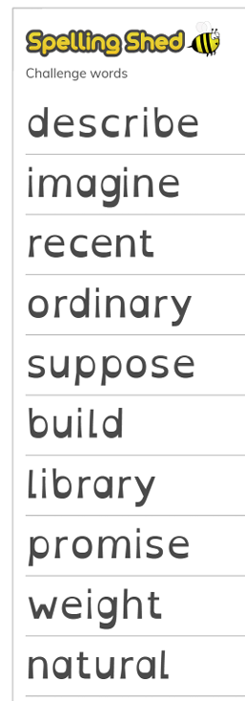 |  | 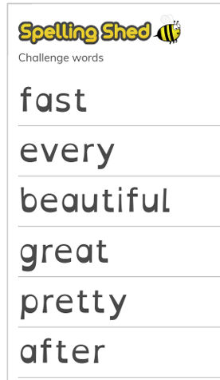 | 

