Spellings this week

6.12.24 | 6.12.24 | 6.12.24 | 6.12.24
Grizzly Bears | Honey Bears | Polar Bears | Panda Bears
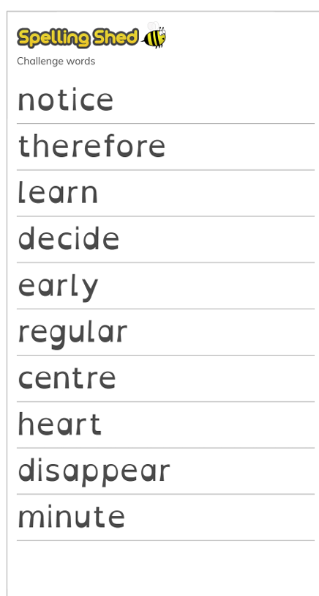 |  | 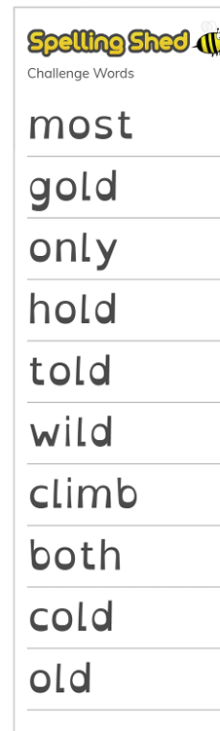 | 

