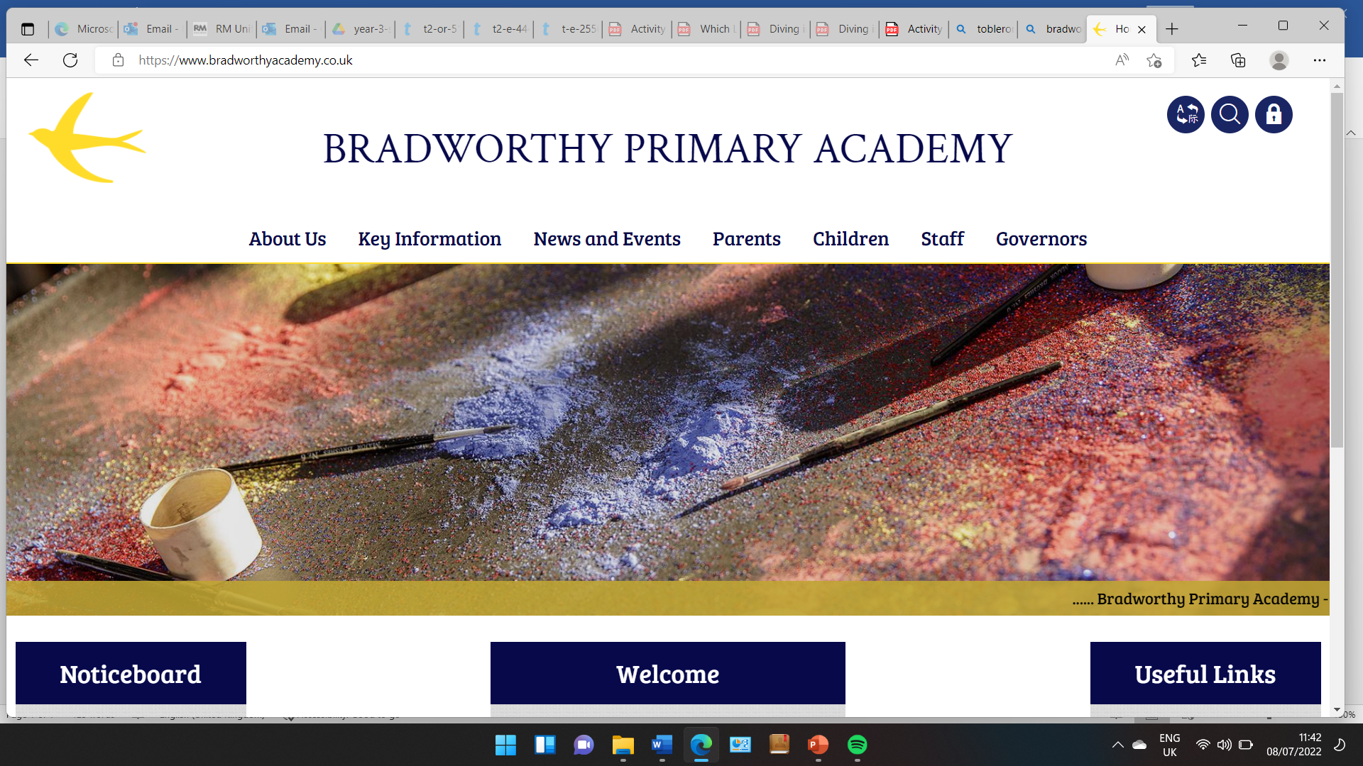
Class 3

Highlights This Week in Class 3
Friday 22nd November 2024
This week’s main events:
Science this week
In Science this week, we were learning about the effects of different surfaces and friction on speeds of an object moving. We completed an experiment where we tested toy cars on a slope on different surfaces to see how far the car would travel. We measured the distance and then discussed which surface created the most friction.

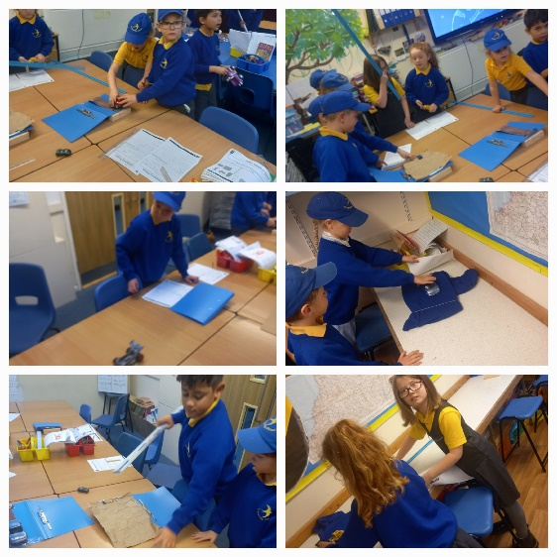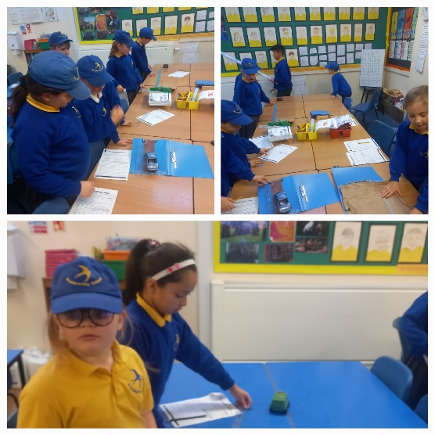
Homework
Please continue to listen to your child read and encourage them to practice their times tables either on paper, verbally or on Ed Shed. A fresh set of spellings will come up on Ed Shed this evening. (Please see spelling lists at the bottom of the letter for those of you who don’t use Ed Shed).

Take care,
Imogen x

Class 3 dates for your diary:
Thursday 28th November – Swimming in the morning at Ruby Oak Park
22.11.24 | 22.11.24 | 22.11.24 | 22.11.24
Grizzly Bears | Honey Bears | Polar Bears | Panda Bears
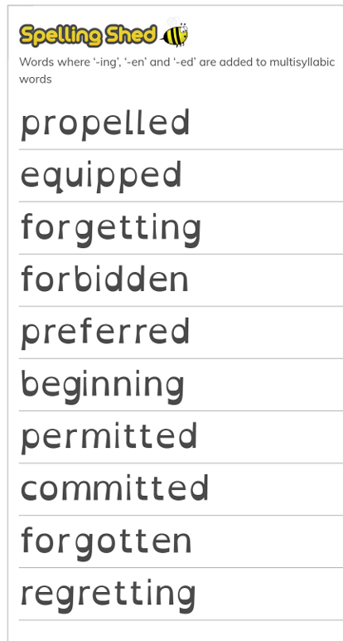 |  | 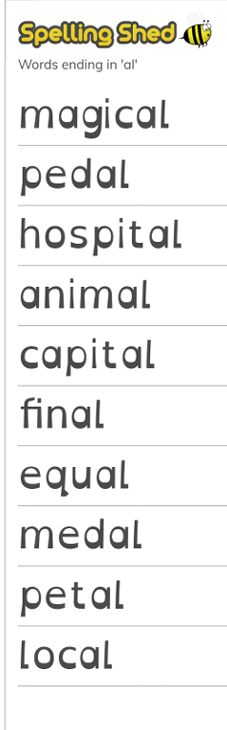 | 

