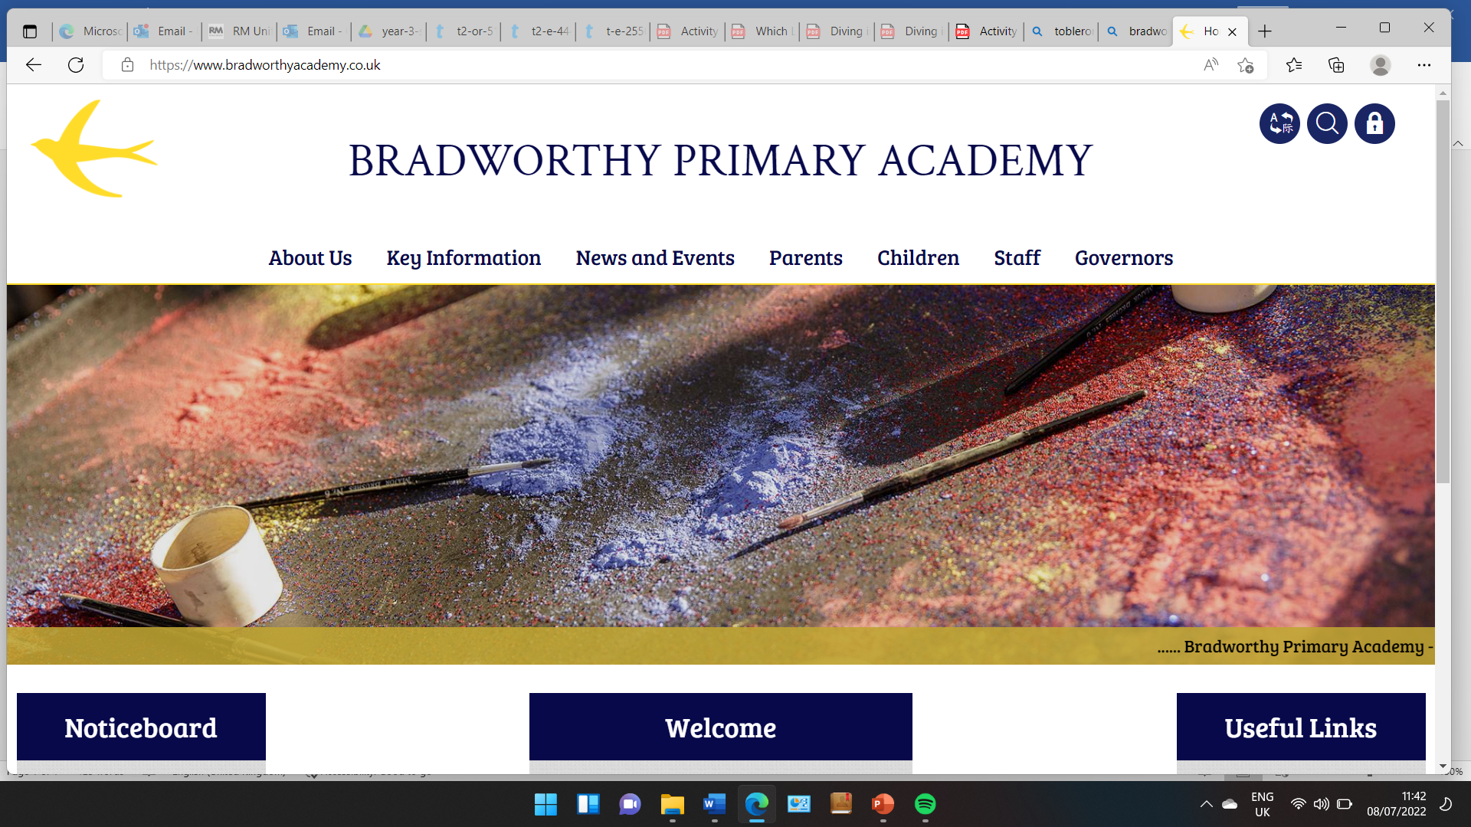
Class 3

Highlights This Week in Class 3
Friday 29th November 2024
This week’s main events:
Science this week
In Science this week, we were learning about magnets and what kinds of materials they are attracted to.
Geography
This Friday we have been continuing our map work with a mini project about where we live in the world. We spent a lovely morning, colouring maps and finding out the planet, continent, country, county, city, town, village and street that we live on.
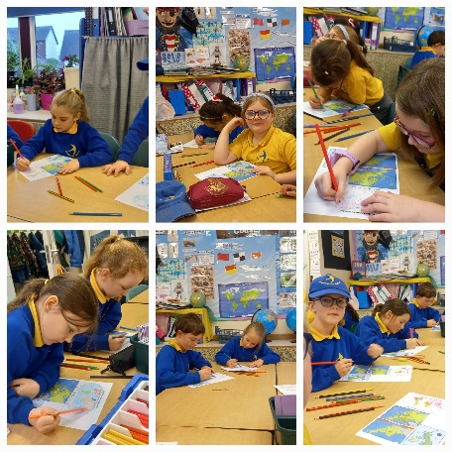 | 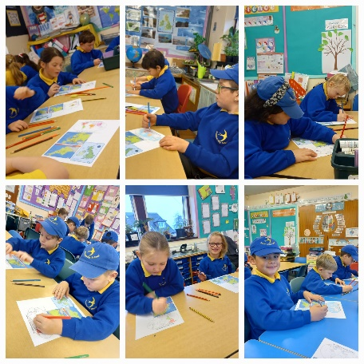 | 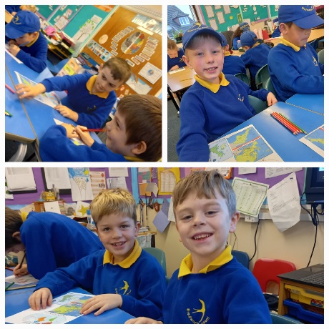

Swimming
This Thursday, we had our final swimming lesson at Ruby Oak. The children had a lovely time, and had their fun session.
English
This week we have been designing our own dogs and dinosaurs! We have been reading a set of books called ‘How Dogs/Dinosaurs Really Work’. We have been working on our creative ideas for different parts of the skeleton and insides of the animals. Have a look at some of our designs below:
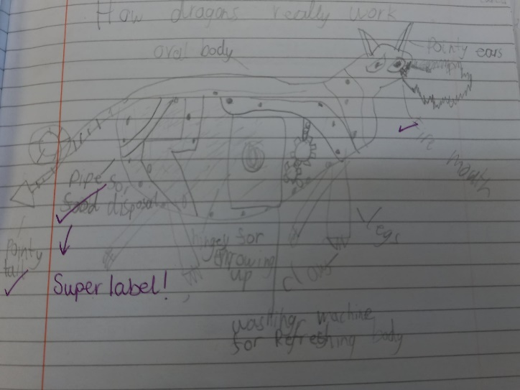 | 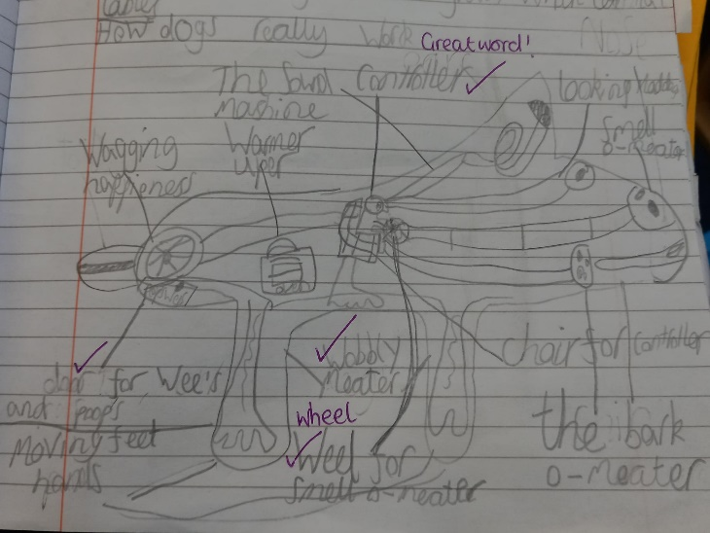
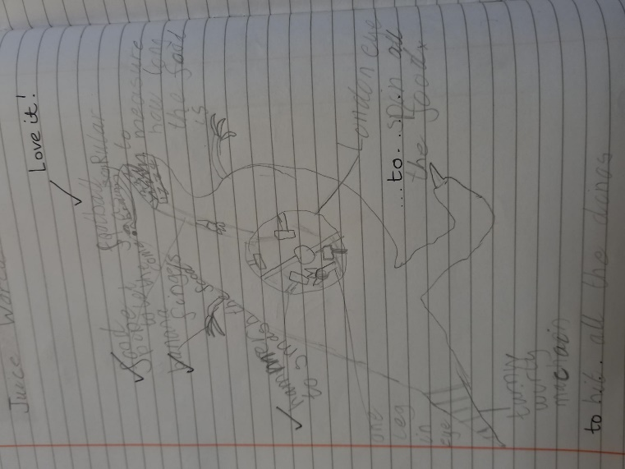 | 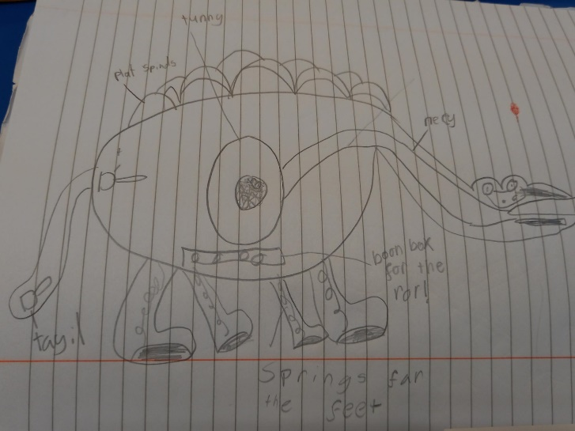

Homework
Please continue to listen to your child read and encourage them to practice their times tables either on paper, verbally or on Ed Shed. A fresh set of spellings will come up on Ed Shed this evening. (Please see spelling lists at the bottom of the letter for those of you who don’t use Ed Shed).

Have a wonderful weekend, let’s hope we get a bit of a breather from the rain and drizzle!
Imogen x

6.12.24 | 6.12.24 | 6.12.24 | 6.12.24
Grizzly Bears | Honey Bears | Polar Bears | Panda Bears
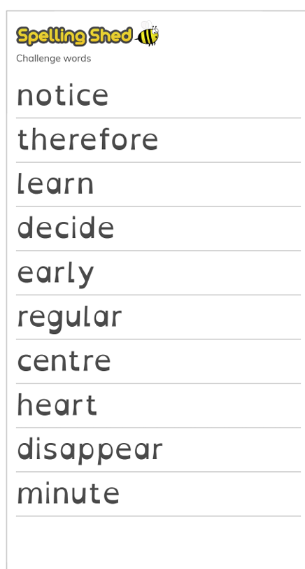 |  | 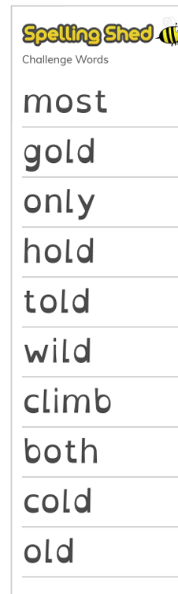 | 

