
Class 3

Highlights This Week in Class 3
Friday 8th November 2024
Dear All,
It has been so lovely to see everybody back at school! We hope you all had a lovely half term.
This week’s main events:
Swimming
Monday, Tuesday, Wednesday and Thursday mornings were spent at Ruby Oak Park for our swimming lessons. The children have been getting on really well, and they will have their final session, including play time on Thursday 28th November.
Homework
Please continue to listen to your child read and encourage them to practice their times tables either on paper, verbally or on Ed Shed. A fresh set of spellings will come up on Ed Shed this evening. (Please see spelling lists at the bottom of the letter for those of you who don’t use Ed Shed).
DT- Sewing – Tuesdays to Fridays
Following on from our Coast’s topic, we will be sewing some little felt fish. If there are any of you who would be able to come and help with this in the afternoons over the next few weeks, please could you let me know, or email me. It would be really lovely to see you!
Rosemoor next week
We will be off to Rosemoor next Friday for our Science session on Soil, and also for a walk and exploration of all the autumnal colours the gardens have to offer. Hopefully I have emailed everyone who wanted to come and help and you’ve received these!
Children will be wearing their school uniform, with waterproofs over the top. Caps are essential as they help us to spot the children and do head counts etc. It helps to keep them all safe and makes our job a lot easier when out and about!
Have a wonderful weekend everyone!
Imogen x

Class 3 dates for your diary:
Friday 15th November – Trip to Rosemoor
Thursday 28th November – Swimming in the morning at Ruby Oak Park
8.11.24 | 8.11.24 | 8.11.24 | 8.11.24
Grizzly Bears | Honey Bears | Polar Bears | Panda Bears
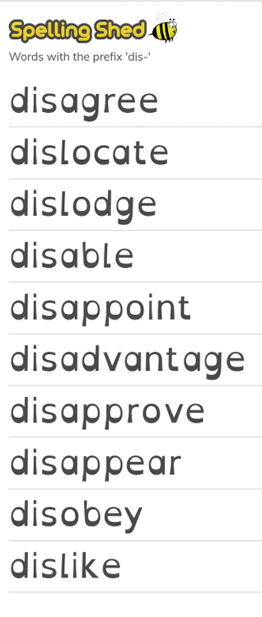 |  | 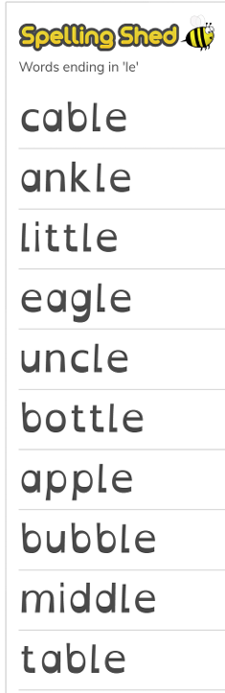 | 

