
Class 3

Highlights This Week in Class 3

Friday 25th October 2024
Dear All,
It’s been a rather busy end to term!
First of all, apologies for the lack of spelling test on Friday. We just couldn’t fit it in with our beach trip and the rest of the week has been pretty manic! We haven’t actually spent a full day in school!
Thank you so much though for your support with times table and spelling practice at home, as well as regular reading sessions. The children get 2HPs for every ‘signature’ in their reading record from a grown up. It’s really exciting to see the children progressing up their book band levels and seeing their proud smiling faces!
This week’s main events:
Swimming
Monday, Tuesday and Thursday mornings were spent at Ruby Oak Park for our swimming lessons. The children are getting on really well, showing fantastic manners and a real enthusiasm to improve their swimming abilities!
Harvest
On Wednesday morning, we attended our yearly Harvest festival. The children sang beautifully and we had a lovely service, remembering the important message or nurture and caring for one another with kindness!
Beach Trip
On Friday we had a fantastic day at Bude, studying the coastline and the various coast defences used at Crooklets and Summerleaze beach to help protect the cliffs and town against the ongoing coastal erosion.
Thank you so much to David, Michael, Clare and Fliss for your company and help!

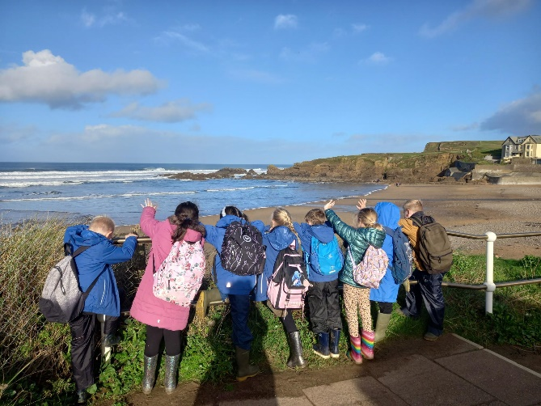
Here are some photos from our trip (I’ll try and get more up on the website this week)
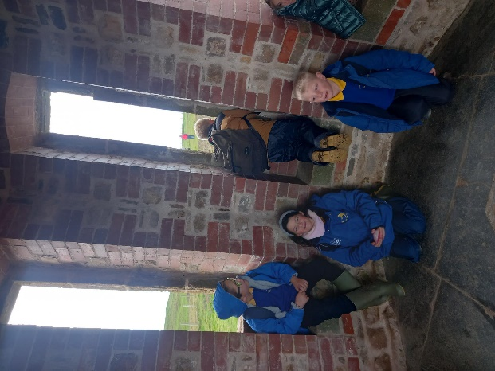
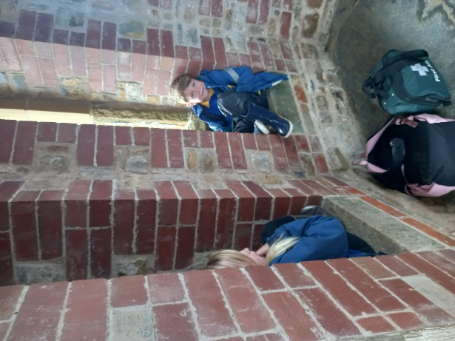
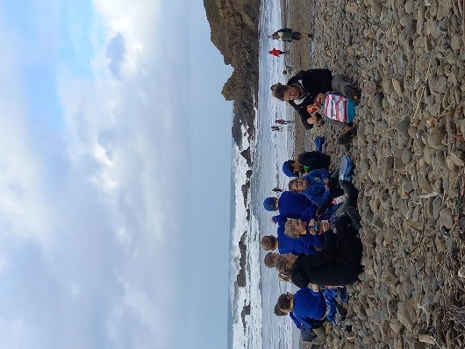
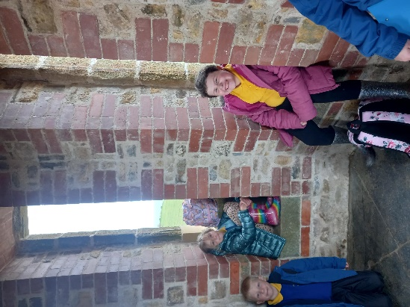

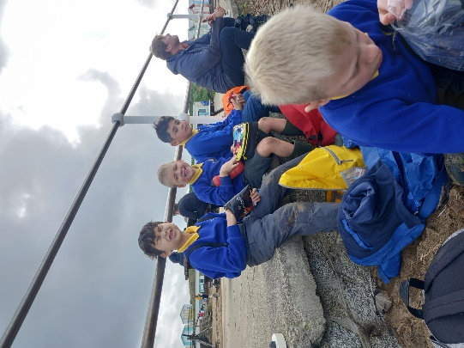

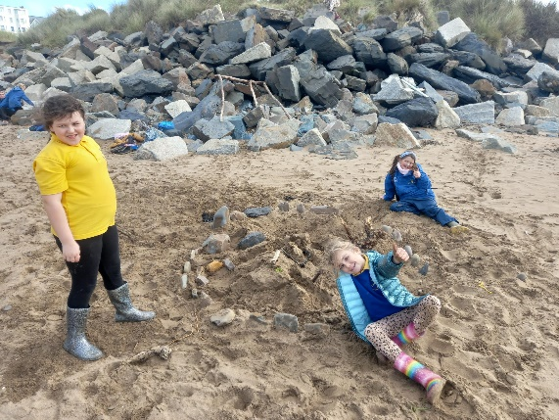
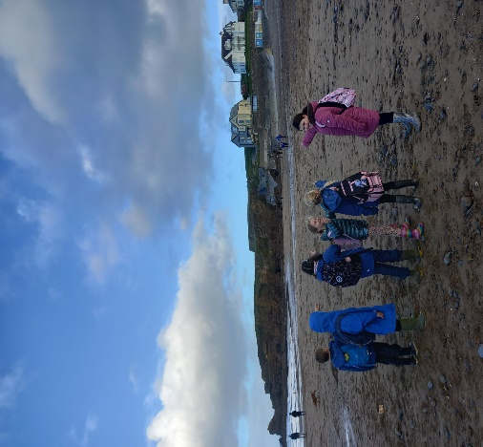
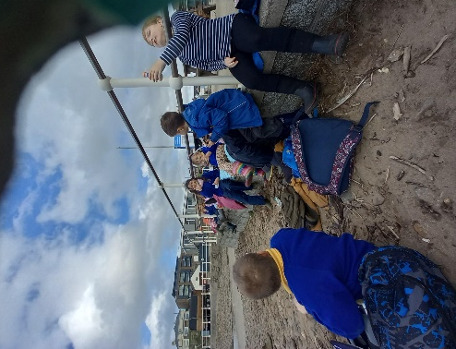
Homework
Please continue to listen to your child read and encourage them to practice their times tables either on paper, verbally or on Ed Shed. A fresh set of spellings should have come up on Ed Shed yesterday afternoon and we will test these at the end of the first week back to school. (Please see spelling lists at the bottom of the letter for those of you who don’t use Ed Shed).
Swimming
Please don’t forget that we will be swimming on the first day back, as well as the Tuesday, Wednesday and Thursday.
We have added Thursday 28th November as another swimming morning, due to the session we missed during Harvest. This will be their last session of swimming for Year 3.

Have a wonderful half term and we really look forward to seeing you all back the week after next!
Imogen x

Class 3 dates for your diary:
Monday 4th November – Swimming in the morning at Ruby Oak Park
Tuesday 5th November – Swimming in the morning at Ruby Oak Park
Wednesday 6th November – Swimming in the morning at Ruby Oak Park
Thursday 7th November – Swimming in the morning at Ruby Oak Park
Friday 15th November – Trip to Rosemoor
Thursday 28th November – Swimming in the morning at Ruby Oak Park

25.10.24 | 25.10.24 | 25.10.24 | 25.10.24
Grizzly Bears | Honey Bears | Polar Bears | Panda Bears
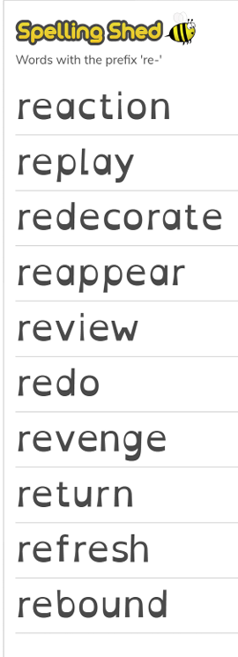 |  | 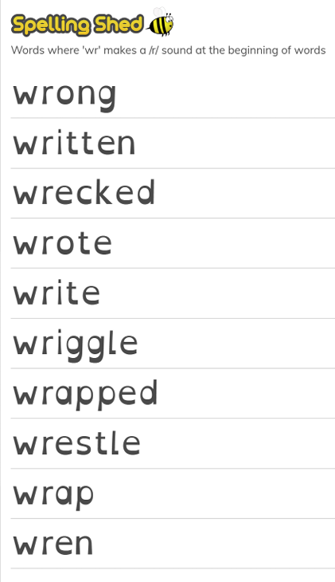 | 

