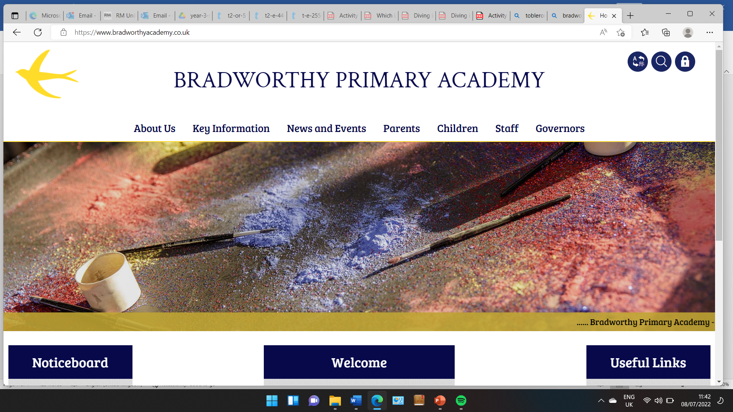
Class 3

Highlights This Week in Class 3
Friday 18th October 2024
Dear All,
I am proud of… Getting over the overhang in climbing
I love maths and learning about animals a lot.
Some highlights from this week:
I have enjoyed reading and I have put in lots of effort to finish my book. When I read, it’s like I am on holiday.
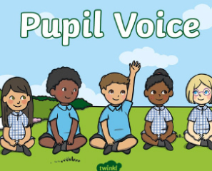
I have really enjoyed singing and dance.

My favourite things are climbing, art and seeing my friends.
Doing Art with Simon. He said mine was great.
I love maths

The Park
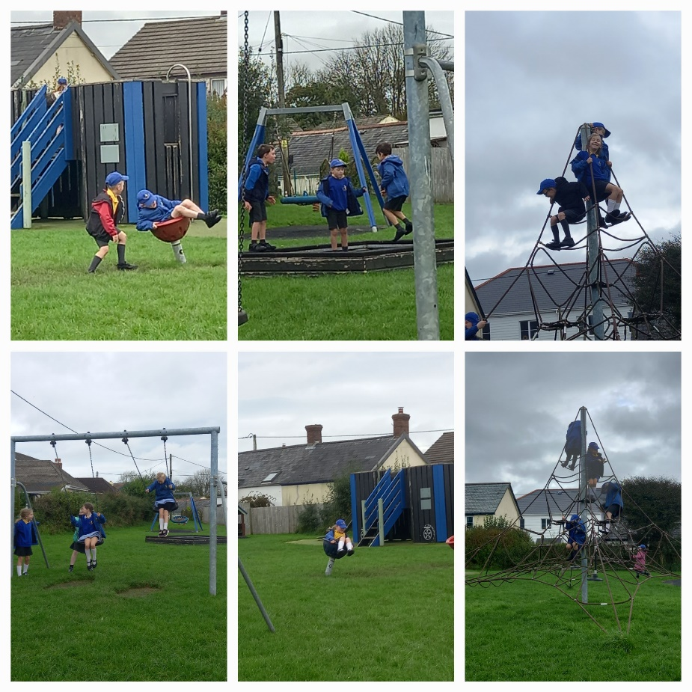
After a busy and hard working week, we ended the week with a trip to the park as a treat!

The class had lots of fun!

Spellings:
Little yellow spelling books will come home today but will need to be back on Monday. Some children left them behind this week so please can they bring them on Monday too as we really need them in school.

18.10.24 | 18.10.24 | 18.10.24 | 18.10.24
Grizzly Bears | Honey Bears | Polar Bears | Panda Bears
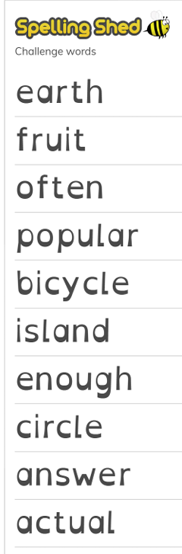 |  | 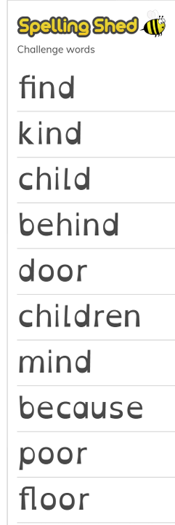 | 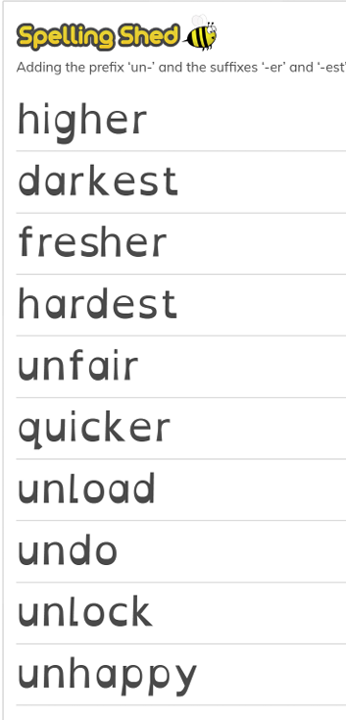
Swimming
Just a reminder that next week we will be swimming on Monday, Tuesday and Thursday mornings. (On Friday, we will going to the beach for our coasts trip to look at coastal defences.)
The week after half term, we will be swimming on Monday, Tuesday, Wednesday and Thursday.
Have a lovely weekend all,
Miss Young x

