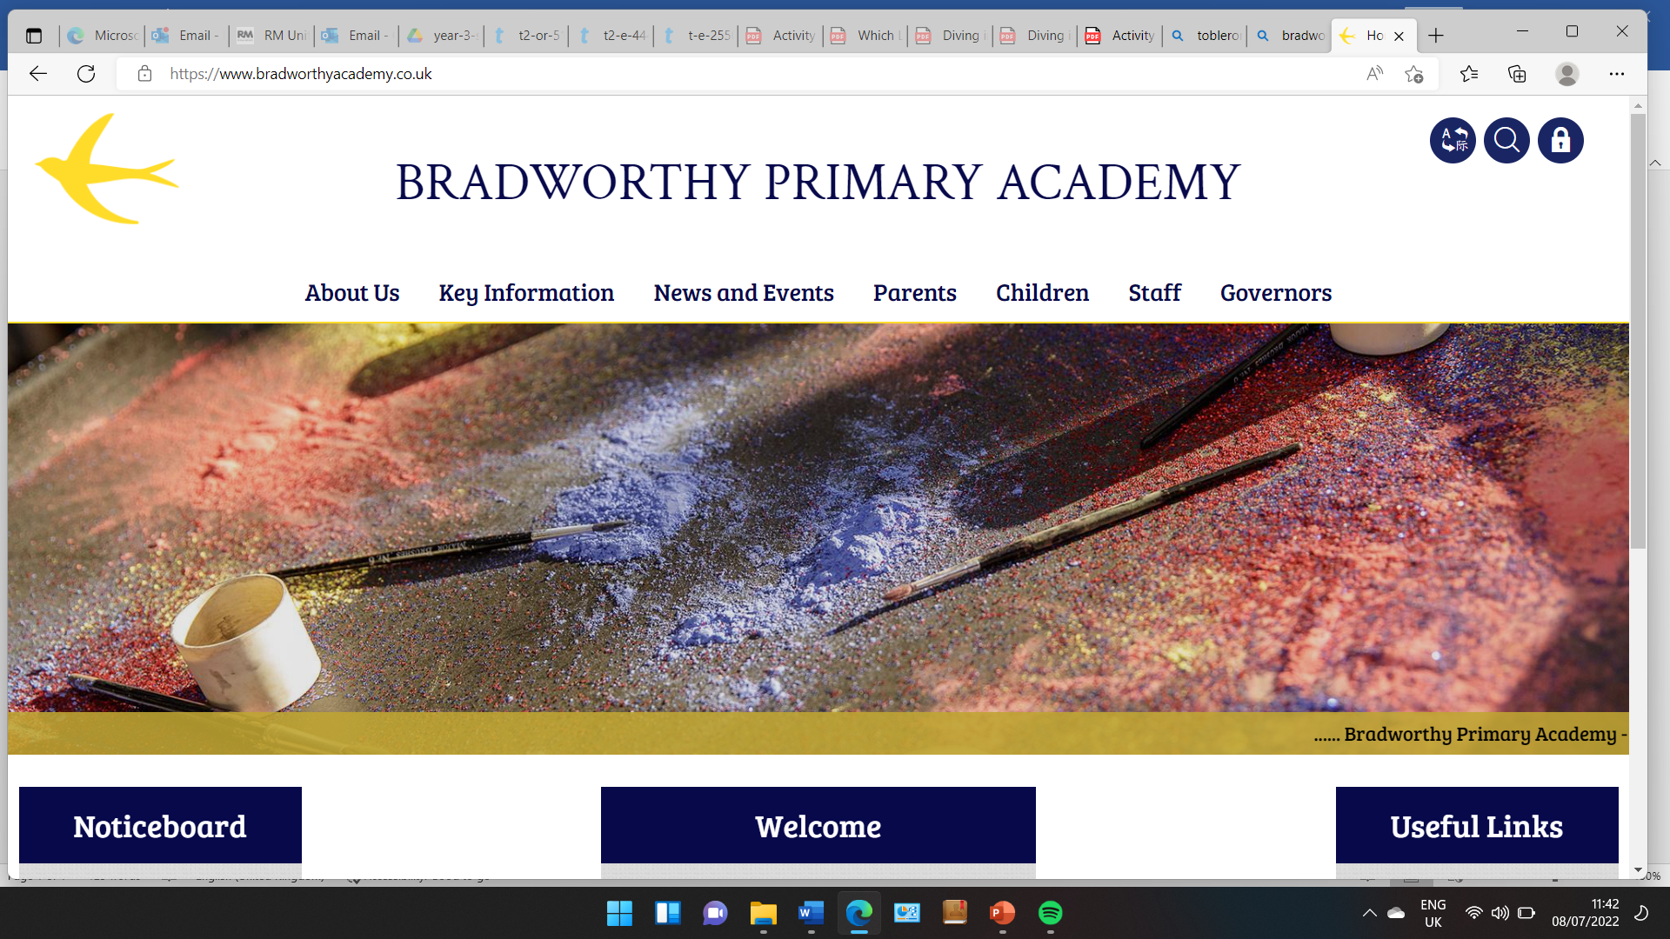
Class 3

Highlights This Week in Class 3
Friday 11th October 2024
Dear All,
English
We have been learning this week how to write non chronological reports. We have been talking about any pets we might have at home, and what we need to look after them. If you have a photo of a pet at home, please send it in and we can use these for our reports next week. Don’t worry if you don’t have a pet at home as we can sort out a photo of animal of their choice.
PE
This Thursday, children had their usual Climbing/Dance session. Some children managed to reach the top of the Year Six wall this week!
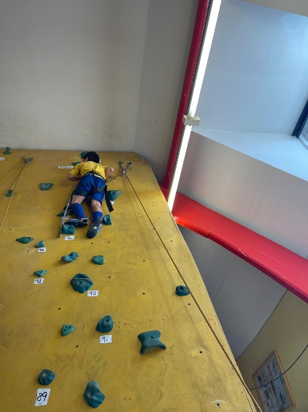
Homework
Thank you to all of you have been encouraging children to practice their times tables and spellings at home. We have been doing the spelling tests in a little yellow book, and left their big orange homework books for practicing in. We will send these yellow books home so that you can see their scores but they must bring them back after the weekend please as we will need them to do their weekly tests.
The new spellings are now on Ed Shed (Thank you Miss Runneckles for showing me how!). The spellings are also below:
11.10.24 | 11.10.24 | 11.10.24 | 11.10.24
Grizzly Bears | Honey Bears | Polar Bears | Panda Bears
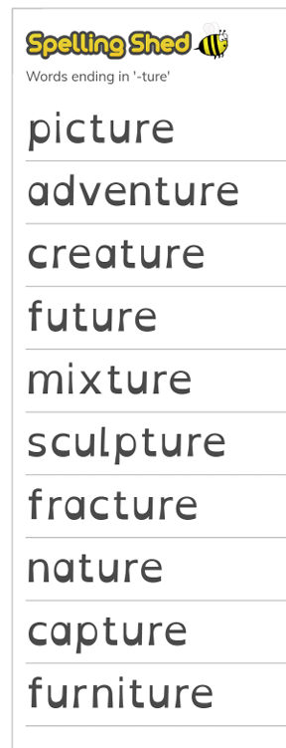 |  | 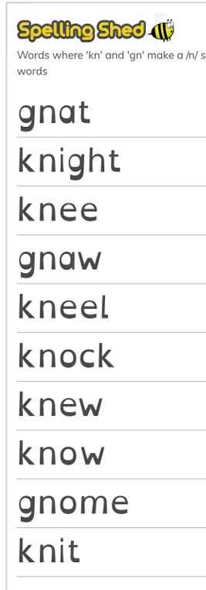 | 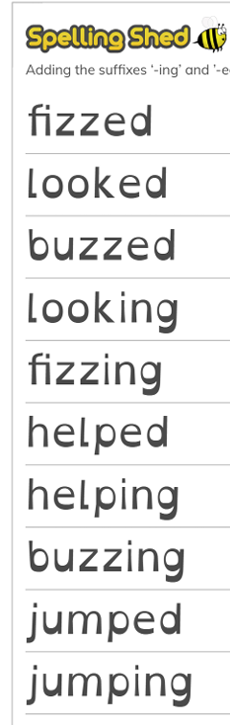

Bake Off
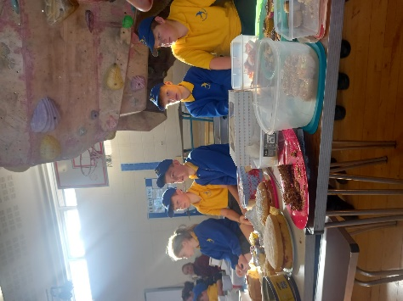
What a feast we have had today! There was an incredible array of bakes – thank you everyone!
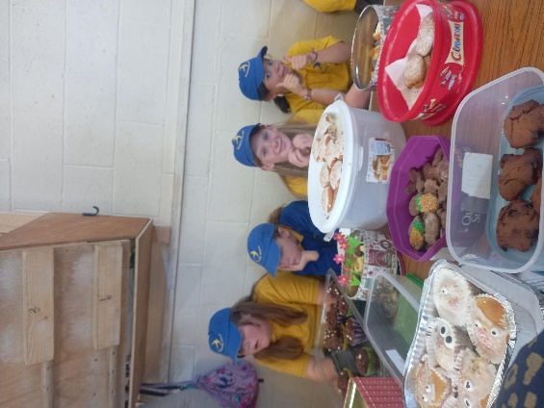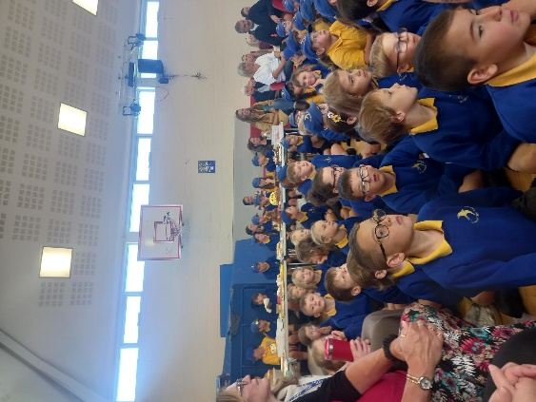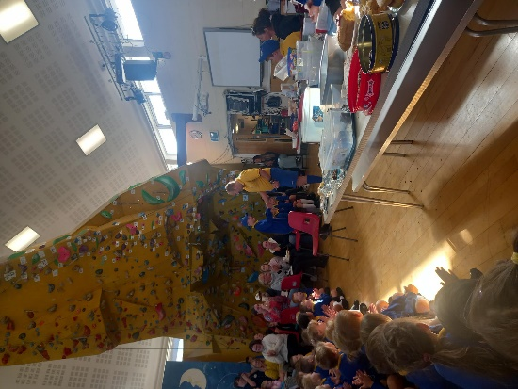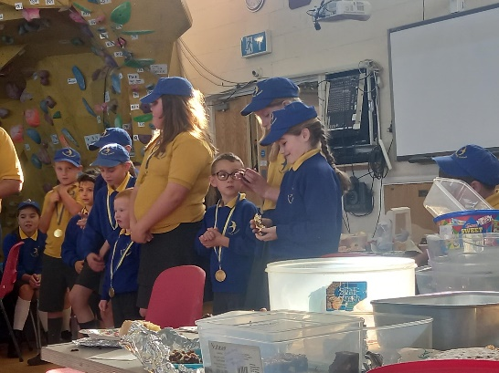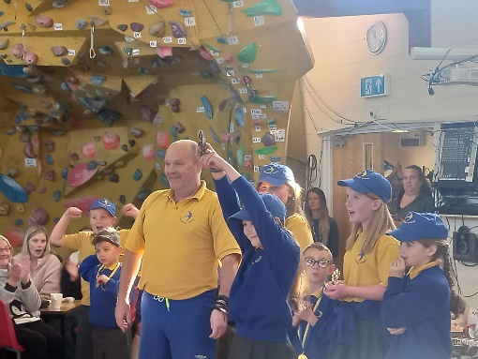

Trips
There are 2 letters coming home about trips to Rosemoor and the beach. Please sign and return.

Please don’t hesitate to get in touch with any queries or messages for us.
Have a wonderful weekend everyone, see you all next week!
Miss Young x

