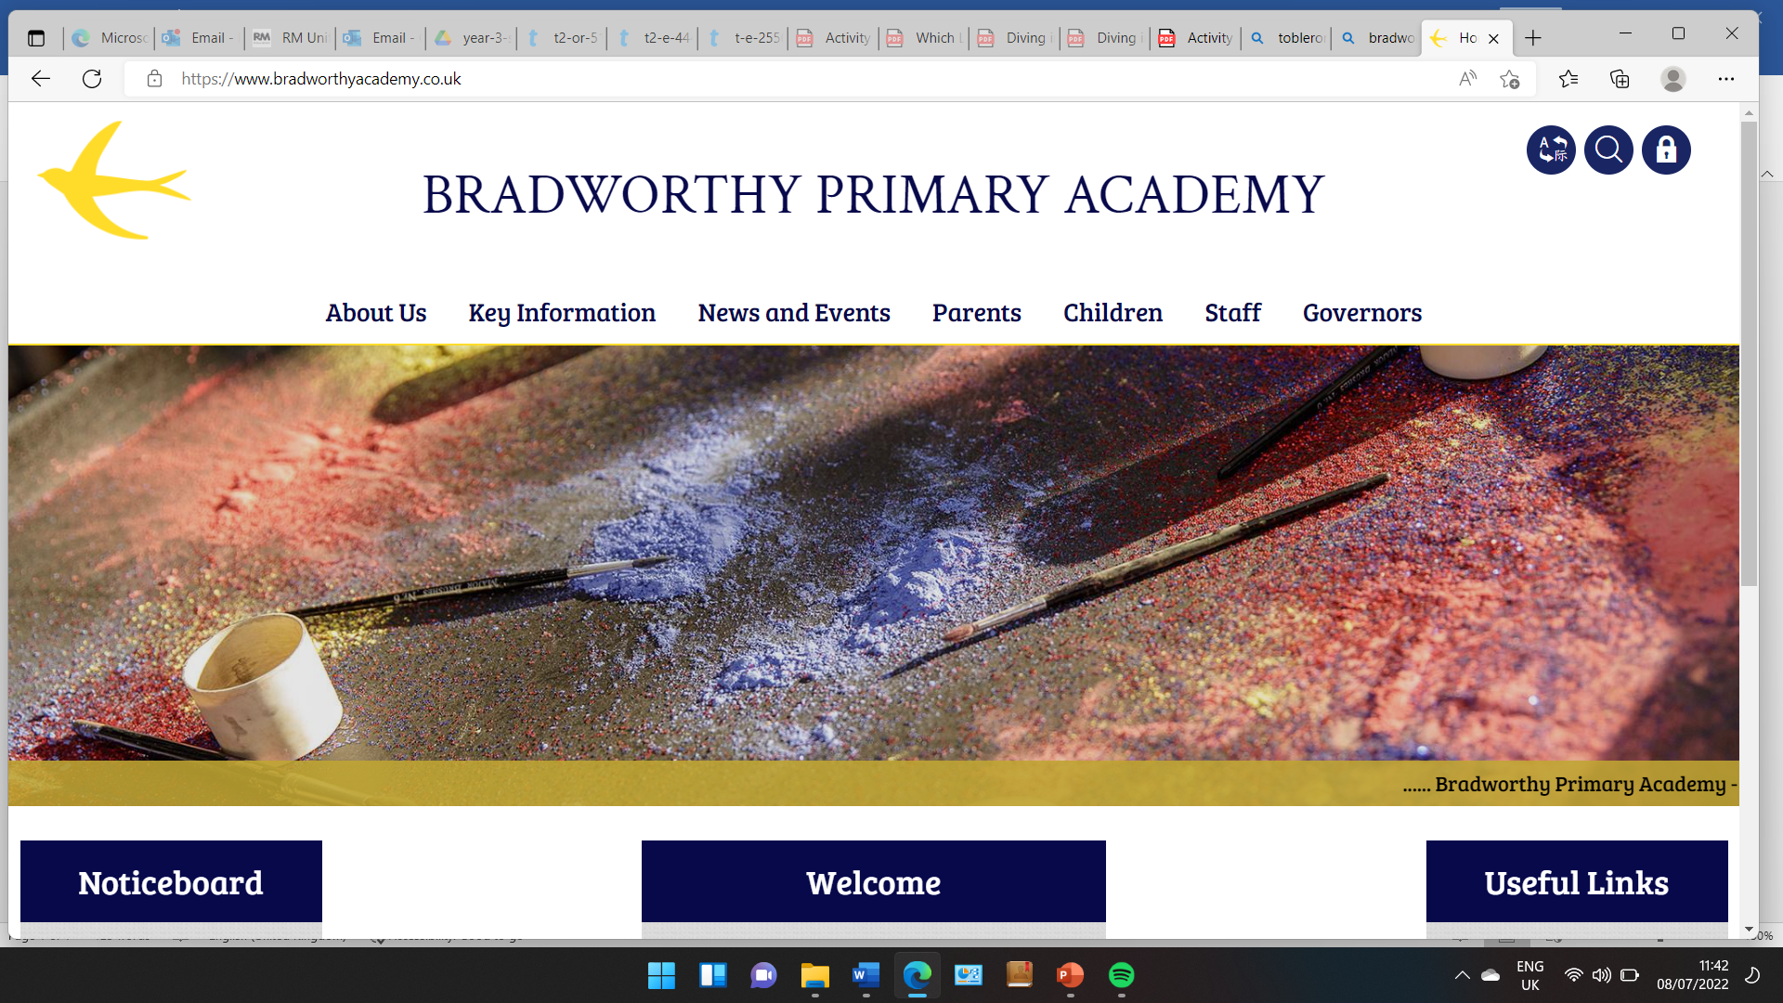
Class 3

Highlights This Week in Class 3
Friday 4th October 2024
Dear All,
We have had another jam packed week in Class 3, which has flown by!
Assembly and Art
On Wednesday afternoon, Class 3 and the rest of the school had an assembly with our new vicar. Class 3 then spent the rest of the afternoon creating their own versions of Matisse painting, cutting and sticking different shapes (sorry I forgot to take photos of these!). They all looked very vibrant - thank you Mr Sentence!
English and Cooking
We have been learning this week, how to write instructions, particularly recipes. We have looked at different texts and highlighted and discussed their features. We played a game on Thursday called ‘Do As I Say’ where we worked in pairs. One person had to give very precise instructions, whilst their partner had to follow the instructions exactly! Here the children are trying to get their partner to put on their jumpers which was easier said than done! We learnt that it was very important to give clear and precise instructions!
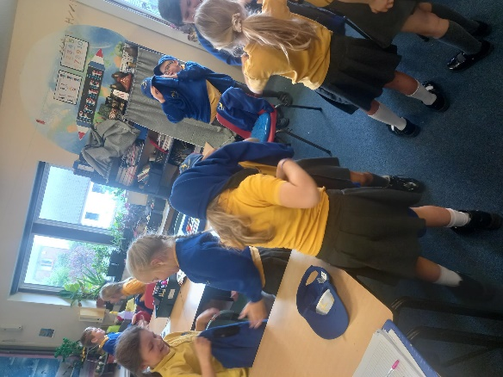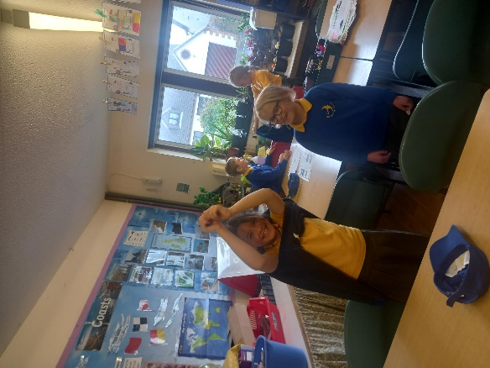
We put our instruction writing into practice by writing a recipe for apple crumble. We then spent Friday morning making apple crumble in groups! We used the apples grown from the school’s apple tree outside of Class 2. Children followed the steps in their writing to make their crumble and then had a rather lovely time in the afternoon eating their creations! As you can imagine, the school smelt amazing all lunchtime whilst the crumbles cooked!
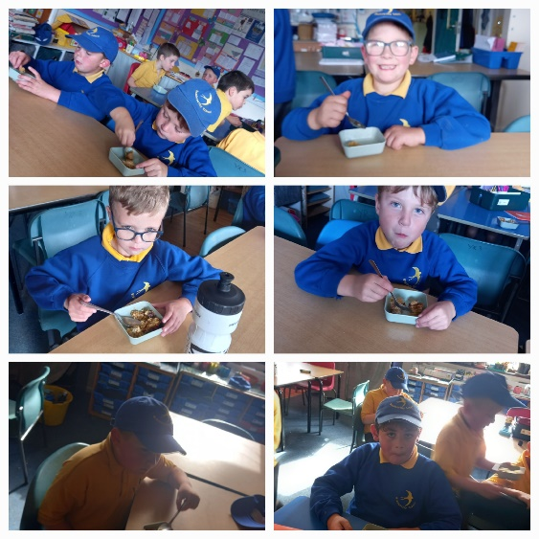
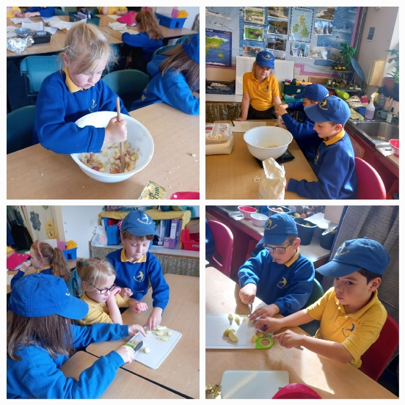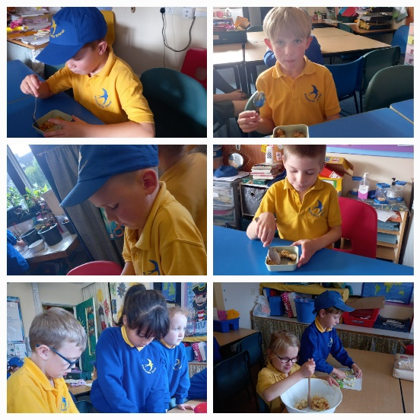
PE
This Thursday, children had their usual Climbing/Dance session. Children are currently climbing every other week, to ensure we can have small groups climbing for an hour with Simon. Some children have been choosing to climb at lunch time too. The children have been practicing bat and ball skills in their PE lessons with Elliot this Thursday and Friday. Lots of fun to be had all round!
A special find!
Otis brought in a special stick that had been chewed by a beaver! He showed it around to the class and we discussed what beavers were, and looked at the dams that they make in rivers. We were fascinated by all the tiny bite marks! Thank you Otis!
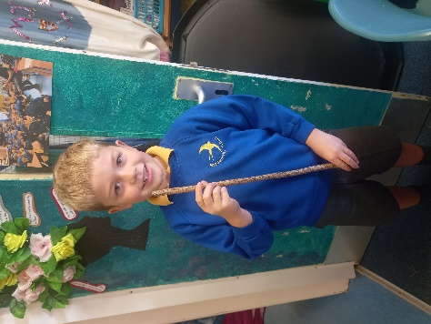

Homework
Fantastic efforts on homework this week, well done class 3! I could see so many spellings and times table practice in their homework books. Thank you for all your support with this. The new spellings are at the end of this newsletter. For some children I have suggested a certain number of spellings to practice in their homework books.
Library Books
The aim is to give children the opportunity to change their library books on a Thursday with Kymble, our librarian. Hopefully children came home with a library book to share with you yesterday.
If children need to change their reading books, they can do this when they come in, in the morning on their own accord.

Please don’t hesitate to get in touch with any queries or messages for us.
Thank you for your continued support, we really value your input.
Have a wonderful weekend everyone, see you all next week!
Miss Young x

4.10.24 | 4.10.24 | 4.10.24 | 4.10.24
Grizzly Bears | Honey Bears | Polar Bears | Panda Bears
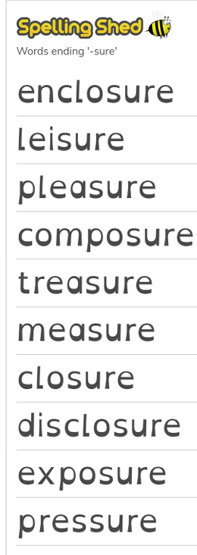 |  | 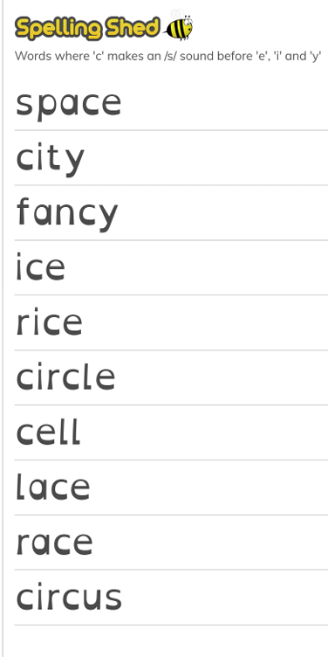 | 

