Class 3 Literacy Lesson: The Boneyard Rap
Aims:
- To play with sounds and actions in a poem
- To explore ways of performing a poem
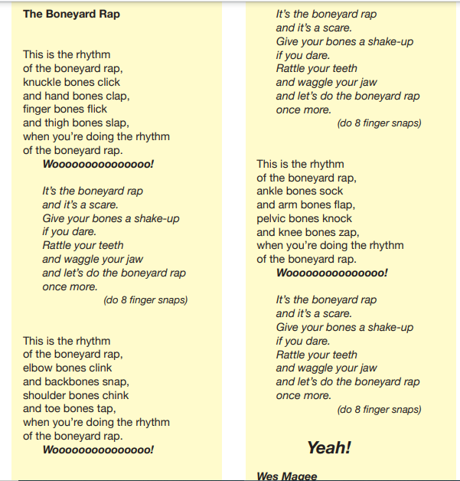

Here is a link the Wes Magee reading his poem, The Boneyard Rap
https://childrens.poetryarchive.org/poem/the-boneyard-rap/
Have a listen to this. You may want to listen several times.
For your activity, I would like you to learn a few lines of the poem, maybe even a whole stanza/verse (like a chunk of writing).
I would also like you to come up with some actions, e.g. clapping, tapping your toes, patting your knees, clicking your fingers, to go with the lines that you learn. You could get a grown up to read it out whilst you do the actions and then join in with your learned lines or you could do the actions to the recording in the link.
You could get a grown up to film you doing the actions too!

