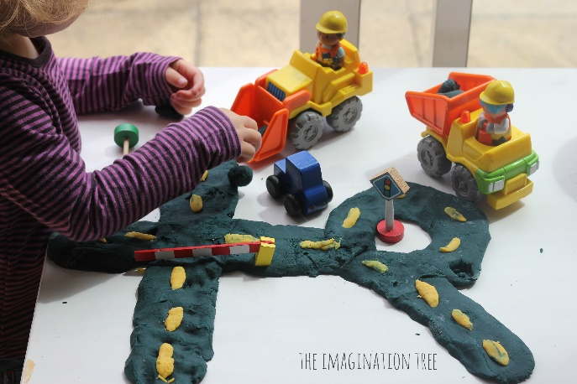
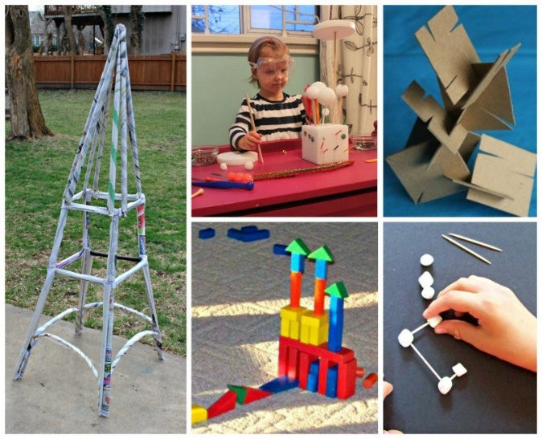
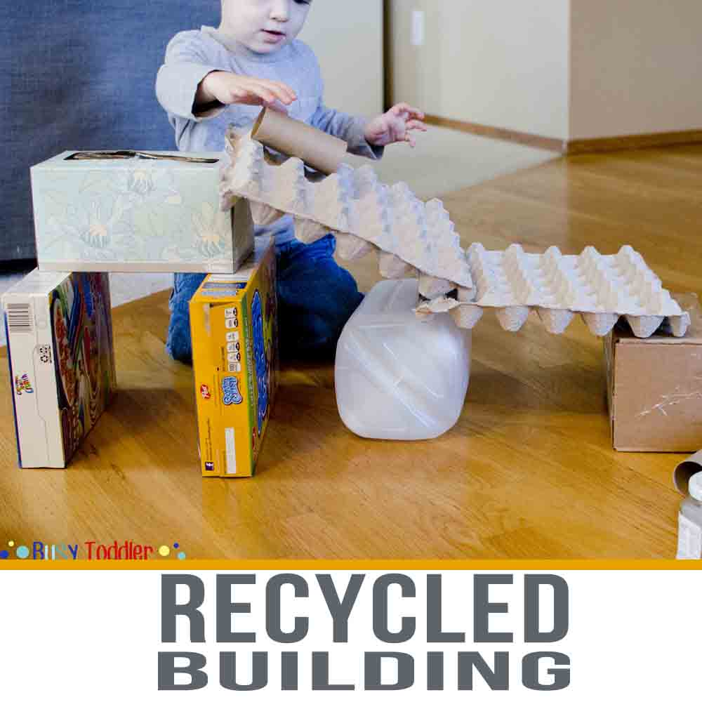

Monday Maths

Your maths lesson for this morning is a practical activity, where you can play around with lots of different shapes using different materials.
You could build a road, a building, a mini bench for a toy you have. The list is endless. Its all about having a play around with different shapes, since you have been learning about them last week.
When you have finished your construction, please write a list of the different shapes you can spot in what you’ve built.
E.g. In that photo of the road made from playdoh, I can see rectangles and a circle for the roundabout.
You can use recycling materials, play doh or building blocks.
Please send us a photo of your creation! Have fun!

