Class 3 Home Learning
Monday 11th January 2021
Hello Class 3!
We hope you had a lovely Christmas and New Year! We’re looking forward to reading about your favourite presents and what you got up to.
Mrs Davies and I have been so proud of all the amazing progress you guys made last term – you really worked so hard. We know it’s really disappointing that we can’t be in school altogether this half term but we will make up for it when we are back in class - we have lots of fun projects planned!

This document lays out the next week and what is expected in terms of home learning. I will upload additional documents of things like worksheets for you to print or have a look at – they wouldn’t fit into this document without jumbling everything up!
This is a long document, but remember, it is a weeks worth of work!
From Tuesday morning, there will be a pack of this document, and worksheets in a folder for each of you to collect, should you wish.
There are a handful of you who have requested packs to be sent home to you and these will be done at the start of the week.
However, for everyone else, you are welcome to come and collect your pack from the play house in the playground at school. Please remember to maintain social distancing when collecting them.

Your Christmas Homework

I know we mentioned in your homework that we would be starting our multiplication and division topic this January. However, with the changes this month and the home learning that will be going on, we have decided to put this unit on hold until you are all back in school. Mrs Davies and I have decided to cover the measurement and shape units this half term, amongst some other lessons.
We also set you a challenge of 20 reads over Christmas….make sure this is all written into your reading record and we will sort out treats when we are back in class – we promise!!
Along with this, you had some spelling homework set. Please can you get a grown up or older sibling at home to test you on your 20 words and let Mrs Davies and I know your scores via email. Thank you!
(Well done to all those of you who have been practicing your spellings over the Christmas holiday on Spelling Shed, I have been really impressed by some awesome scores!!)
This weeks work – Monday 11th – Friday 15th January 2021 (!)
I’m now going to set out your lessons for the week. There is a lot to read, but remember this is your entire weeks’ worth of work.
Reading
We would like you to do 15 minutes of reading per day. This really can be anything, whether it’s a news article, shopping lists, a magazine, comic, story book etc. Please record this in your reading record each day with a signature from a grownup or older sibling.
Your reading challenge for this half term is 25 reads. Once again, make sure these are all written in your reading records with the date and we can then hand out prizes in class once we have counted these up.
Reading Comprehension
We would like you to do a reading comprehension activity once a week, as we did in class in the mornings. You can choose when to do this during the week but I’ve suggested in the weekly plan that it is your Literacy lesson for a Friday.
I will attach a document of your comprehension activity below.
Writing
We will be posting a postcard activity out to you this week for you to complete.
This is one of your writing tasks for the week. The aim is for you to post these back to us and we will display them in class so they are here for you when you come back! Mrs Davies will be coming in near the start of the week to sort this activity out and post it out to you. This may take a few days, so start your story (below) first.
We would also like you to write a story using the photo below as inspiration.
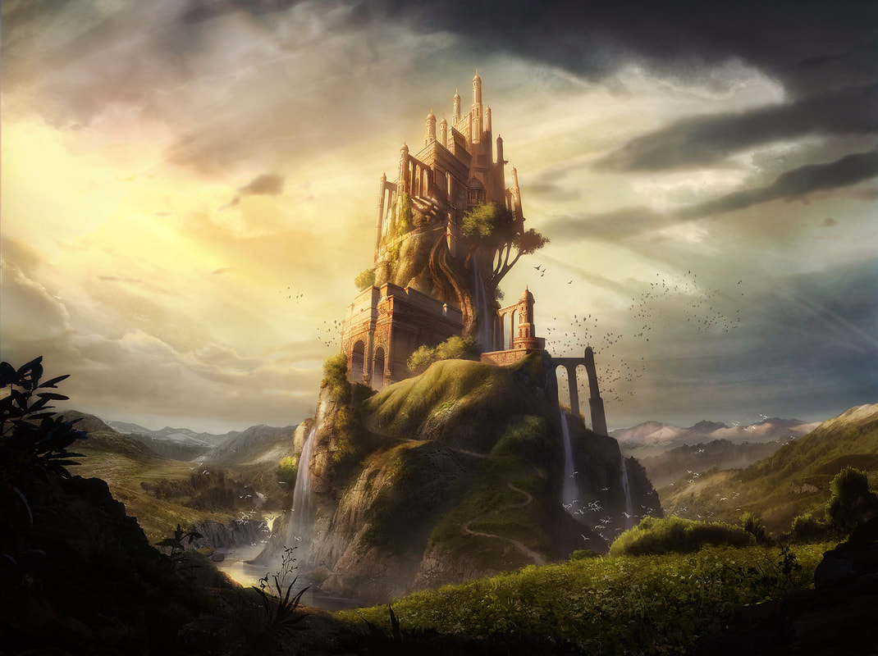
Have a think about who might live here. Could it be a king, or a princess, or a monster hidden away from the world? Is it the most powerful kingdom in the world? Have a think about a problem that could happen in your story. It might help if you come up with a plan before you start. Think about the:
- Beginning (Who are the main characters, where do they live?)
- Build up (What do the characters get up, is there a problem starting to appear?)
- Problem (This is something bad that happens in your story)
- Resolution (How is the problem fixed? By who?)
- Ending (This is how you finish your story. Is it a happy ending? A sad ending? A shocking ending?)

This plan, writing your story and checking and finishing off your story should take you the equivalent of what would take us about 3 lessons in class.
Please can you send us a photo or your story when you have finished – it would be lovely if you drew a picture at the end, maybe of your favourite scene in the story or your favourite character?
Spelling
Your last lesson of the week for Literacy is your spelling lesson. The words are from the spelling shed planning what we have been using in class. I will upload on a separate document, the activities to complete with it.
There are 2 activities to do on there.
Spellings
actual
answer
bicycle
circle
earth
enough
fruit
island
often
popular

Maths
The maths is more structured day by day than your writing. Each day there will be a lesson for you to do. Some will be from the BBC website home learning section and some will be worksheets that I will upload on here.
I will upload a photo of the maths plan for the week below in a separate document
There are some shape lessons and some measuring lessons for you to do.
For each lesson, I have put a mental maths activity for each day for you to focus on. These can be found on EdShed/Maths Shed, under the Number Skills section. https://play.edshed.com/en-gb/number It is best to do these mental maths activities first as a bit of a warm up, just like we do in class.
There is a different mental maths activity for Friday (How many triangles?) which I will upload on a separate document below.

There are some videos on this link on espresso which give you an introduction to measuring. Have a play around on here and check out some different videos before your lessons on measuring (Wednesday, Thursday and Friday)
Espresso: Estimating length 1 and Estimating length 2 videos:
https://central.espresso.co.uk/espresso/modules/m2_measures/length/index.html?source=subject-Maths-Lower%20KS2-Measurement-Videos#
This link will open up a variety of videos, make sure you choose the estimating length 1 and estimating length 2 videos for Friday’s lesson. You can choose a video to watch on Wednesday and Thursday.
Friday’s lesson I will upload below on another document
Monday’s lesson on the BBC website can be found on this link:
https://www.bbc.co.uk/bitesize/articles/zfqt2v4
https://www.bbc.co.uk/bitesize/articles/zdjtjsg

I’ve grouped together 2 lessons here, as the first lesson doesn’t have any activities with it. You can choose one of the two activities from the second link to complete.
Tuesday’s lesson can be found here on this link:
https://www.bbc.co.uk/bitesize/articles/zq6p7yc
You will need a pencil and paper for the activity at the end of the lesson, to see how many 2D shapes you can find around your home.

Science
Your Science topic for this week is LIGHT. Here is the link for this week’s lesson
https://www.bbc.co.uk/bitesize/topics/zbssgk7/articles/z2s4xfr
Your activity to go with it, is to write down a list of 10 light sources you can find at home. As with all your work, please send us a photograph of this to our class email!
Mrs Davies has said also that there is an Operation Ouch on BBC at 11.35-12.05pm on Monday if you would like to watch this you can. It was part of your last Science topic with Mrs Davies so may be an interesting watch!

Topic
Mrs Davies and I will set you a country to research each week. Your activity is to create a poster each week on the set country. Again, please send us a photo of your work, we can’t wait to see what you create!
This week your country is MADAGASCAR

Coding – Scratch
Most of you will be using a tablet or laptop etc to access some of the home learning so that will be good practice for you all, navigating around a screen. I would also like you to have a go at using Scratch, an online program that introduces you to Coding.
https://scratch.mit.edu/projects/editor/?tutorial=getStarted
I haven’t sorted log ins yet, but will look into this, this week. For now, you can create a program on here without having a log on. So have a play around.
If you click on the link at the top of the page which says ‘Tutorials’, it will give you some instructions on how to start using the program. For this week, just have fun playing around with it!
Art
Piet Mondrian
This week, since we will be using rulers for our measuring activity, I thought it would be nice if we practiced a piece of art involving straight lines. If you have a look at the link below, you will see the type of pictures I’m thinking of.
https://www.tate.org.uk/kids/explore/who-is/who-piet-mondrian
I thought it would be really nice if we did something like this:
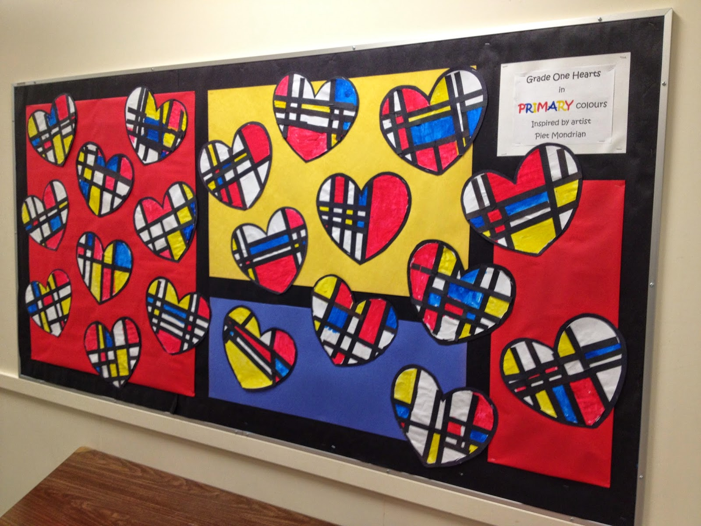
You could either do your art onto an A4 page and then cut it into a heart when you’ve finished, or do it straight onto a heart shaped piece of paper.
You will want to use primary colours, yellow, red and blue, as in this photo. You can use black tape, or just black pen or paint for the lines. Don’t forget to leave some of the spaces blank, so that they are white.
We would love to see photos of your art work. We will either print them off, or if this doesn’t quite work, hold onto them and when we are back at school, we can display them in class.

Health and Wellbeing
We would like to set an activity each week to do with our well being and keeping positive.
I think it’s safe to say that the past year and the start to this year hasn’t been the easiest time for any of us. It’s okay to feel a bit down in the dumps sometimes and there is a lot going on at the moment that is different to what we are used to. It’s rubbish that we can’t all be together in our class this half term, but it’s important we try to make the best of the situation we are in.
Your activity this week is to create your own ‘gratitude’ or ‘thankful’ jar.
I will upload this activity on a separate document
Keep an eye out for a spare jam jar or a tub for you to turn into your gratitude or thankful jar. Then everyday, I would like you to write on a tiny piece of paper, something that you are grateful for and pop it into your jar. The more you start noticing the good things that are happening in your life, the easier it is to keep positive. It may be that your sister let you borrow her toy and that made you feel grateful or thankful. I would like this activity to continue throughout the next month or so and hope it will give us some positive thinking time!
Please email us on the class email if you want to chat or need some help (Parents and Class 3 children) We really are all in this together and we are here to listen and help where we can.

French and Music
I’ve been setting all this home school work over this past week/weekend so that it’s ready to upload on Monday. I won’t be able to upload your Music or French learning for Monday when I upload all of this. However, Mrs Davies and I will be sorting out log ins etc. throughout the next week so we can do some of this from next week onwards.
(On the note of music…I always find a dance and sing along to my favourite song at home is a great pick me up if I’m feeling a bit sad! Eden and Finley and I spend hours dancing to the Disney channel on Youtube!! So, when you feel like you need cheering up, why don’t you ask a grown up to pop on your favourite song to sing and dance to! )
PE
Last but not least, please make sure you are doing some daily exercising. This could be a Joe Wicks workout or a walk or run. It really does such a lot of good for keeping a positive frame of mind and it’s important to try and look after ourselves.

We would like to hear from you all at least once a week, either via the class webpage, blog or email.

Well….I think that’s all! This is all new to Mrs Davies and I but we’re learning quickly and hope we haven’t forgotten too much!
Please remember, any problems let us know via the email or the blog or class page. Mrs Davies is on duty on Tuesday in school and I am on duty on the Thursday so these days we will try our best to get back to you amongst teaching the key workers in school. The other days will be as usual, Mrs Davies on the laptop on the Monday and I will be available on Wednesday and Friday.
Take care everyone!
Mrs Musson xx

