Class Four Home Learning
Week beginning Monday 11th January 2020
Hello everyone. Here is your home learning activities for the week ahead. Please do not rush to get this all completed in one day. I’ve tried to make sure you have enough to last at least 3 to 5 hours per day so please stick to the plan for each day.
Maths
As we are going to be off until at least half term, I have decided to split the 5 weeks up into a mixture of revision of the work that we have already done in school last term and some new units of work for you to learn at home based on shape and measurement. I know that I said in school we would be doing fractions that half term but I will save that unit for when we are back in school together.

Monday
Please follow this link to the BBC lesson on comparing numbers. There are 6 slides to learn from and 2 activities available. Please complete at least activity one but you can do both if you want to.
https://www.bbc.co.uk/bitesize/articles/zhpq7nb
There is also a short video here to watch from White Rose to help with this lesson if you want to watch it.
Numbers to 1000
https://whiterosemaths.com/homelearning/year-4/week-1/
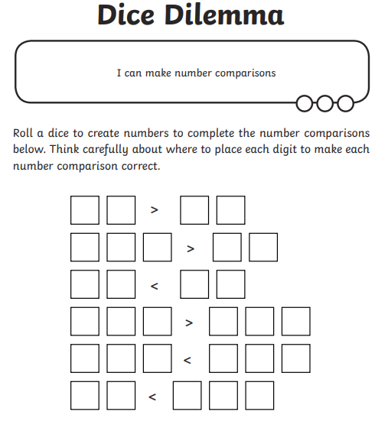

Tuesday
Please follow this link to the second lesson on numbers to 1000. This time it is ordering numbers to 1000. Please complete the quiz and have a look at the learn section. You then need to complete the following questions please.
Ordering numbers - Year 4 - P5 - Maths - Catch Up Lessons - Home Learning with BBC Bitesize - BBC Bitesize
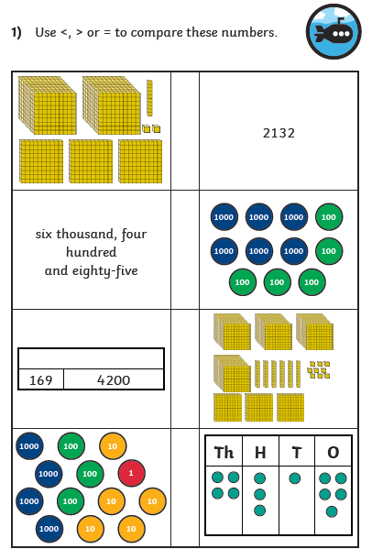

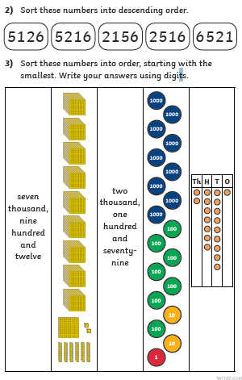

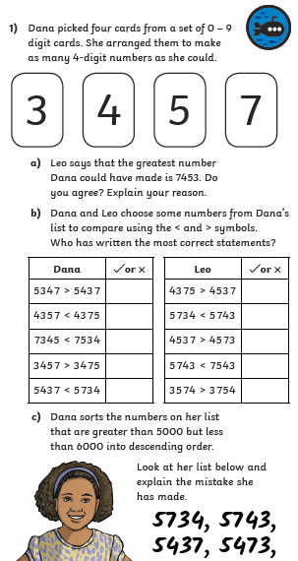

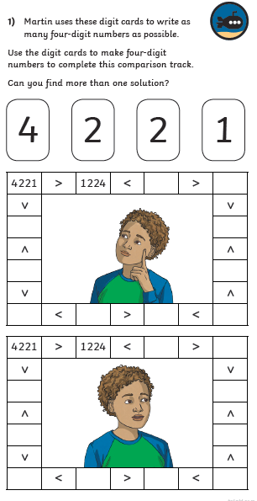Wednesday
The rest of the week we will be looking at converting between different units of measure and the work for these days is in your work pack.
Today you will be working on converting units of work. Please read the ‘Lets Learn’ sheet and complete the guided activities. Then you need to complete the worksheet.

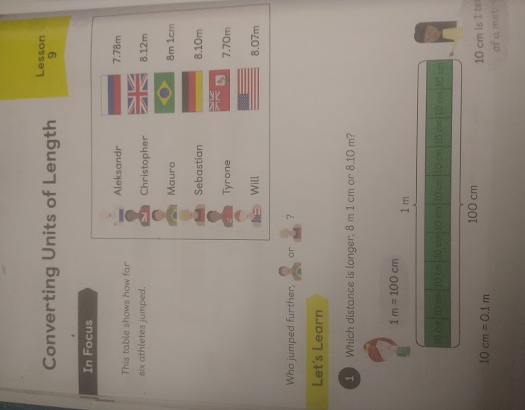
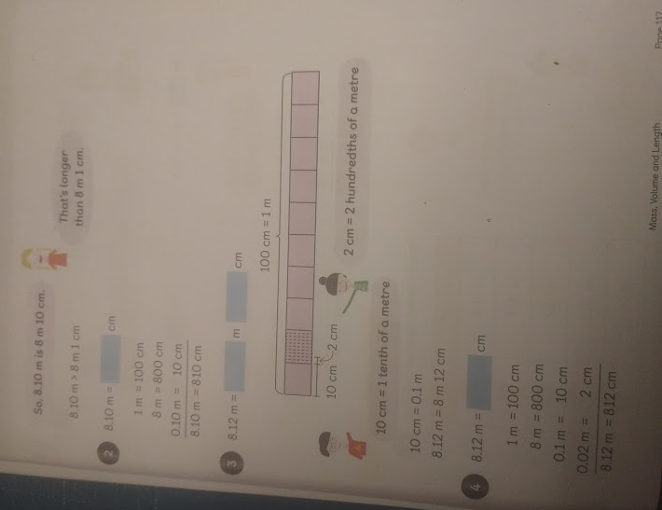
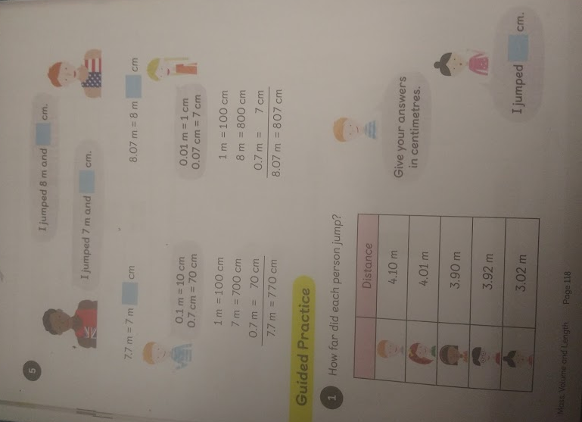
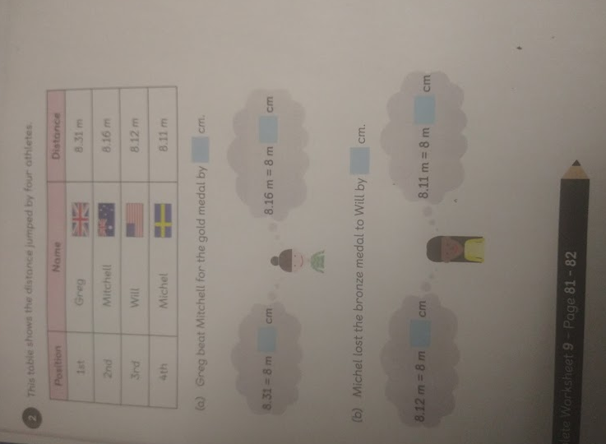
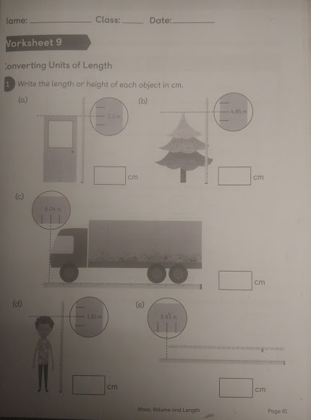
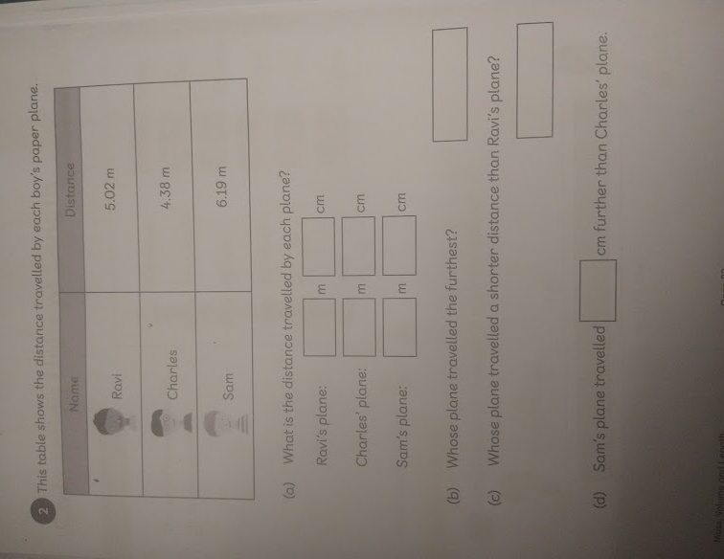
Thursday.
Today you are working on converting units of measure. Please find the sheets in your work pack. You need to read through the ‘Lets Learn’ bit and complete the guided activity. There are 2 worksheets for todays lesson. Please complete all of the first one titled ‘Converting Units of Length’. Then you need to work through the second one from our Busy Ants text books that we use in class. Please complete at least challenge one.

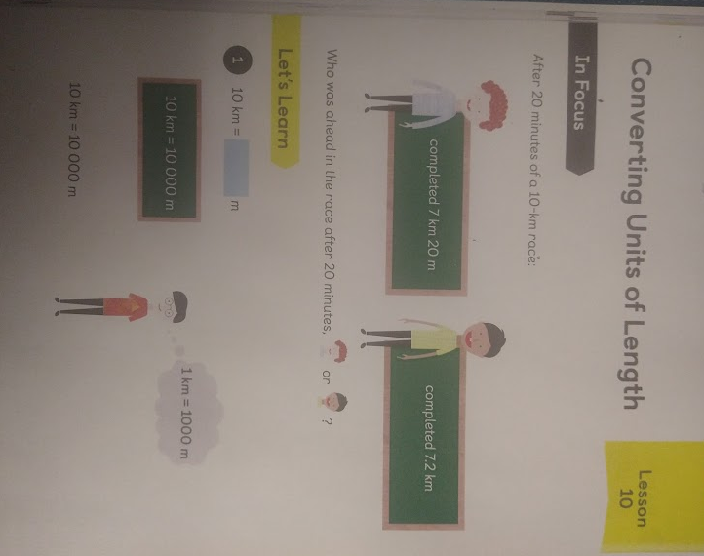
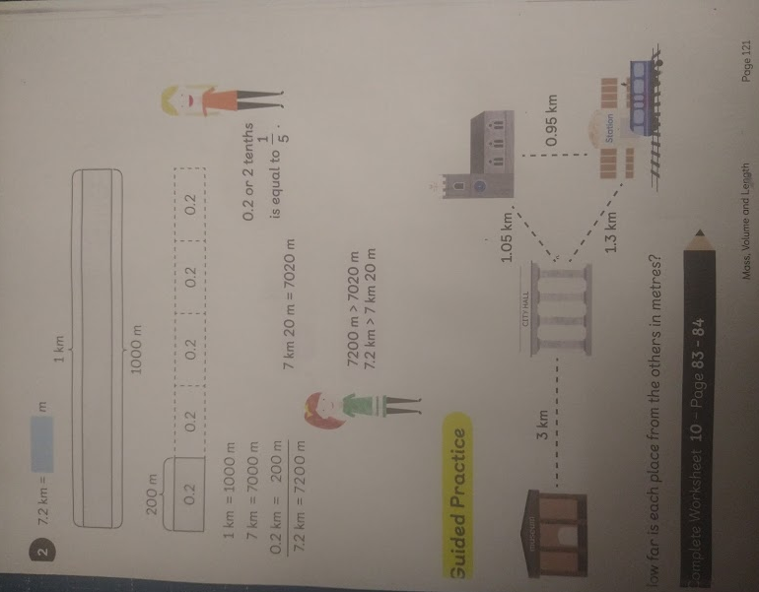
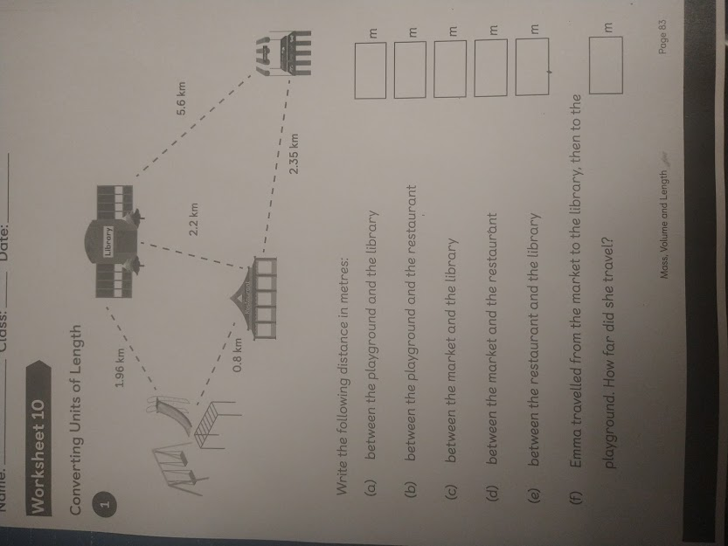
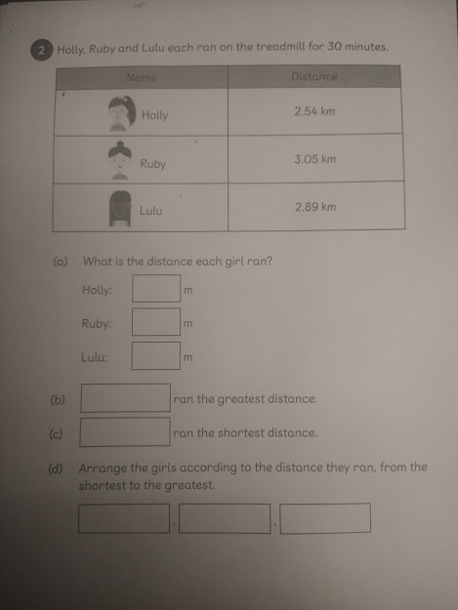
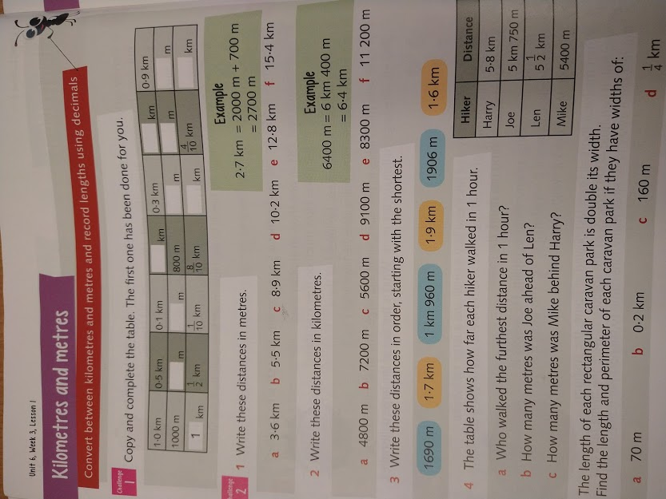
Friday
Today you need to log onto Espresso and complete the activities on converting measure. Please follow this link.
https://central.espresso.co.uk/espresso/modules/m2_measures/activities/converting.html
Once you have worked through these, there is another Busy Ants worksheet for you to complete titled DIY measurements. Please complete at least challenge one and two but you can do challenge 3 as well.

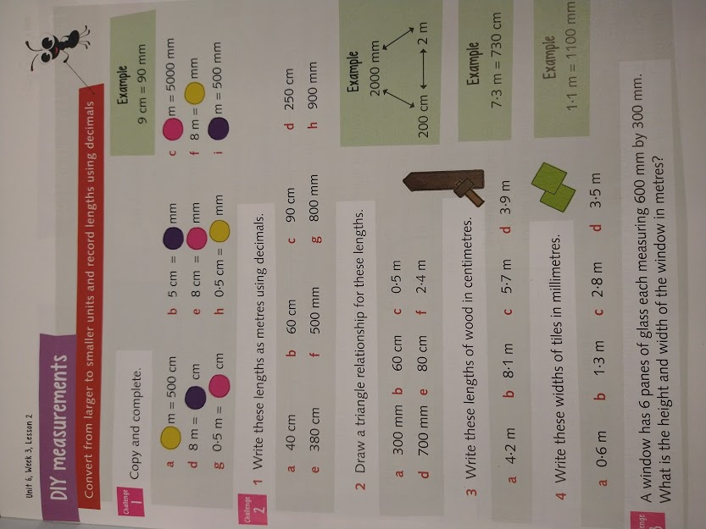
Literacy
Monday– Fronted Adverbials
Please see BBC lesson https://www.bbc.co.uk/bitesize/articles/z62ckmn
Please work through the activities on Fronted Adverbials. There are 4 to complete. As an extension you could see if you can find 5 fronted adverbials in your reading book.

Here is activity 2, 3 and 4 from the lesson.
Activity 2 -
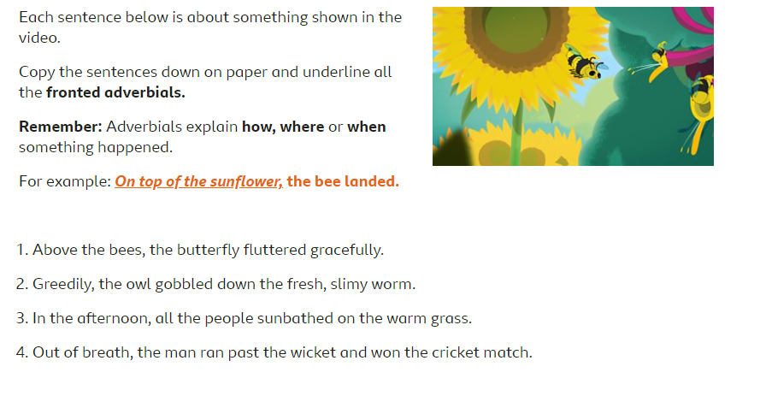

Activity 3 –
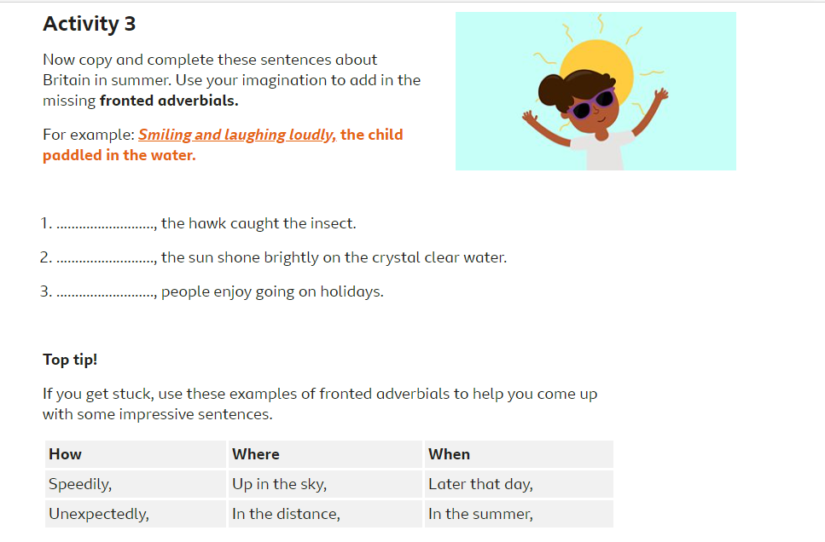

Activity 4 –
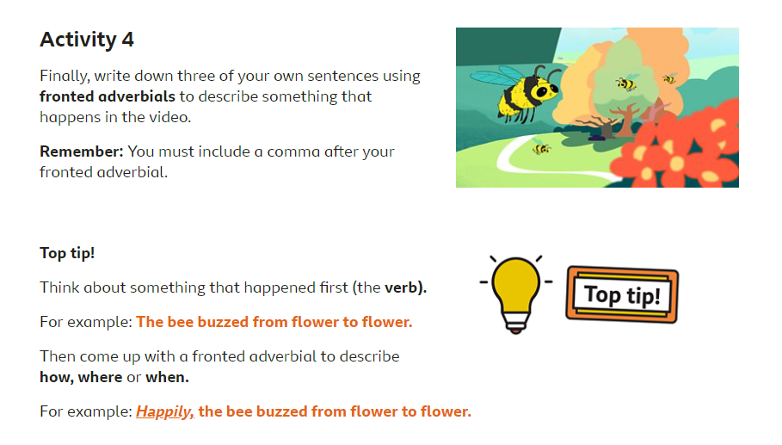

Tuesday – Spelling
usually
finally
beautifully
thoughtfully
wonderfully
carefully
faithfully
peacefully
cruelly
generally

Please see your work pack for 3 worksheets to complete for these spellings.

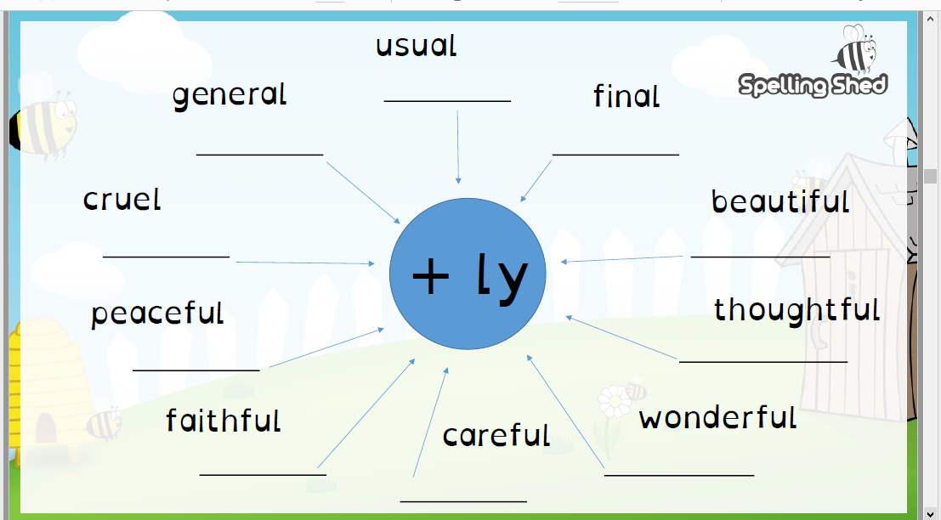
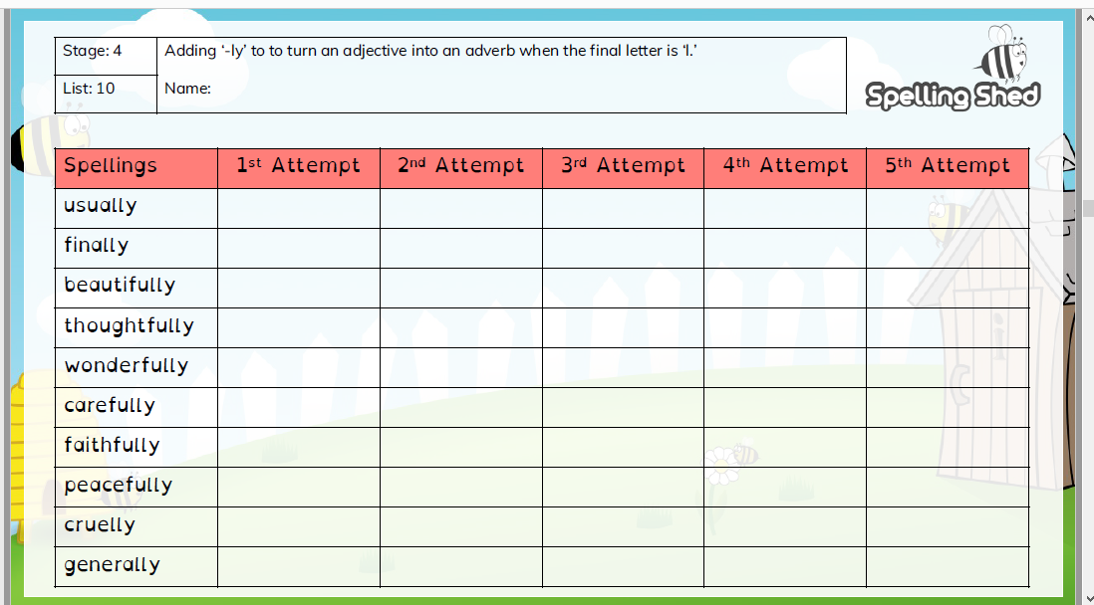
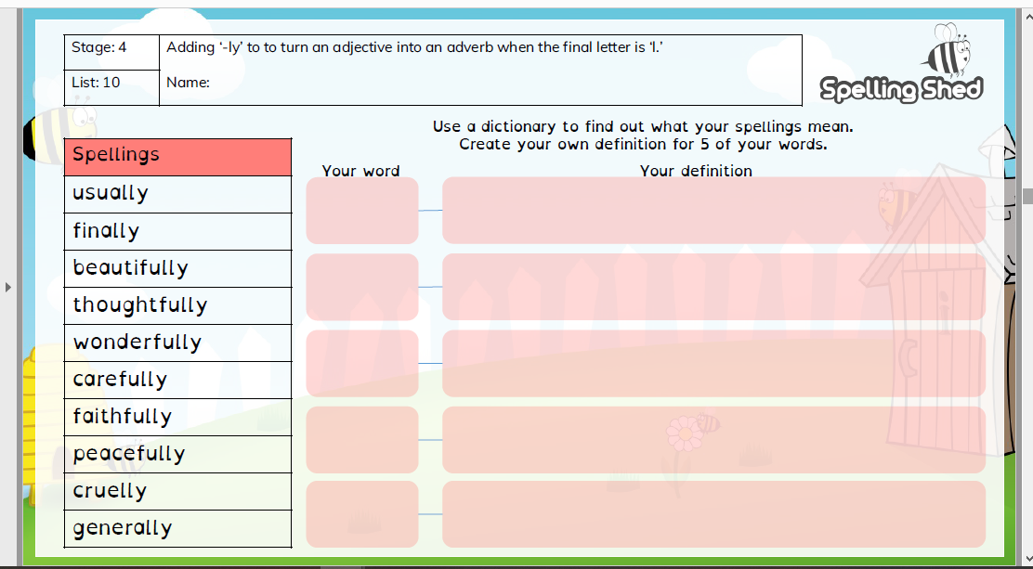
Wednesday/ Thursday/ Friday – Recount
(This will take 2 or 3 days to complete)
Please complete this BBC lesson about writing a recount. For activity 3, please write a one page recount about your Christmas holidays.

Https://www.bbc.co.uk/bitesize/articles/zkpvbdm
Activity 1-
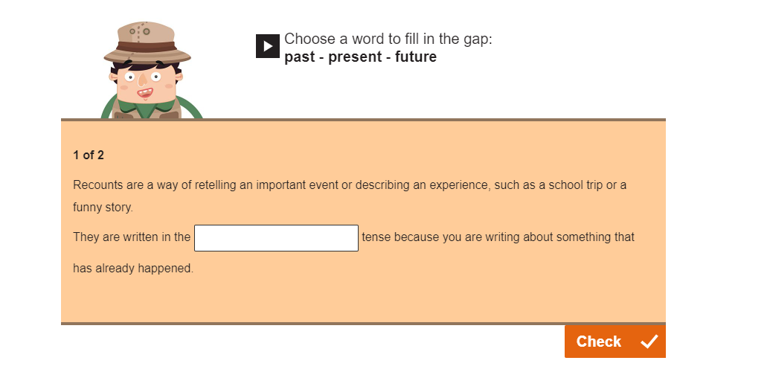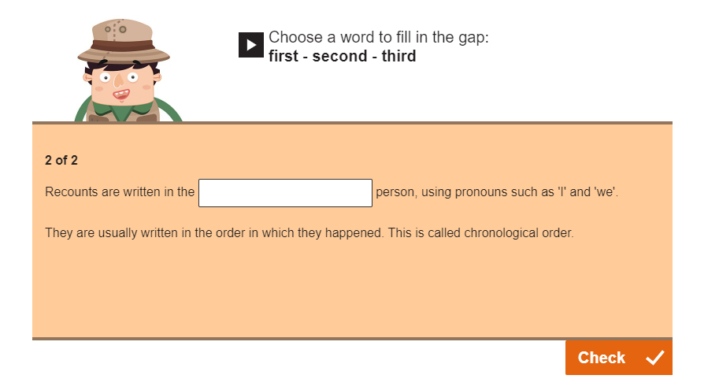

Activity 2 –
You need to watch the video for this activity.
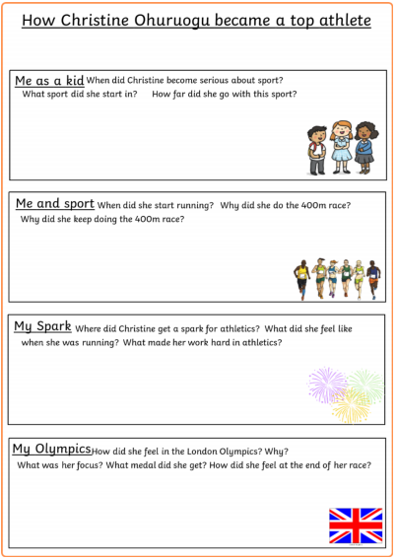

Activity 3 –
You need to write a recount about your Christmas holidays. This should be at least one page long and include paragraphs.
This will take a couple of days and you need to make sure that you make a plan before you write it and then go back through and check/improve your work when you finish.
Don’t forget to check that your writing makes sense –
Is your punctuation correct?
Have you missed out any full stops or commas?
Have you checked your spellings?
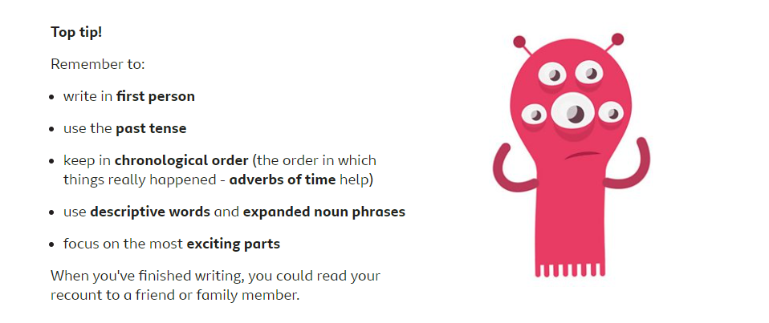

Reading
Please continue to read for 15 minutes per day and make sure you are writing that in your reading records to count towards your signatures. If you reach, or have reached, a certificate number (50, 100, 150, or 250) please let me know and I can arrange a certificate for you.
I will be posting some reading challenges/activities on the blog for you throughout the week.
Here is a reading comprehension for you to complete at some point this week please.

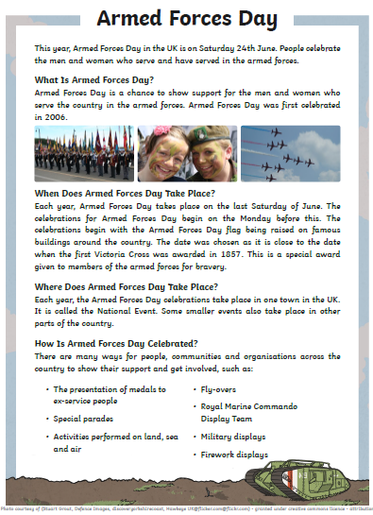
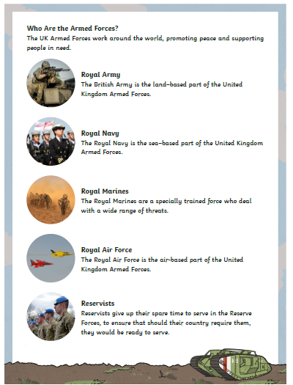

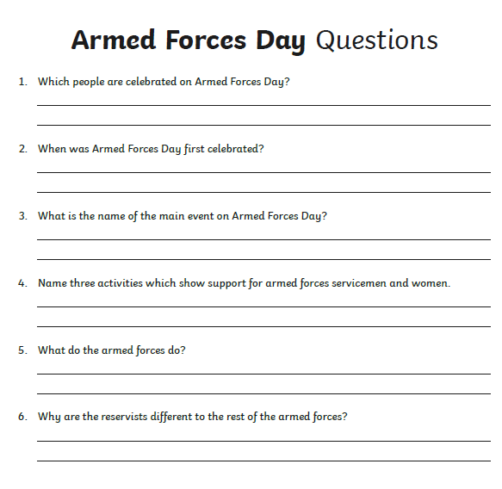

Topic
I know that you were expecting to be doing the war topic this term however, I was really looking forward to doing this is class with you and I think it will be best to change things around and save this for the summer term when, hopefully, we can do it together at school.
This term we will be working on a joint history project with the Year Five and Sixes. We will be looking at a different historical ‘topic’ every week for you to research.
This week we will be looking at Ancient Egypt.
I am going to attach the worksheets for you to complete each day to research this topic properly. At the end of the week, you could use your research to create a poster about the topic.
Here is the research for you to complete each day:
Monday – Who – key people from Ancient Egypt
Tuesday – What – What was life like at the time?
Wednesday – Where – Key locations from Ancient Egypt
Thursday – When – Timeline of key events through this period of time.
Friday – Why – Why were they important – (why do we remember this period of time?)

Please see the following worksheets to complete each day:

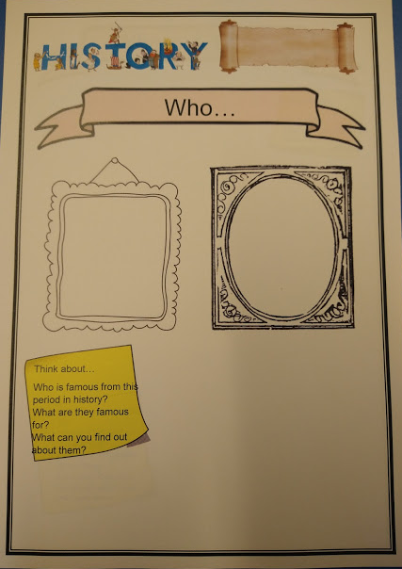
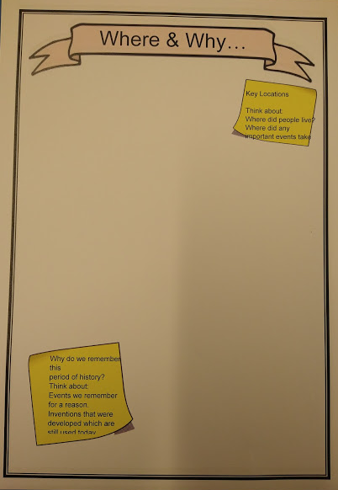
D
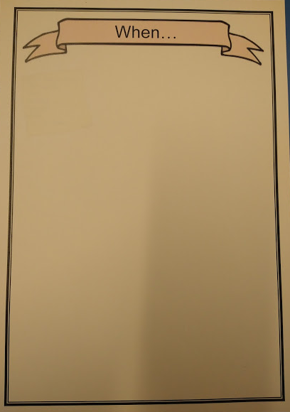
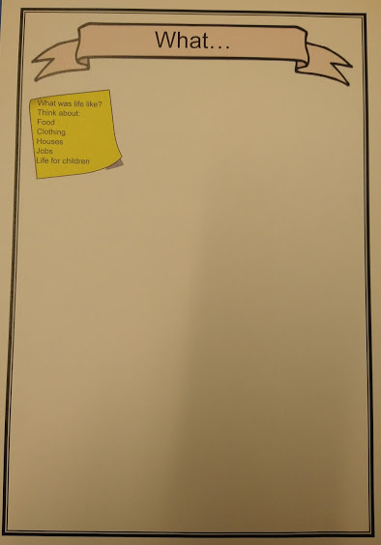
Science
This half term we are looking at ‘Living Things and Their Habitats’.
This week we are looking at classifying animals.
Please head over to Espresso and watch this video about The Key to Classification.
https://central.espresso.co.uk/espresso/primary_uk/subject/module/video/item638078/grade2/module622509/index.html

You can then complete these worksheets.

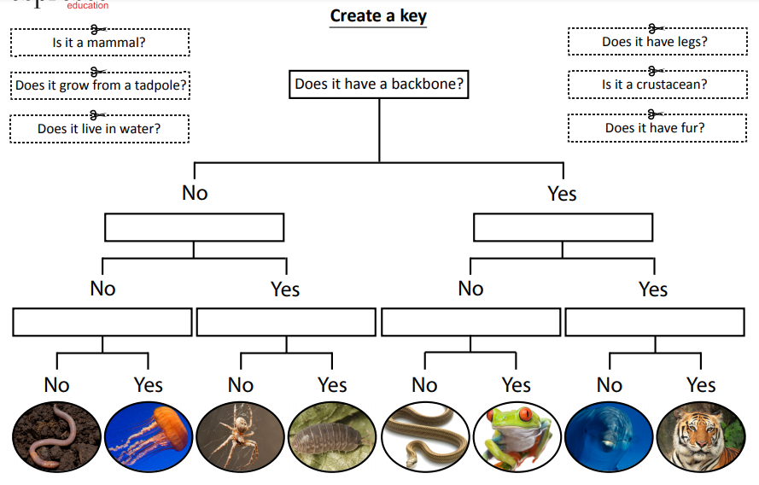
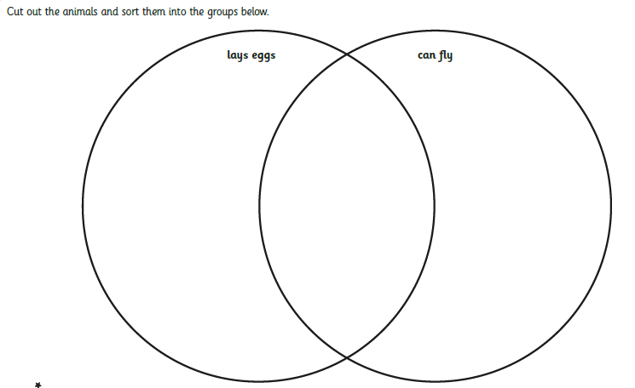
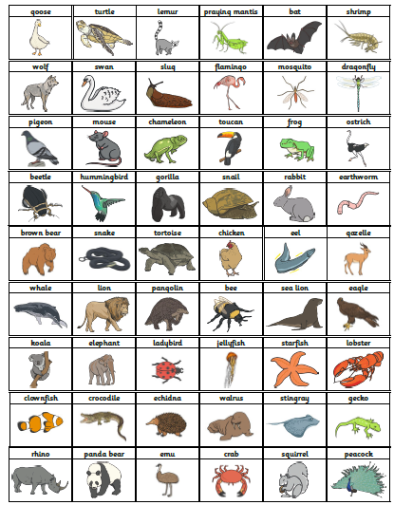
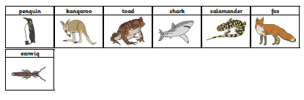
Art
This week I would like you to draw an A4 size picture of either a character from the book you are currently reading or a character from a book you like. Please email me a picture of them so that I can upload them to the class page.

