Bradworthy Primary Academy
October Newsletter 2025
Hello everyone,
I hope you are all well and haven’t found it too difficult to get yourselves back into the school routine. The children certainly seem to be back in the swing of it here in school!
We’ve already been out on plenty of day trips which you will read about later, all of our after-school clubs are underway and it is excellent to see them being so well attended as always.
Attendance and Holidays
Firstly, thank you!
Once again, our attendance figures were well above the national averages last year which makes our jobs in school much easier – Bradworthy 95% compared to 93% nationally
We’ve had a few people asking about holidays in term time over the past few weeks so here is where we stand with holidays/absences in term time moving forwards………
In the past we have always said how beneficial things like holidays in term time can be and how this can provide valuable family time and learning opportunities outside the classroom. Unfortunately, we are finding ourselves under increased pressure from the government to clamp down on this and issue fines. As such you will find a letter attached to the end of this newsletter which we are now required to send out twice a year.
We have been taking our time to consider our options regarding holidays/absences in term time and after recent review, our governors have concluded that whilst we appreciate how beneficial things like holidays can be, we are now in a position where we are unable to authorise any requests for absence unless there is an ‘exceptional circumstance.’ Please note that it is not our intention to issue fines for unauthorised absences unless your child’s attendance is below the national average. This will be considered on an individual basis.
In short:
You can still go on holiday, however we aren’t going to be able to authorise it and, as long as attendance is good enough, you won’t get fined!
Parents Evenings
We will be holding parent meetings after school on the evenings of Tuesday 21st and Wednesday 22nd October.

These will provide an opportunity for you to chat with your child’s teacher about how your child has settled in to their new class and discuss any concerns that you might have. Please note that we will be holding another set of meetings later in the spring term when the teachers will be able to talk about things like academic progress in more detail.

These coming meetings will be reasonably short in nature (no more than ten minutes per appointment), however we are quite happy to talk at greater length if you wish. If this is the case, we would ask that you get in touch so we can sort something out, possibly on another occasion, so that we don’t end up running very late and keeping people waiting unnecessarily.

We will be using an online booking system this year to book appointments. If you would like to make an appointment, please open the email from primary site when it comes titled ‘Invite to event’ and click on the button ‘book my time slot’. Each class will be sent two emails of invitation. One will be for appointments on Tuesday night and the other for appointments on Wednesday night and slots are booked on a first come first served basis.
If you need any help booking an appointment, please ring the office and we will be able to help you.
Bake-Off
Next Friday the 10th October be will be holding 2025’s Great Bradworthy Bake Off, arguably one of the best events on our calendar.
Once again, we will also be raising money for an important charity - Macmillan Cancer Research.
Children from across the school are invited to bake cakes, biscuits or savoury creations – choosing from the following categories.
- Chocolate
- Chocolate Brownies and other Individual Cakes
- Savoury
- Free From
- Citrus
- Biscuit
- Fruit and Vegetable

- All Categories – Best Decorated

Children are welcome to enter as many categories as they wish - We will be asking for a 50p donation for every entry.

On the morning of the competition all entries will need to be taken into the school hall where we will have staff showing you where to put them.

From 11.00am we will be inviting parents to join us to enjoy a cup of tea or coffee and a piece of cake while we announce the winners and give out trophies and medals.

Children will also be asked to bring in a few pence to buy cakes (something like 30p per cake) which they can eat at break time and if there are enough left they may well be lucky enough to have an afternoon treat as well.

This has always been a wonderful occasion and we hope that as many children as possible will enter, and that as many parents, grandparents, etc will join us on the day.

Harvest Festival
We will be walking down to the church at 2pm on Wednesday 15th October for Harvest Festival and it would be brilliant if as many of you as possible were able to join us.
Children across the school have started to learn songs and our older children in the rock band are also preparing a couple numbers. I’m sure it will be a great event.
This year we will be adding a 'Harvest Offering' to the service where each class will donate a box of non-perishable food items to both the Holsworthy Food Bank and the St John Food Box. If you are able to send your child/ren in with something to donate that would be greatly appreciated thank you. We will be collecting these in a box in each class from Monday 13th October.

Curriculum
As I’m sure you already know, our school is driven by our ethos and all of staff are very much invested into it. Obviously, a big part of this is providing children with a wealth of experiences and opportunities which allow children to find their strengths, build their confidence and lay the foundations for their future. However, at the core of all of this is strong teaching and learning. Our children have always achieved well and this is supported by many years of results which are well above national averages in maths, reading and writing.
This said, we are always grateful for any help that you as parents can make through the work you do with your children at home.
We can’t stress enough how important it is to spend time reading with your children and this doesn’t necessarily mean hearing them read. Spending time reading to your child is just as beneficial and will encourage them to find a passion for reading and a desire to read for pleasure which is exactly what we want.
If you would like to know more how you could support your child at home with their learning please make sure you book a slot to speak to your child’s teacher at our upcoming parents evenings.
Magical Tots - Learning Through Dance
Our Magical Tots afterschool club at Bradworthy is designed for children from Reception to Year Four focusing on confidence building through music, movement and learning through play. Each session inspires creativity, teamwork and a love of performing in a fun and supportive environment.
We still have spaces available for this club. Please contact the school office to secure a place on the magical dance floor.
- Mondays from 3.30pm-4.30pm in the school hall with Miss Amy
- £4 per session booked via the school office
www.magicaltots.co.uk

Sports News
Our inter-house cross country competition took place last Monday and was a great success. The children had a great time wading through the mud and we were so impressed with all their efforts and sportsmanship.

Cross Country Winners:
Year 2/3/4 Boys Race: 1st Matthew, 2nd Otis, 3rd Archie

Year 2/3/4 Girls Race: 1st Bella, 2nd Lyla, 3rd Bernie

Year 5/6 Boys Race: 1st Ernie, 2nd Noah, 3rd Ralph

Year 5/6 Girls Race: 1st Lilly, 2nd Ella, 3rd Isabelle

Overall Results: 1st Puffins, 2nd Herons, 3rd Magpies, 4th Robins

BREMCo North Devon Cross Country League:
Our team started their cross-country season this weekend with their first fixture at Kingsley College and I would say this is probably the hardest course of the lot. Once again, we have a huge number of entries which is great and we had some brilliant results as always, although, at the time of writing, we are still awaiting the official results to come through. Well done to all that took part!

Tag Rugby:
Nine children from Class Five and Six went to Kingsley to play in a Tag Rugby tournament and did incredibly well. Having been drawn in a tough group consisting of Kingsley A, Appledore and West Croft, they managed to win all their group matches putting themselves into the cup. After 2 more games which sadly didn’t go our way, we finished third overall which is fantastic. Especially as this was the first tag-rugby event that we have competed in for a couple of years. Well done all that took part!

Class News
Class One
Class One have been talking about their families. They have learnt about the school (who’s who and where everything is) and have been exploring colour, looking at the ways that artists use colour in their work. They have tried to recreate one of Picassos portraits.
Class Two
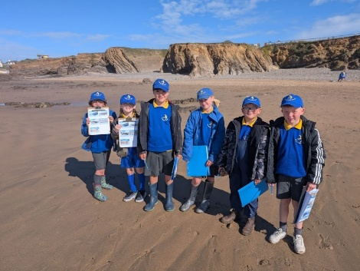
Class Two have welcomed Mrs Carey back this week and we are all pleased to have her back in school. Thank you to Miss Clark who covered the class in Mrs Carey’s absence. The children in Class Two will be starting their two-week swimming block next Monday. In maths the children have been revising how to count in 2s, 5s and 10s and this week they have been learning to count in 3s. Their current topic is castles in History where they have been learning about who lived and worked in medieval castles. Class Two are also looking forward to a visit from local artist Sue Reed who will be coming in on the 16th October.
Class Three
Year Three spent the afternoon on Crooklets and Summerleaze beach on Tuesday afternoon learning about coastal defences which ties in with their current unit of geography (Coasts). They have also started their Design Technology project where they are making felt fishes – assisted by Mrs Bennett. Next week the class are going to Westward Ho! to see how coastal erosion has shaped the landscape.
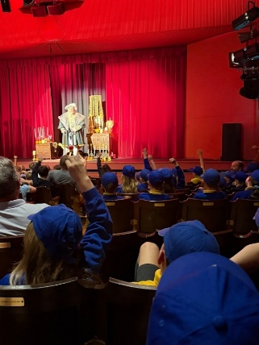
Class Four
Class Four are learning about rivers in their geography lessons at the moment and are due to go on a field trip in a couple weeks time to study the River Torridge. They have also been studying the artist Monet and using his work to improve their brush strokes.
Class Five
Class Five enjoyed a visit to HATS Theatre at the end of last week where they learnt about the life of Henry VIII. They have finished their two-week block of swimming lessons at Ruby Oak Park and are looking forward to starting their Bikeability sessions later in October
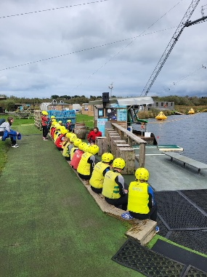
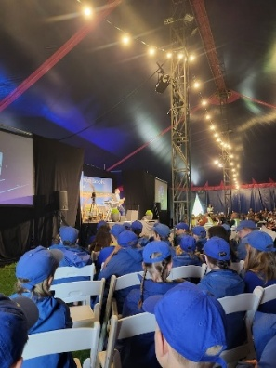
Class Six
Year Six have just completed their two-week block of swimming at Ruby Oak Park and are particularly enjoying learning how to wakeboard at the North Devon Wakepark on Friday afternoons throughout this half term. A couple weeks ago they also spent the morning at the Appledore Book Festival with a few other local schools doing an interactive Murder and Mystery session with the inspirational Gareth P Jones.

Dear Parents

Re: Holidays and Avoidable Absences in Term Time

We believe that in order for a pupil to fully benefit from their education, good attendance is crucial. It is the policy of our school to celebrate achievement and full attendance is a critical factor to a productive and successful school career.

In September 2013, an amendment to the Education (Pupil Registration)(England) Regulations 2006 came in to force and greater clarity was introduced to the issue of schools authorising absence requests. In addition on 19 August 2024, an amendment to the Education (Penalty Notices) (England) (Amendment) Regulations 2024 came into force and set out a new National Framework for issuing penalty notices. These changes reinforced the Government’s view that every minute of every school day is vital and that pupils should only be granted authorised absences by the school in ‘exceptional circumstances’.
A family holiday is not normally considered by the Government to be an ‘exceptional circumstance’ and therefore will not be authorised by this school.

I must take this opportunity to remind you, that should you choose to take your child out of school without the authorisation of the school, then Parental Responsibility Measures could be instigated. This could mean receiving any of the following;
• A Penalty Notice
• A summons to the Magistrate Court which could result in a fine of up to £2,500 and/or a term of imprisonment for up to 3 months.

Schools are required to notify the Local Authority if a pupil has a number of unauthorised absences. Unauthorised absences can be acquired when;
1) Leave has been requested, but the circumstances are such that the school is unable to authorise the leave and it is taken anyway.
2) Leave is not requested and/or the school has grounds to believe that the child has been taken out of school for an avoidable reason (example – a family holiday). Only the Head teacher can authorise an absence. This year there have been occasions when schools have been notified that the pupil is sick, but the school later discovers and reasonably believes that the reason given for the absence is not genuine.
3) A child continually arrives late after the registration period has closed.

This school will be notifying the Local Authority in all of the circumstances listed above.

Should a Penalty Notice be issued as a result of unauthorised absence then one notice will be issued to each parent/carer for each child involved. In addition to natural parents and any person with parental responsibility, any person considered to have day to day care and control of a young person is deemed to be a parent in matters relating to education and school nonattendance (s576 Education Act 1996).

From 19th August 2024, following changes to secondary legislation, the amount charged in a penalty notice was increased.
The first penalty notice issued will be charged at £160 if paid within 28 days. This is reduced to £80 if paid within 21 days.
The second penalty notice issued will be charges at a flat rate of £160 if paid within 28 days. If a Penalty Notice goes unpaid after 28 days, then court proceedings will be initiated.

We understand the disappointment that the refusal of a leave request may cause and we apologise, but as you can appreciate this policy represents the schools responsibility and commitment towards providing your child’s education and supporting their future life opportunities. We hope you will support us by ensuring that your son/daughter obtains the maximum benefit from their time at school by attending punctually for the 190 days each year that the law requires (unless prevented from doing so by an unavoidable circumstances).

Thank you for your anticipated support in this matter.

Yours sincerely

Head Teacher

